Project Vitriol – NEA Testing

1 Testing Strategy Overview
Testing was conducted to verify that the implemented system satisfies the functional and non-functional objectives defined in the Analysis section. The purpose of this stage is not simply to demonstrate that the program runs, but to show that it behaves correctly under normal, boundary, and abnormal conditions.
Testing was structured into:
• Internal Logic Verification – confirming that core calculations and control logic (indexing, command execution, viewport calculations, camera behaviour, serialisation) operate deterministically.
• Functional Subsystem Testing – validating that observable behaviours (map creation, editing, persistence, runtime rendering) align with specified requirements.
• Boundary and Abnormal Data Testing – evaluating validation rules and system resilience when exposed to extreme or invalid input.
• Performance Observation – assessing rendering behaviour and responsiveness under larger map conditions.
Where issues were identified, corrective modifications were applied and the affected subsystem was retested to confirm stability. Representative samples are presented below to demonstrate that the system fulfils its intended purpose.

2 Subsystem Testing

2.1 Map Creation and Validation
This subsystem verifies that map initialisation follows the defined structural rules and that invalid configurations are rejected prior to persistence. It directly supports objectives relating to data integrity, autosave behaviour, and safe project management.

Test Table 1 – Map Creation & Validation
Test ID | Purpose of Test | Test Data | Expected Outcome | Actual Outcome | Screenshot ID
MC1 | Verify new map creates valid empty grid | Width = 32  Height = 32 | 1024-tile grid initialised with default values | Pass | Figures T1
MC2 | Validate manual save required before autosave | Create new map -> modify tile without saving | Autosave disabled until first manual save | Pass | Figures T2.1, T2.2
MC3 | Boundary test – minimum size | Width = 1  Height = 1 | Valid 1x1 grid created without error | Pass | Figures T3
MC4 | Boundary test – large size | Width = 300  Height = 300 | Map created successfully. Viewport rendering prevents performance degradation | Pass | Figures T4
MC5 | Abnormal input – negative size | Width = -10 | Map creation rejected with validation error | Pass | Figures T5
MC6 | Abnormal input – zero dimension | Width = 0 | Validation prevents creation | Pass | Figures T6

Test Table 1 – Screenshot Evidence

Figure T1 - Standard Map Creation (32×32 Grid)
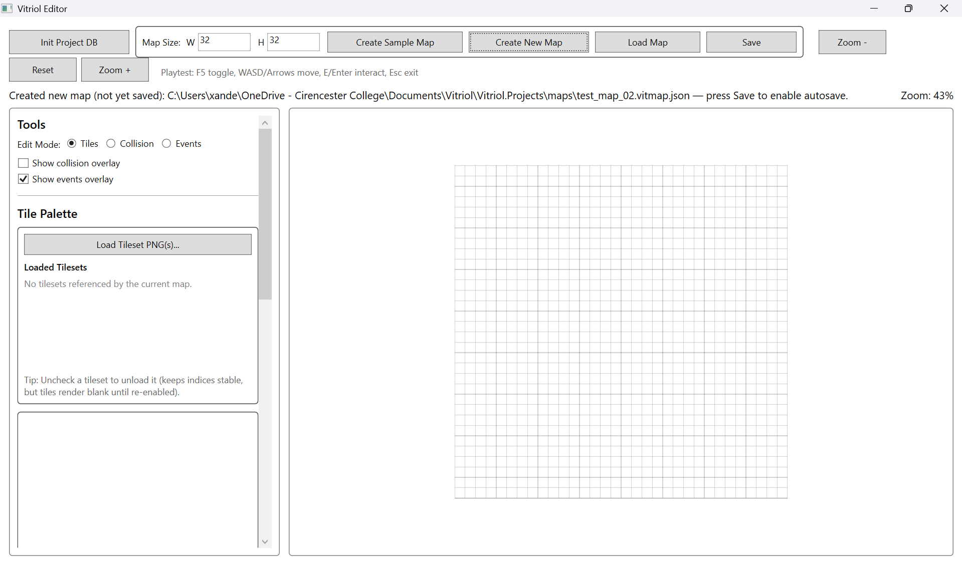
Demonstrates successful creation of a default-sized map with correctly initialised tile grid.

Figure T2.1, T2.2 – Autosave Disabled Prior to First Manual Save
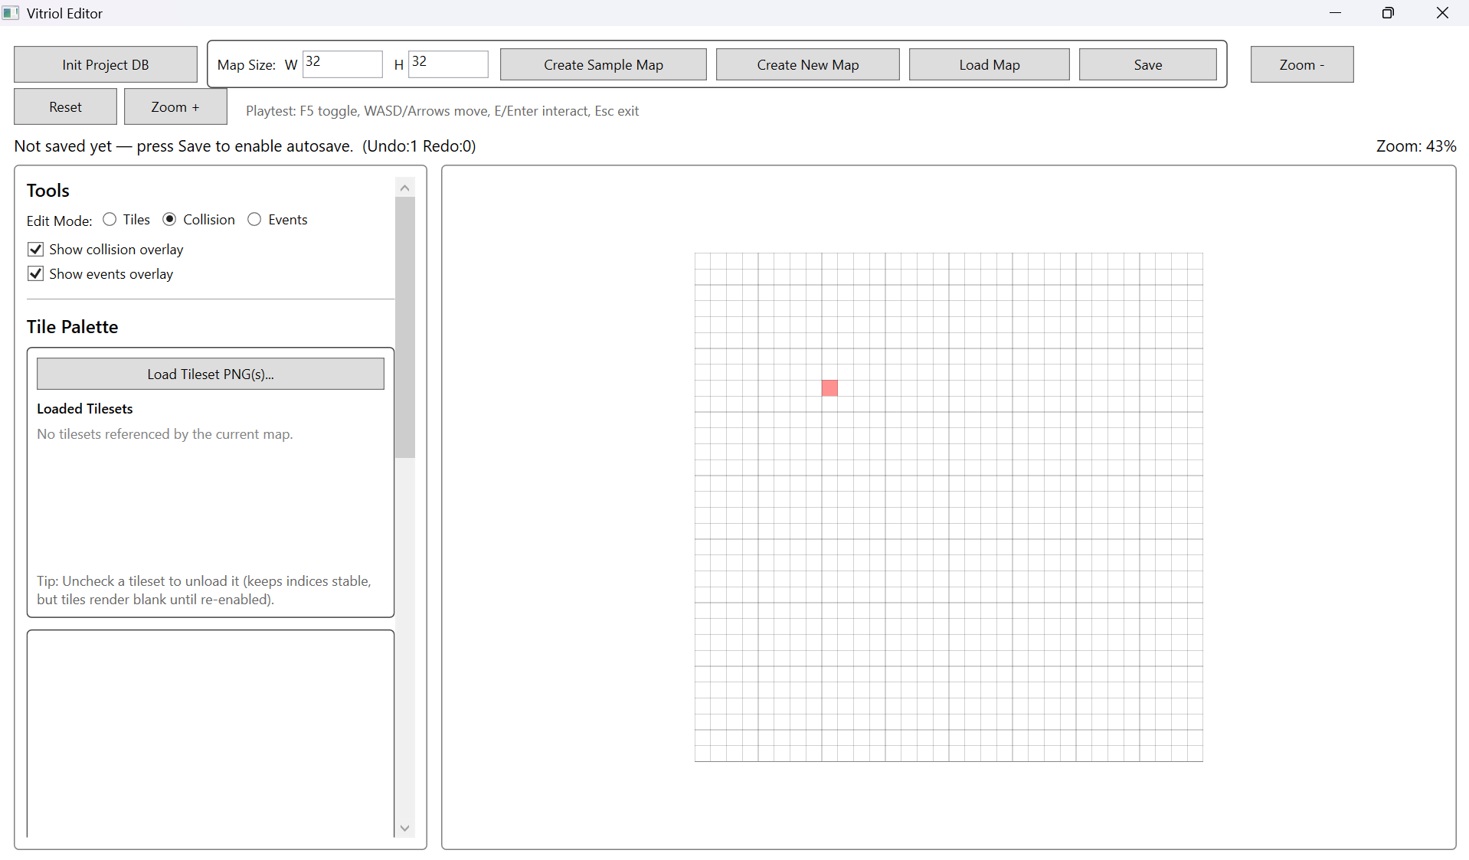
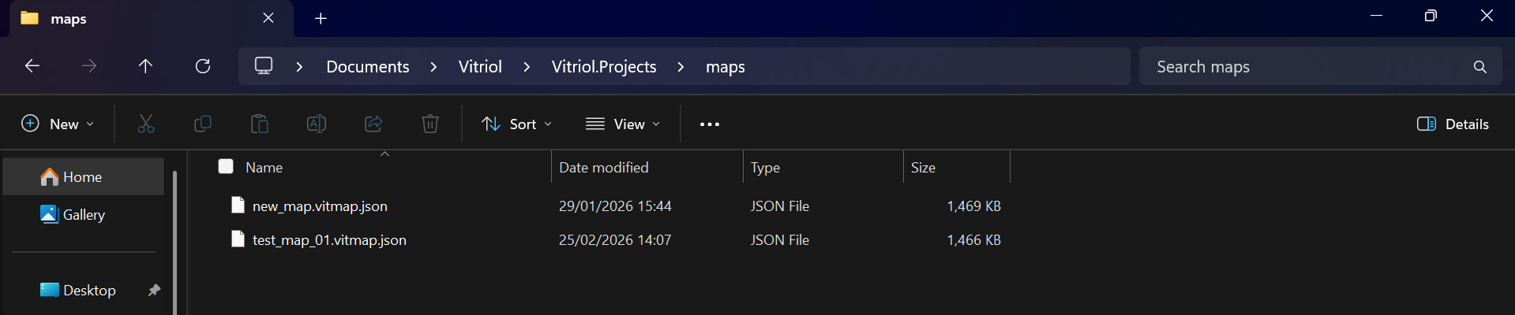
Demonstrates that modifying a newly created map does not trigger autosave before an explicit manual save is performed.

Figure T3 – Minimum Map Dimension Boundary Test (1×1 Grid)
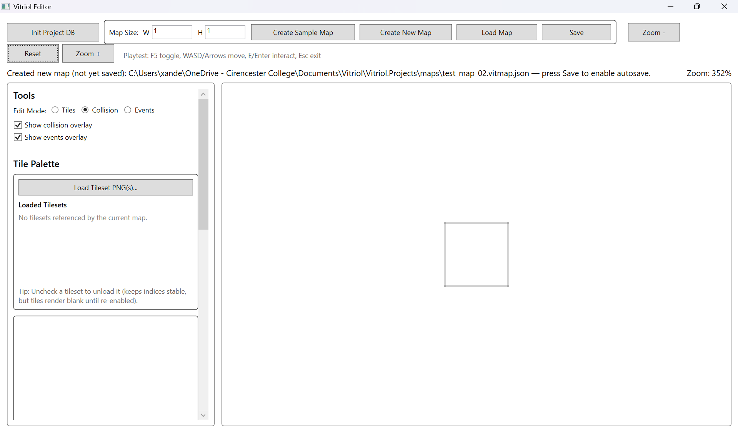
Demonstrates correct handling of the smallest valid map configuration without runtime instability.

Figure T4 – Large Map Creation (300×300) with Viewport Rendering Active
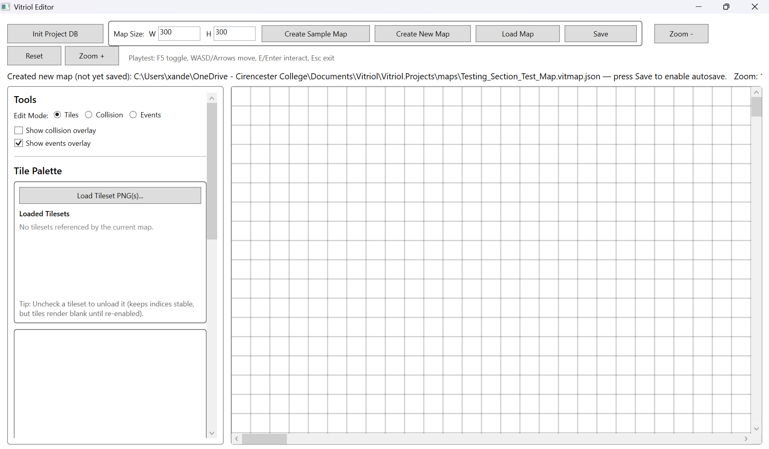Demonstrates stable creation and navigation of a large map using region-based viewport rendering.

Figure T5 – Negative Dimension Validation Rejection
Demonstrates system rejection of invalid negative dimension input prior to grid allocation. 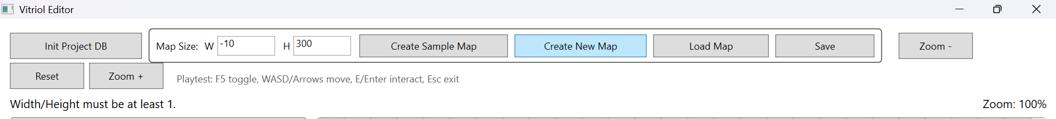

Figure T6 – Zero Dimension Validation Handling
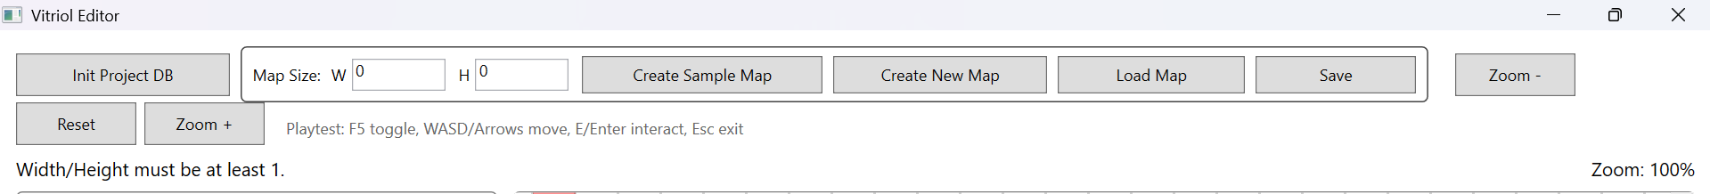
Demonstrates prevention of zero-sized map creation through input validation logic.

2.2 Tile Editing and Undo/Redo
This subsystem verifies that editing operations correctly modify the underlying data model and that the Undo/Redo mechanism reliably restores previous states without introducing inconsistencies.
The command-based editing model was tested to ensure:
- Each paint operation produces exactly one reversible command
- Undo restores the previous tile state
- Redo reapplies the change deterministically
- New edits correctly clear the redo stack
- Autosave behaviour does not interfere with command execution

Test Table 2 – Tile Editing & Undo/Redo
Test ID | Purpose of Test | Test Data | Expected Outcome | Actual Outcome | Screenshot ID
UR1 | Verify tile paint modifies correct grid index | Paint tile at (5,5) | Tile at (5,5) updated only | Pass | Figures T7.1, T7.2
UR2 | Verify Undo restores previous state | Paint tile -> Undo | Tile returns to original value | Pass | Figures T8.1, T8.2
UR3 | Verify Redo reapplies change | Undo -> Redo | Tile updated again | Pass | Figures T9.1, T9.2
UR4 | Verify redo stack clears after new action | Paint -> Undo -> Paint new tile | Redo unavailable | Pass | Figures T10.1, T10.2
UR5 | Multi-step undo stability | Paint 3 tiles -> Undo 3 times | Grid returns to original state | Pass | Figures T11.1, T11.2, T11.3, T11.4

Test Table 2 – Screenshot Evidence

Figure T7.1 – Tile Grid Before Paint Operation at Coordinate (5,5)
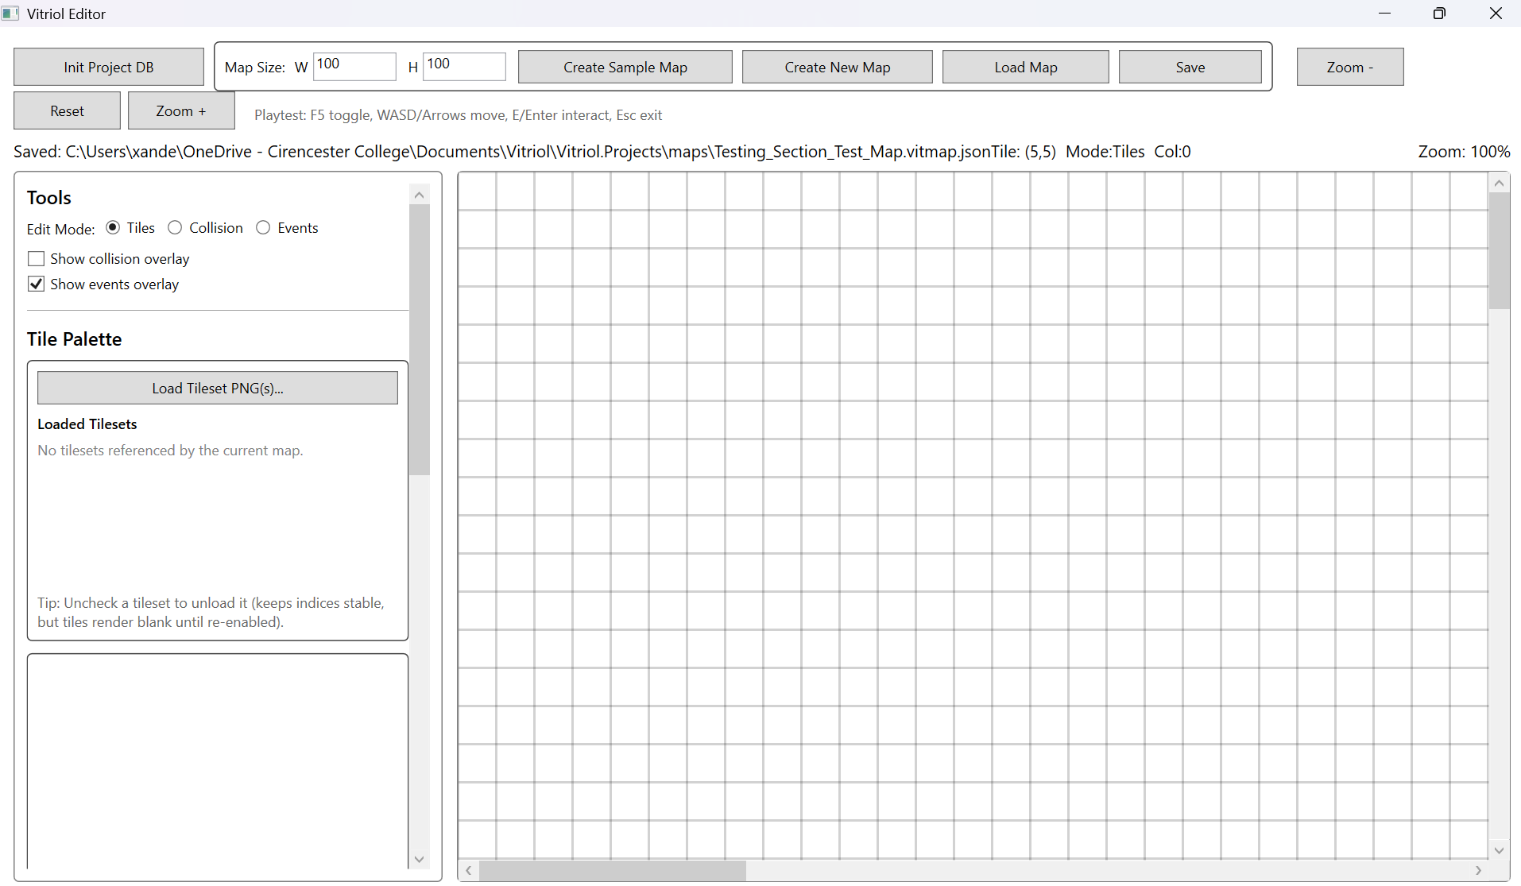

Figure T7.2 – Tile Grid After Paint Operation at Coordinate (5,5)
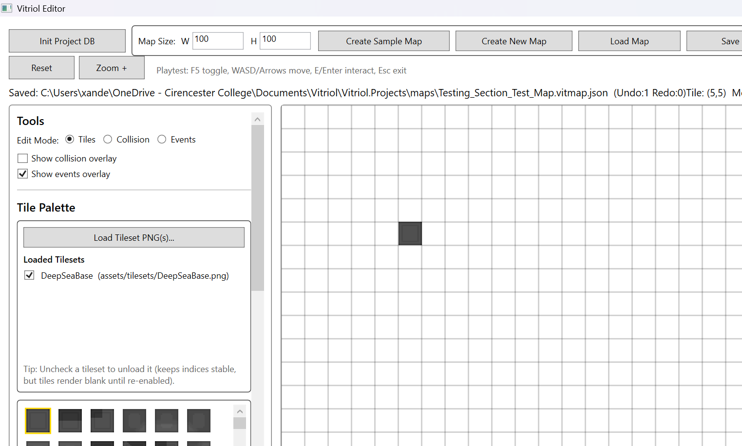
Demonstrates that the paint command updates only the intended grid coordinate, confirming correct 2D-to-1D index conversion logic and isolated state mutations.

Figure T8.1 – Tile Sate Immediately After Paint operation
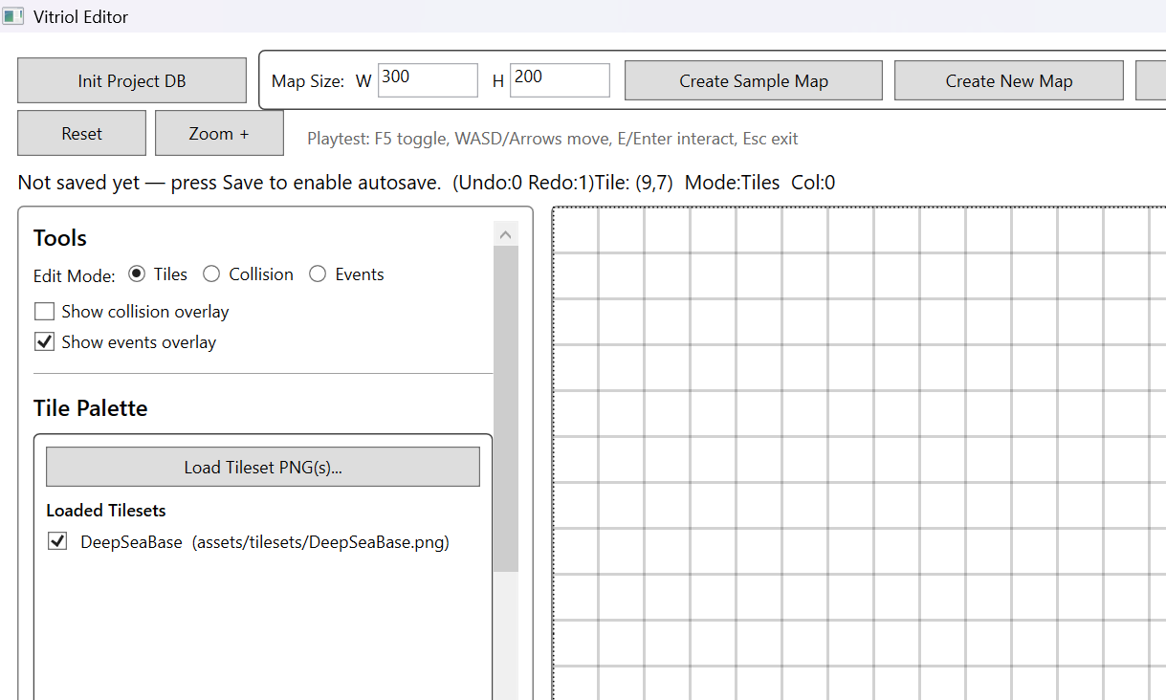
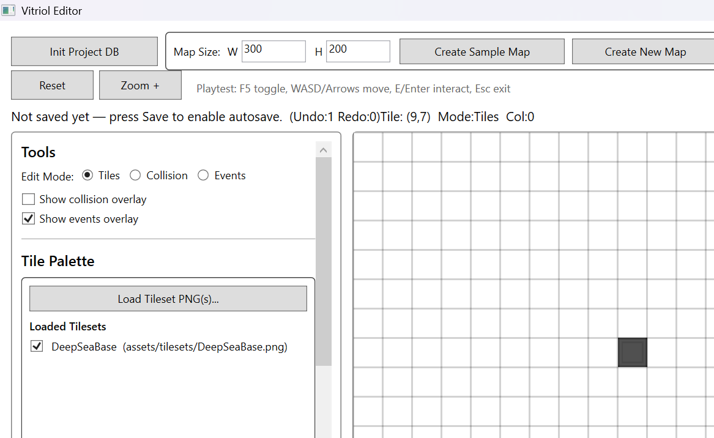

Figure T8.2 Tile State After Undo Invocation (Ctrl+Z)

Demonstrates that Undo restores the previous tile value without affecting unrelated grid cells, validating reversible command execution

Figure T9.1 – Tile State after Undo Operation
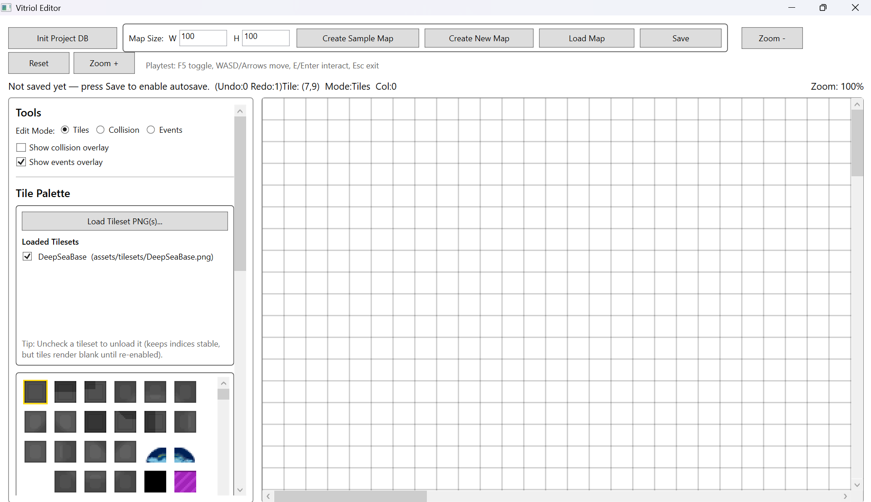

Figure T9.2 – Tile State after Redo Invocation (Ctrl+Y)
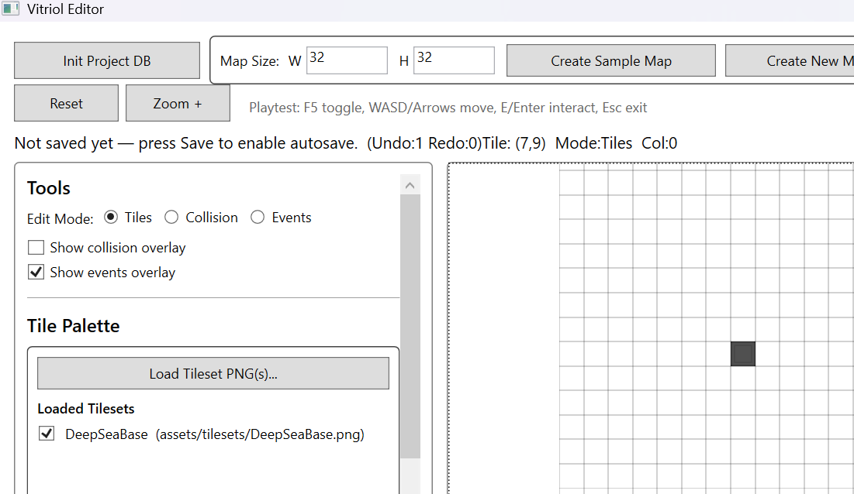

Demonstrates deterministic reapplication of a previously undone command, confirming symmetrical execution behaviour

Figure T10.1 – Tile State After Undo Operation
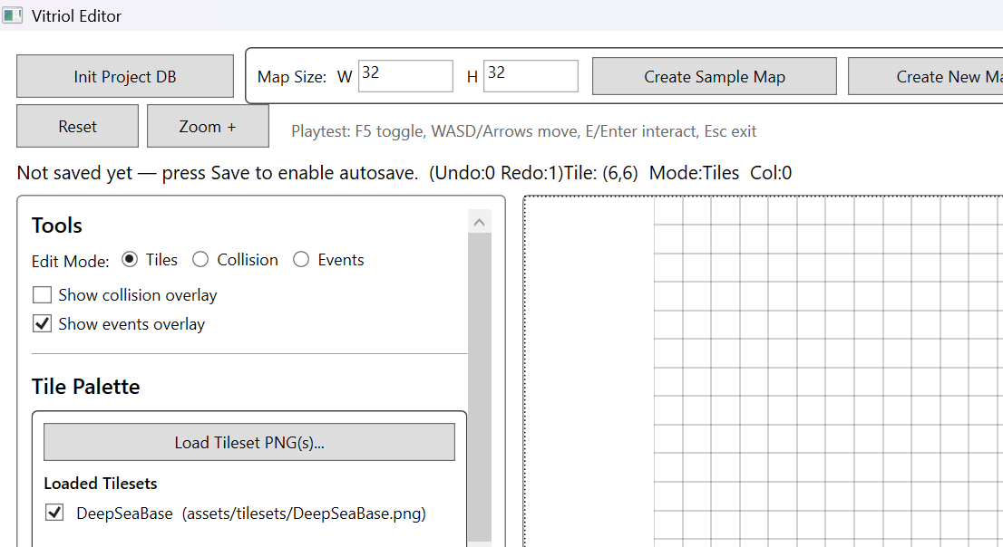

Figure 10.2 – Tile State After New Paint Action (Redo Attempt Blocked)
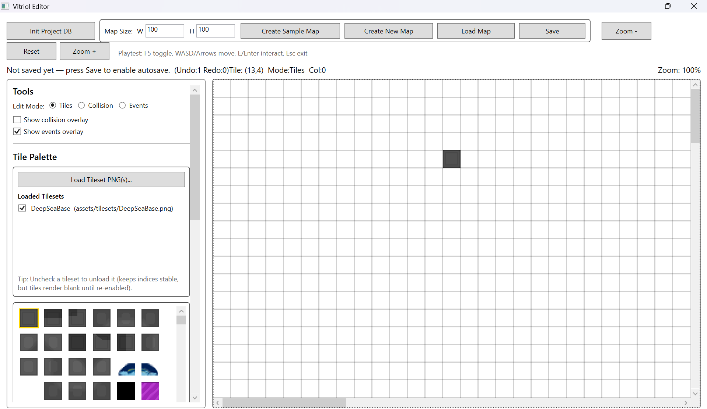
Demonstrates that performing a new edit after Undo correctly clear the redo stack, preventing invalid state replay

Figure T11.1 Grid After 3 Paint Operations
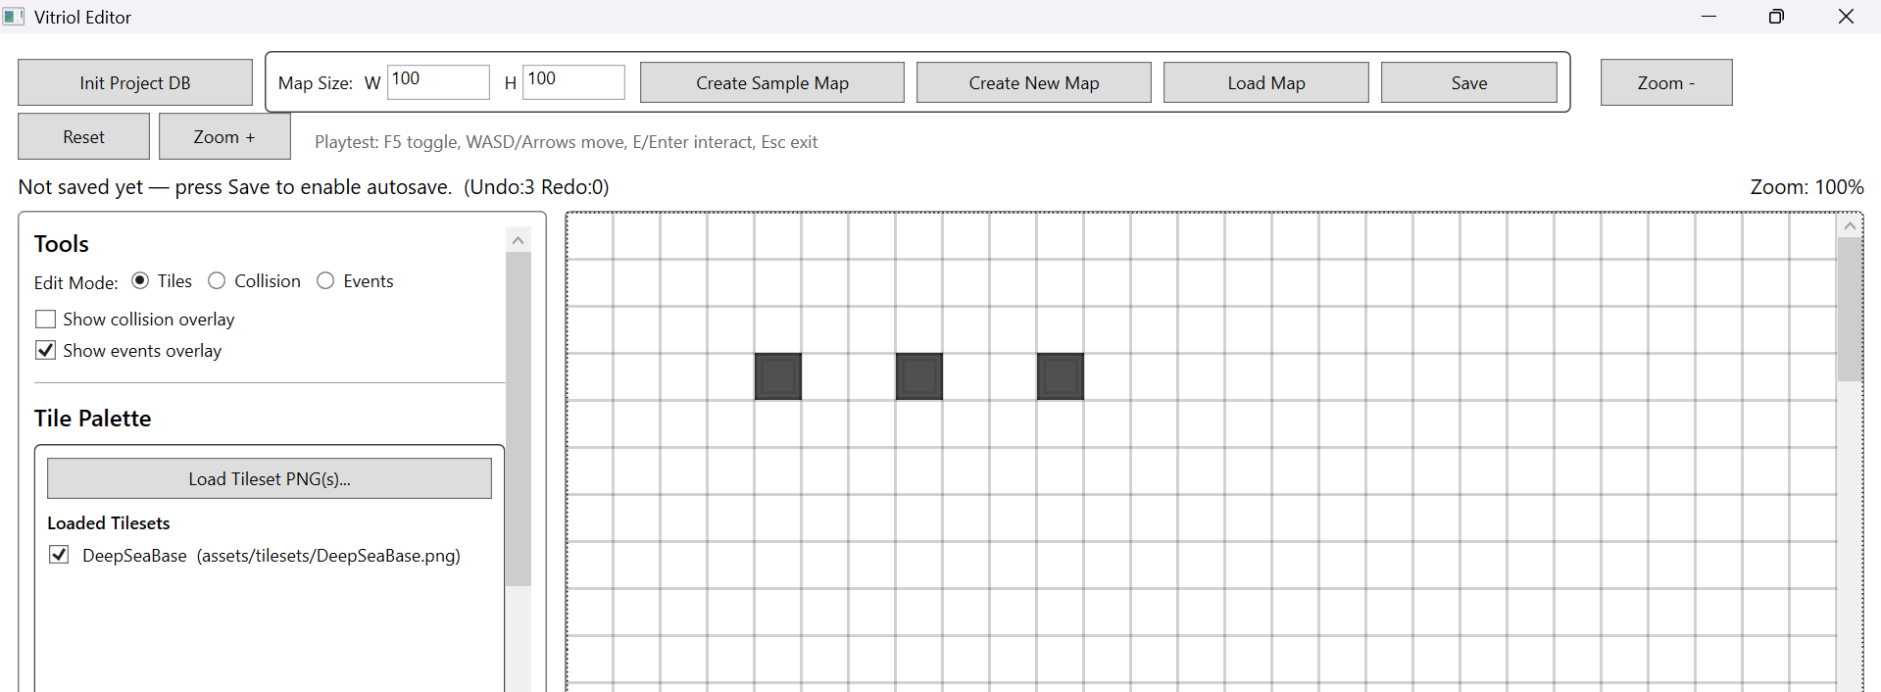

Figure T11.2 – Grid After 1st Undo Operation
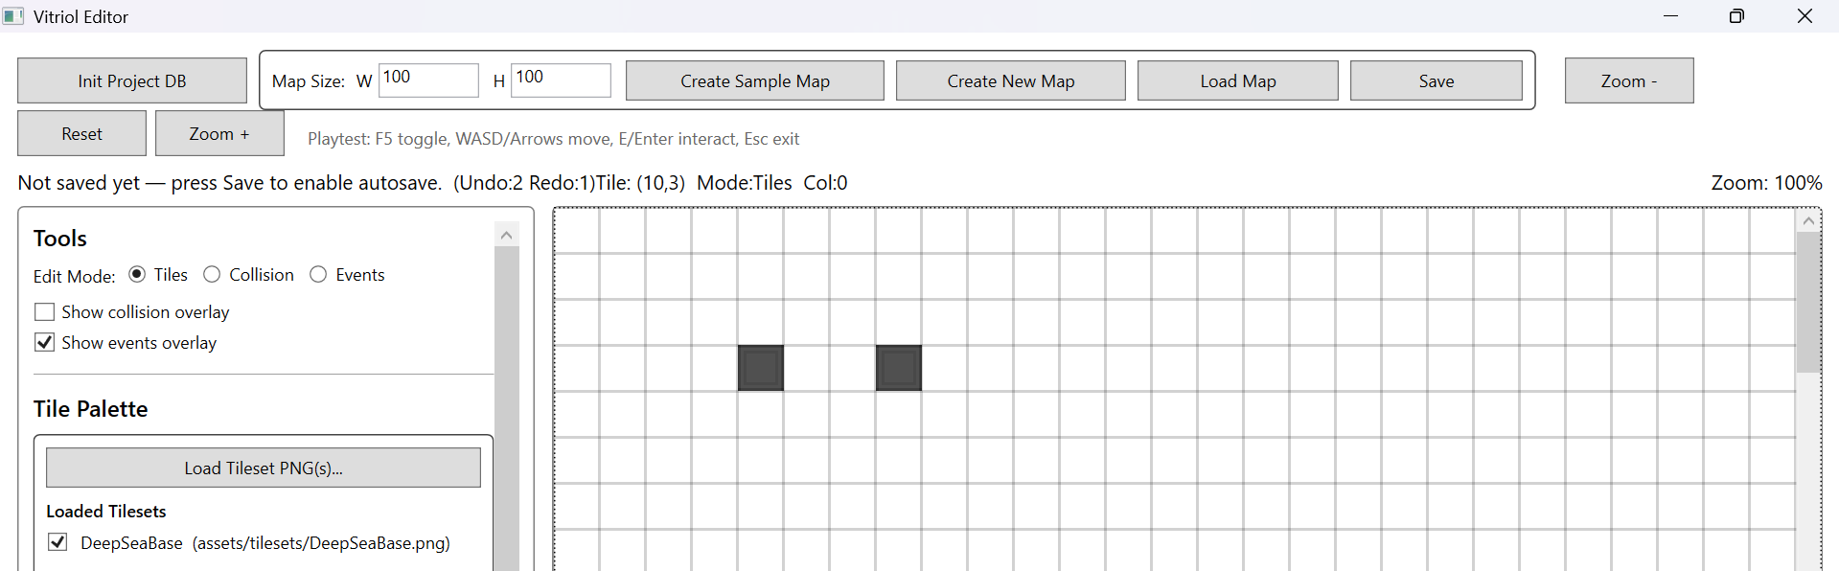

Figure T11.3 – Grid After 2nd Undo Operation
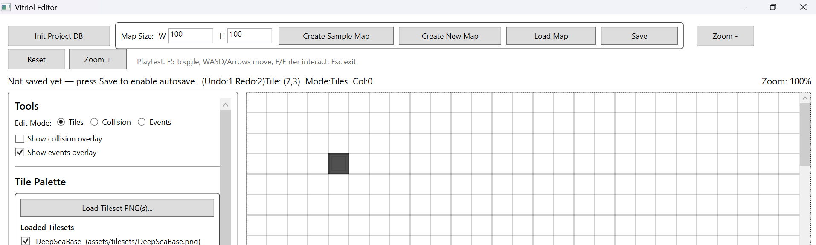

Figure T11.4 – Grid after 3th Undo Operation
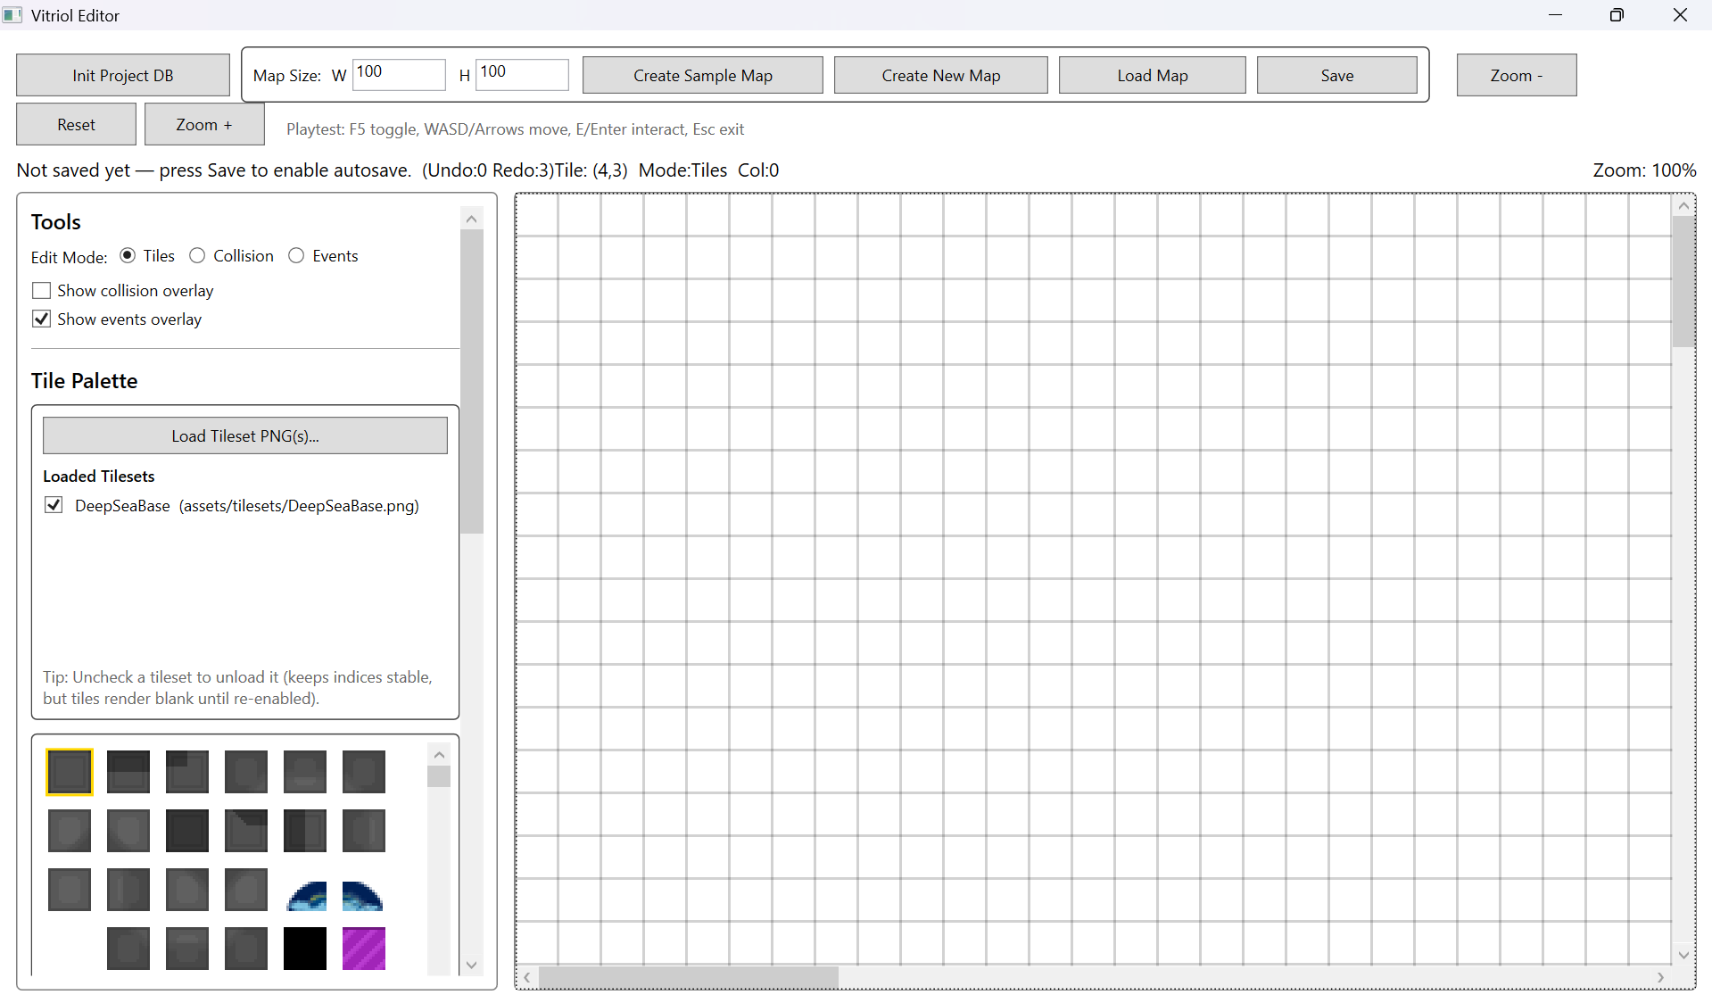
Demonstrates correct last-in-first-out stack behaviour, restoring the grid to its original state after sequential command reversals

2.3 Tileset Loading and Referencing
This subsystem verifies that tilesets are referenced and loaded in a controlled and stable manner, preserving tile indices while allowing memory-efficient toggling of loaded assets.
Testing focused on:
- Correct storage of relative paths
- Successful loading and rendering of tileset images
- Stable tile indexing when toggling tilesets
- Correct behaviour when referenced tileset files are missing

Test Table 3 – Tileset Loading & Referencing
Test ID | Purpose of Test | Test Data | Expected Outcome | Actual Outcome | Screenshot ID
TS1 | Verify tileset reference stored as relative path | Select tileset from project folder | JSON stores relative path from project root | Pass | Figures T12.1, T12.2
TS2 | Verify tileset loads and renders correctly | Load tileset and paint tile | Tiles render correctly in viewport | Pass | Figures T13.1, T13.2
TS3 | Verify toggling tileset does not corrupt map | Load -> Unload -> Reload | Tile indices preserved | Pass | Figures T14.1, T14.2, T14.3
TS4 | Abnormal test – missing tileset file | Rename/remove PNG file | Validation error shown or load prevented | Pass | Figures T15.1, T15.2

Test Table 3 – Screenshot Evidence

Figure T12.1 – Tileset Selected in Editor
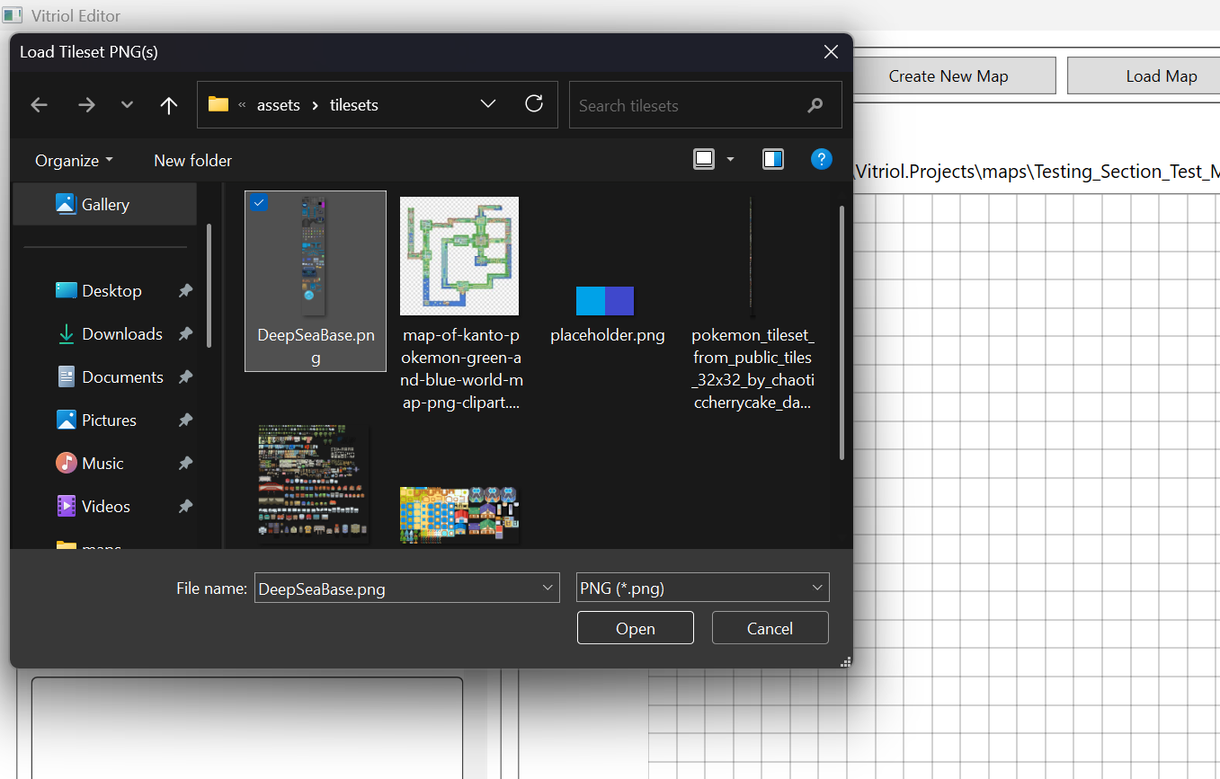

Figure T12.2 – JSON File Showing Relative Tileset Path
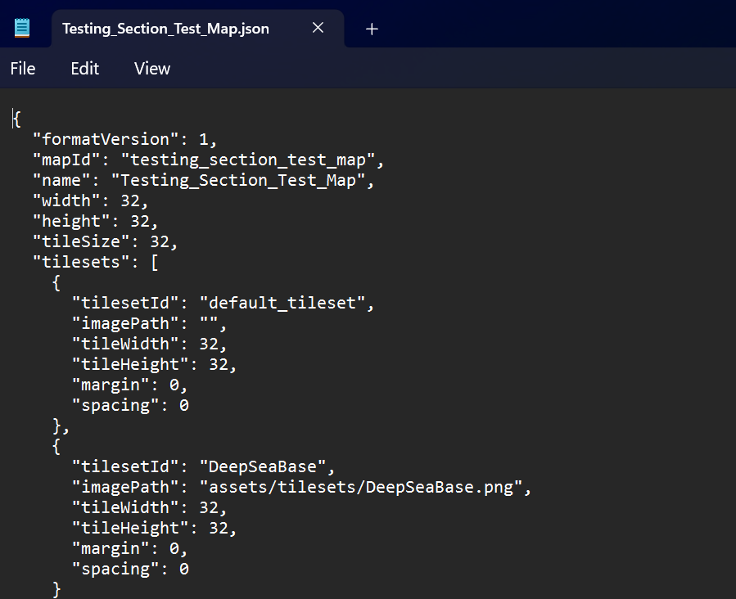
Demonstrates that tileset references are stored using project-relative paths, ensuring portability and version-control compatibility

Figure T13.1 – Tileset Loaded in Editor Palette
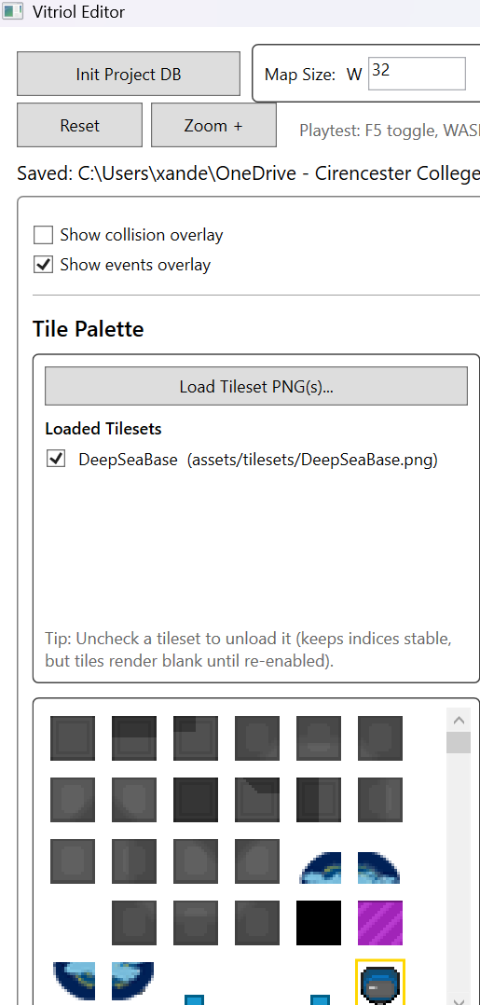

Figure T13.2 – Painted Tiles Rendering Correctly in Viewport
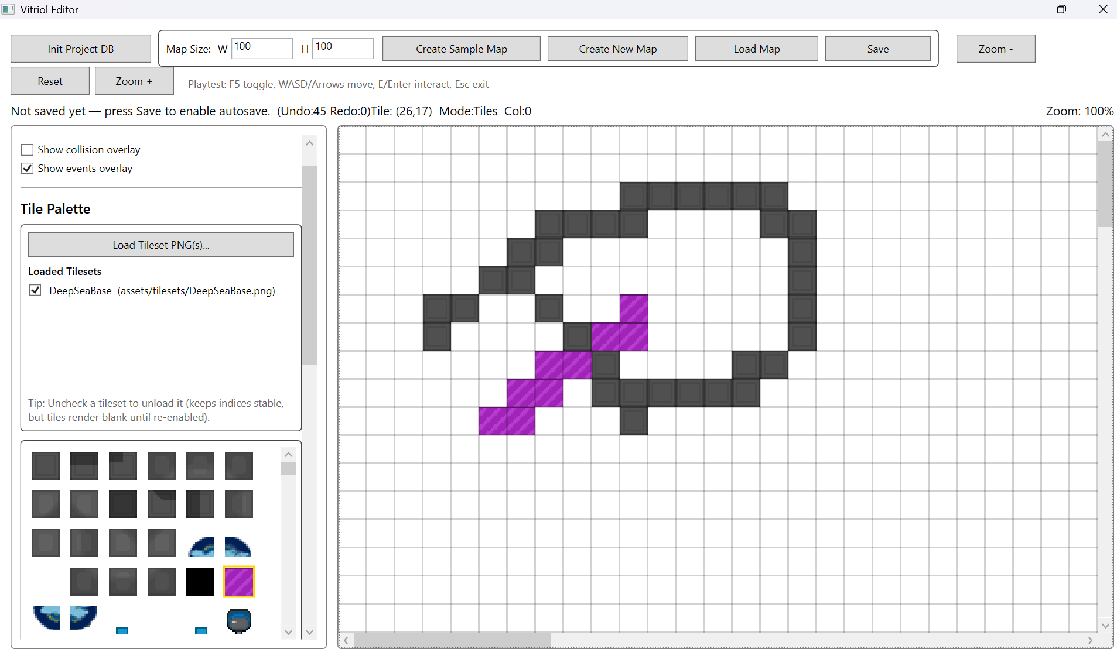
Demonstrates correct tileset loading and rendering within the editor viewport

Figure T14.1 – Painted Map Before Tileset Toggle
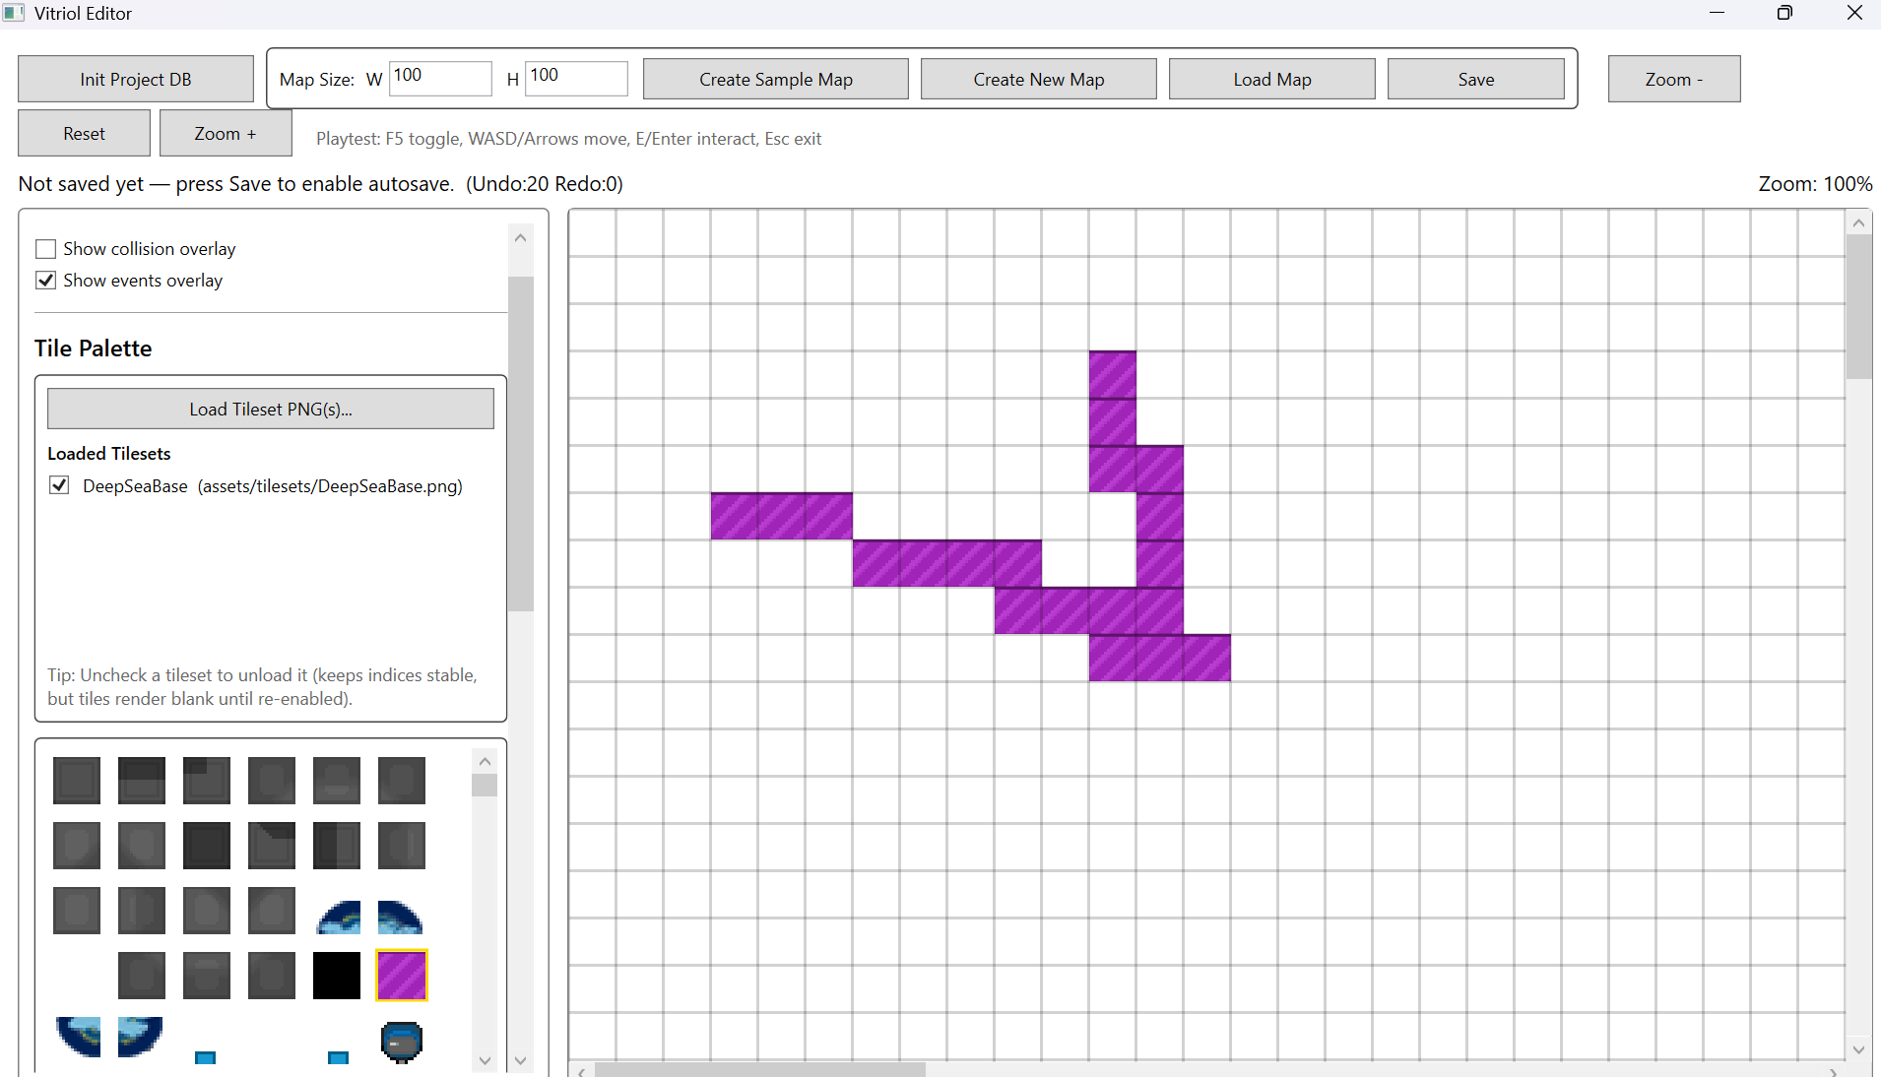

Figure T14.2 – Map After TIleset Toggle
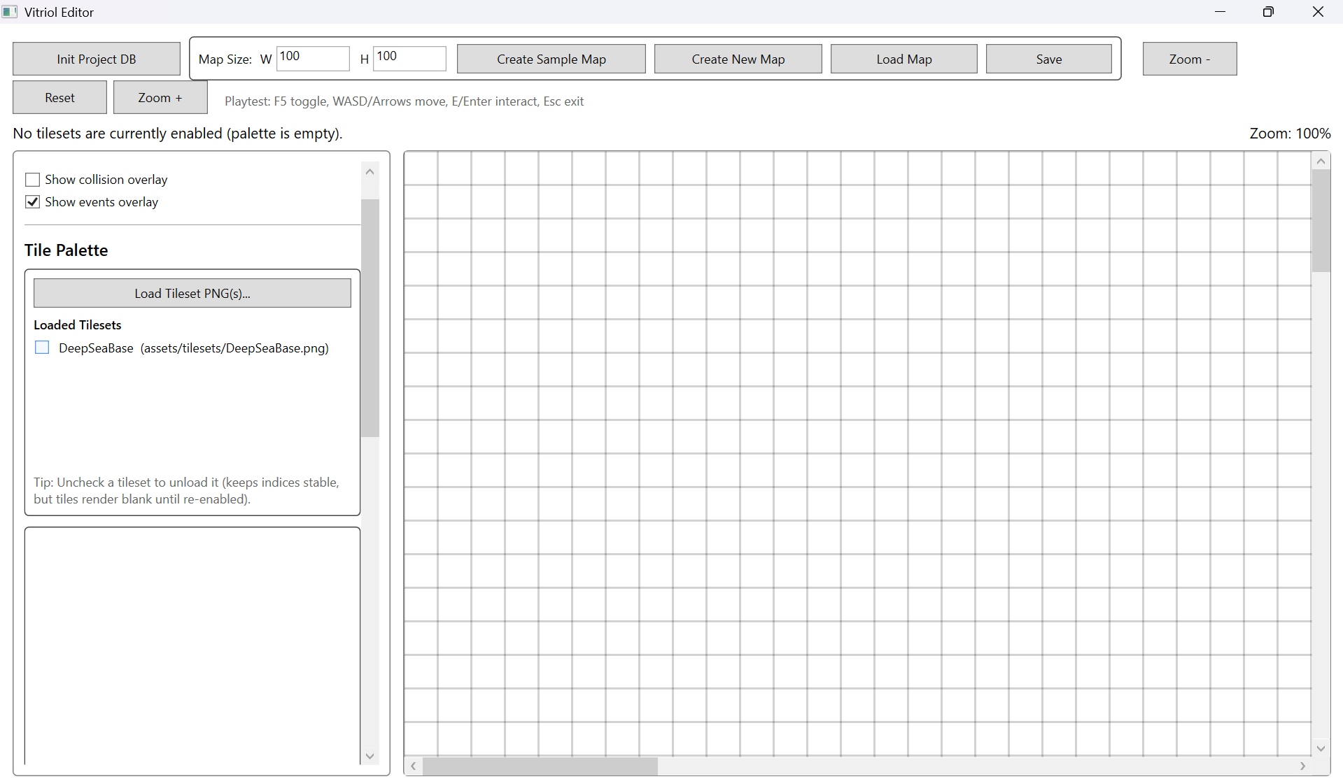

Figure T14.3 – Map After TIleset Reload (Indices Preserved)
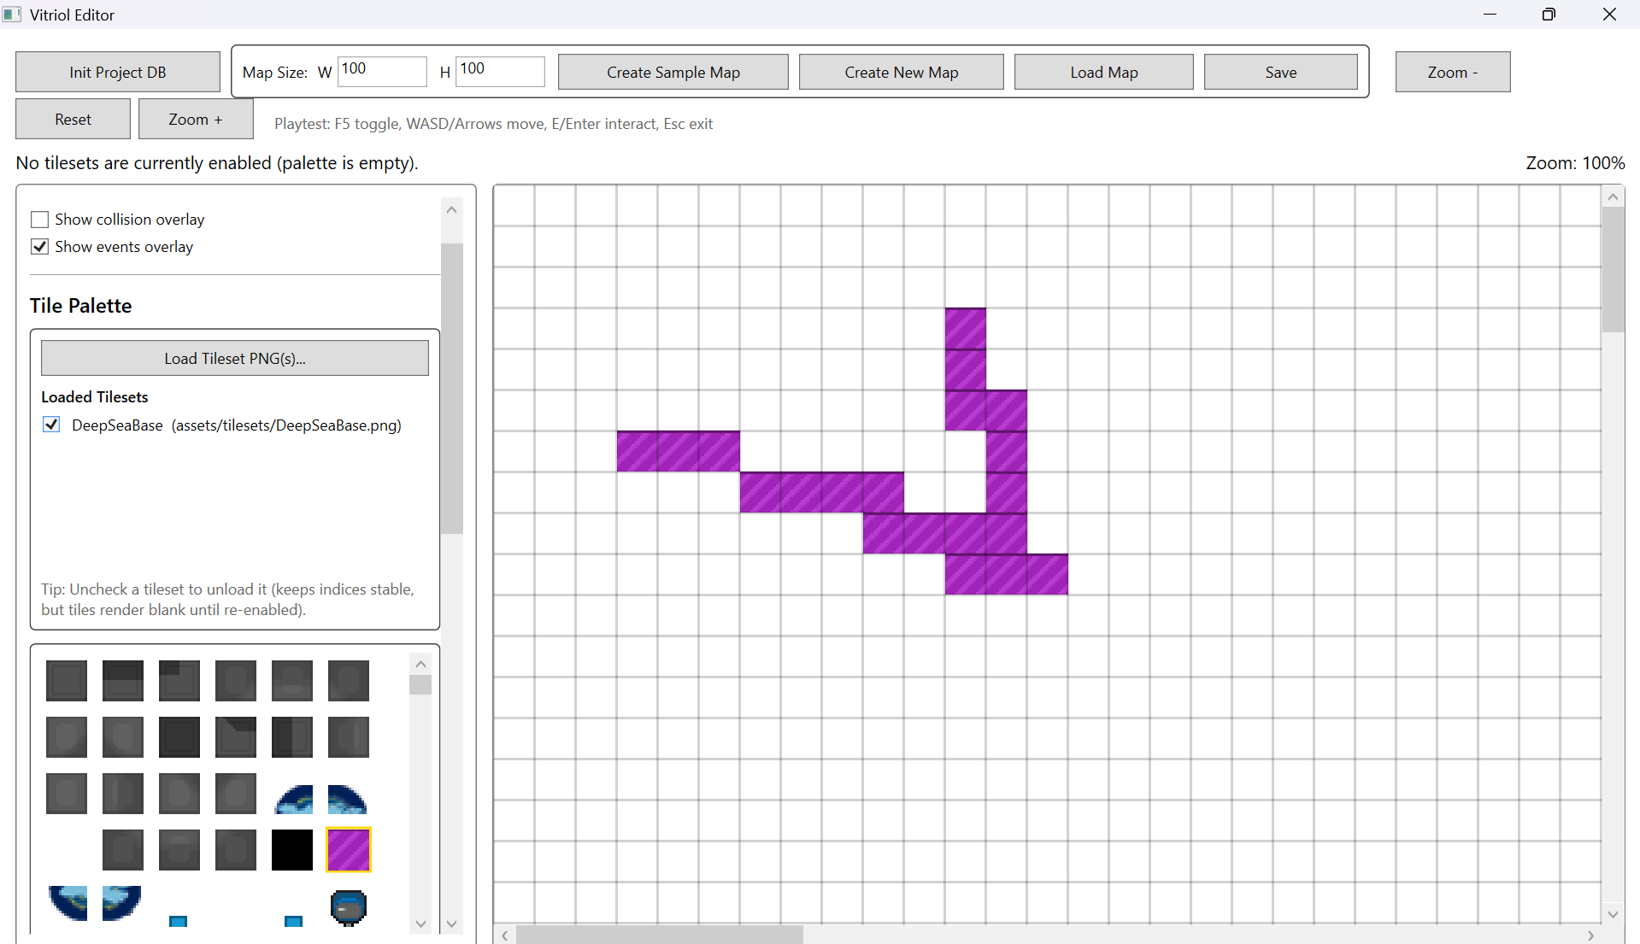
Demonstrates that tile indices remain stable when tilesets are unloaded and reloaded, preventing structural corruption

Figure T15.1 – Loaded PNG File Renamed
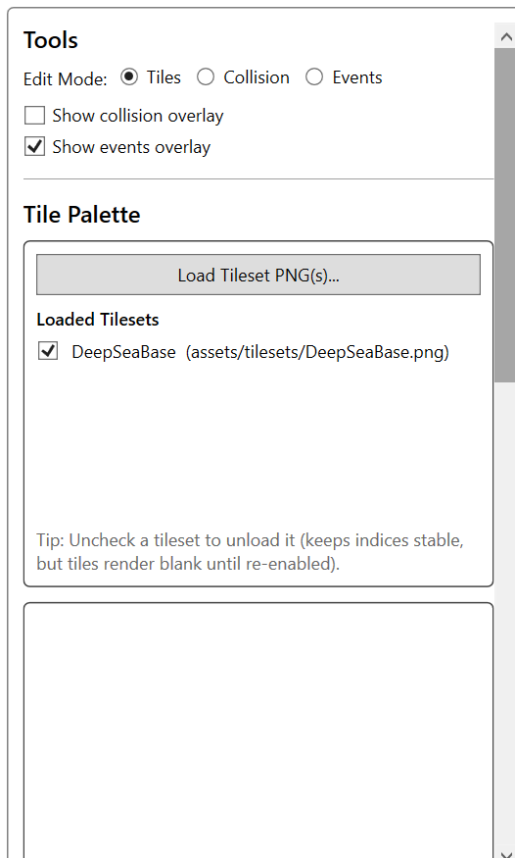

Figure T15.2 – Validation/Error Output for “Missing” Asset
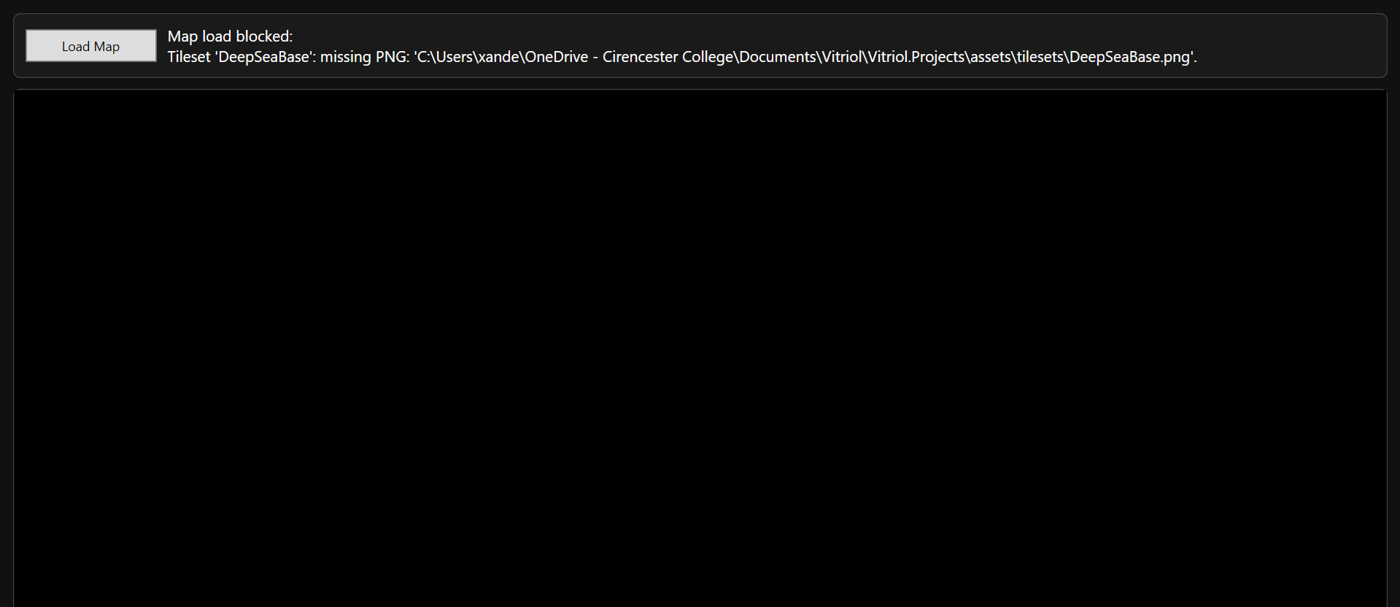
Demonstrates controlled handling of missing asset references without runtime crash

2.4 Event System Testing

Test Table 4 – Event System Testing
Test ID | Purpose of Test | Test Data | Expected Outcome | Actual Outcome | Screenshot ID
EV1 | Verify event placement on map grid | Place NPC event at (10,10) | Event appears at correct coordinate | Pass | Figures T16.1, T16.2
EV2 | Verify event serialisation integrity | Save map after event creation | Event stored correctly in JSON | Pass | Figures T17.1, T17.2
EV3 | Verify event reload stability | Close editor -> reopen map | Event reappears at correct location | Pass | Figures T18.1, T18.2
EV4 | Verify runtime event trigger execution | Trigger event in runtime | Event executes associated behaviour | Pass | Figures T19.1, T19.2
EV5 | Abnormal test – invalid event parameters | Remove required argument manually in JSON | Validation prevents crash/handles safely | Pass | Figures T20.1, T20.2

Test Table 4 – Screenshot Evidence

Figure T16.1 – Map Grid Before Event Placement
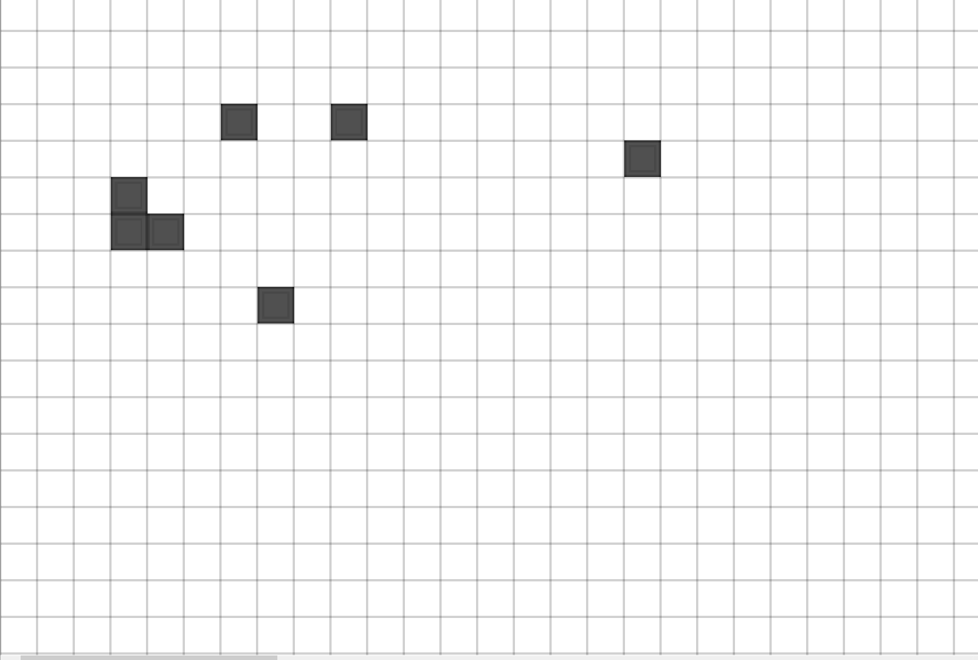

Figure T16.2 – Event Placed At Coordinate (10,10)
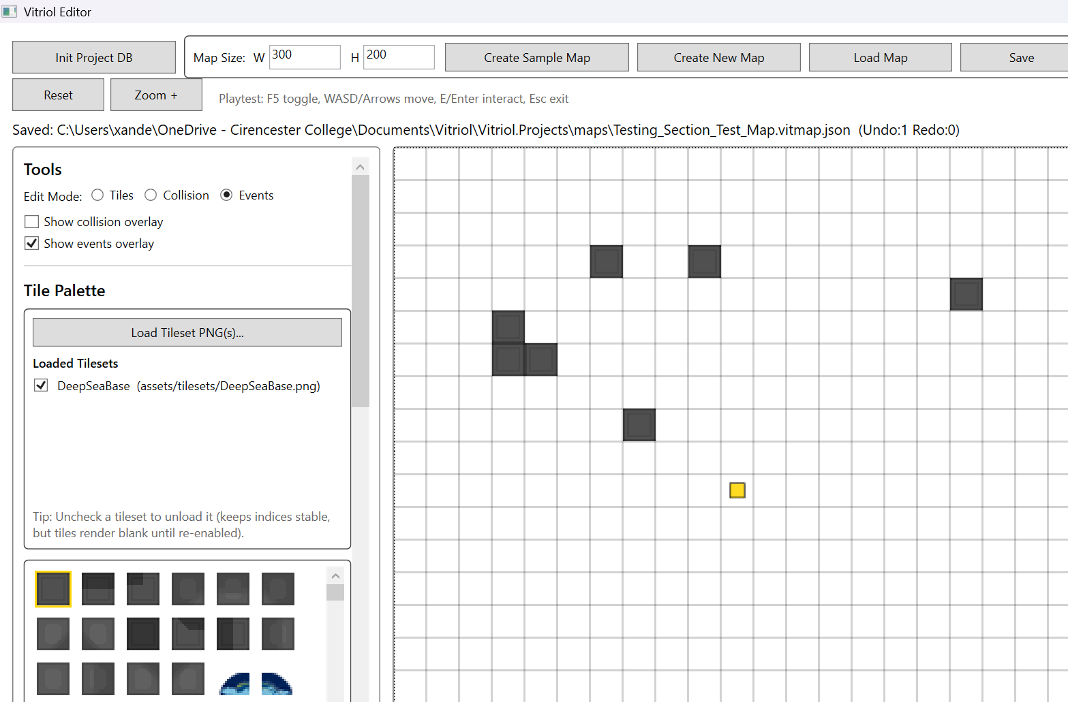
Demonstrates correct mapping between grid coordinate and event object placement

Figure T17.1 – Event Visible in Editor Prior to Save
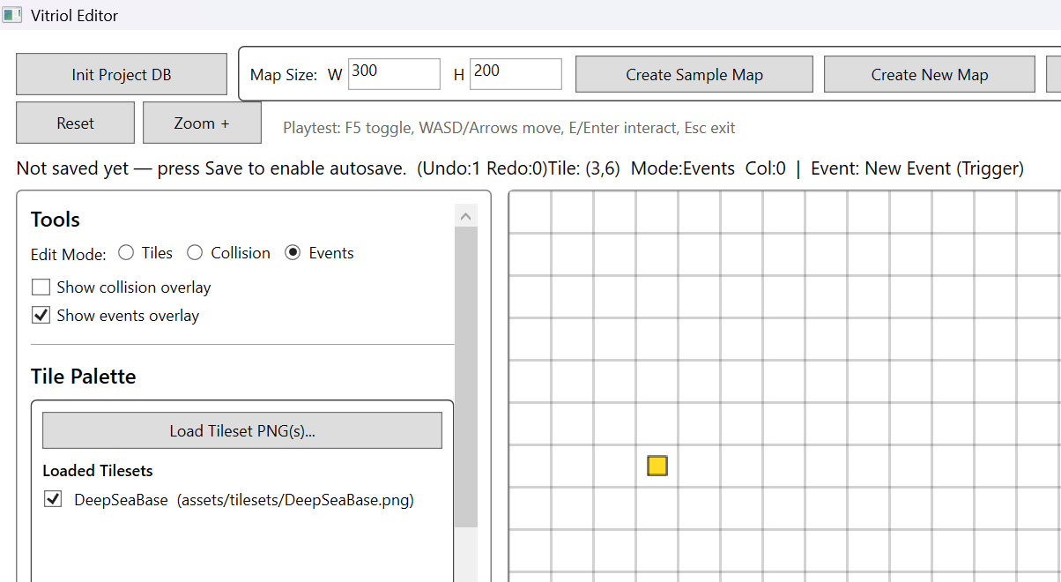

Figure T17.2 – JSON Representation of Saved Event Data
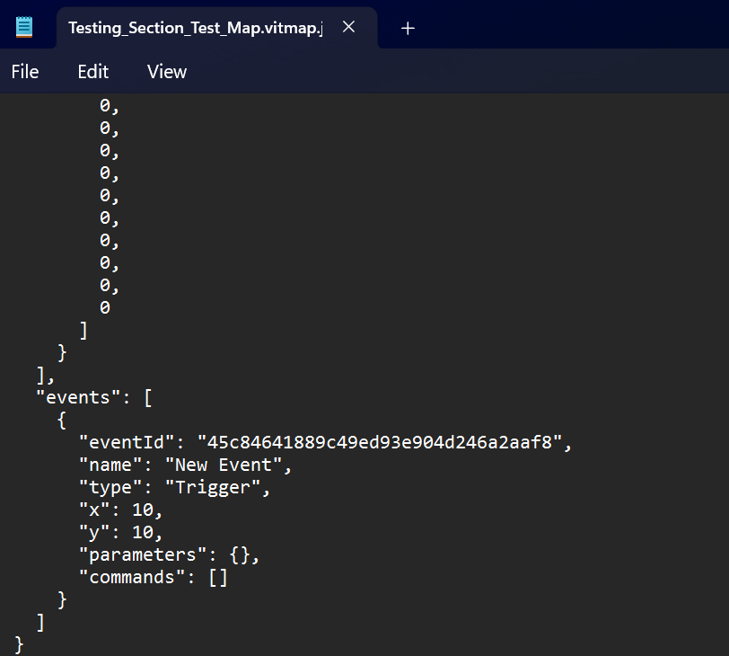
Demonstrates accurate serialisation of event metadata including ID, type, position, and command structure

Figure T18.1 – Event Visible Before Editor Restart
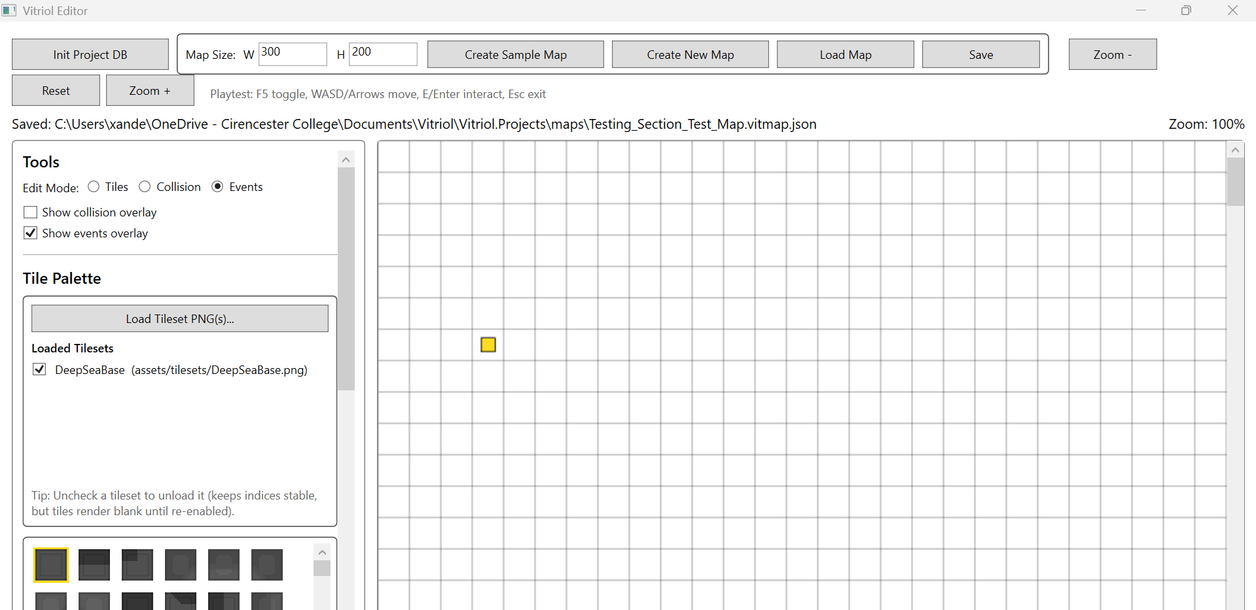

Figure T18.2 – Event Correctly Restored After Reload
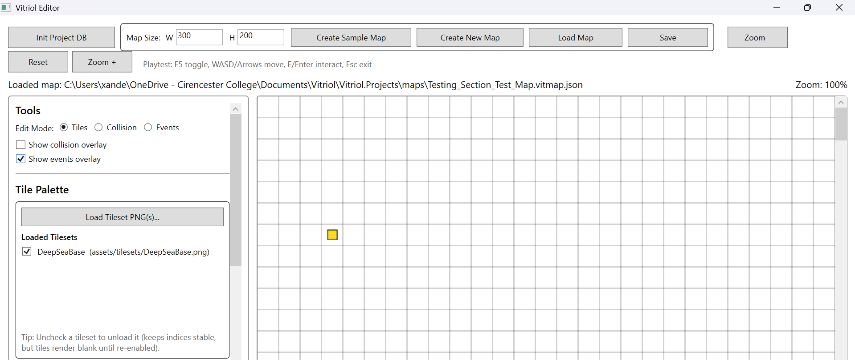
Demonstrates persistence integrity across sessions without data loss

Figure T19.1 – Player Approaching Event Trigger Tile
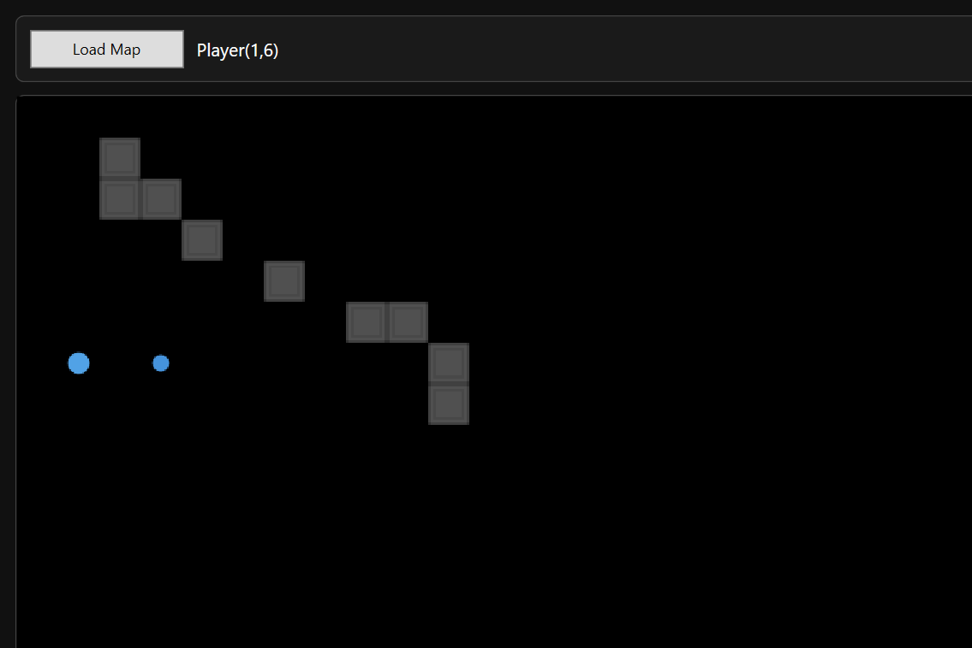

Figure T19.2 – Event Behaviour Executed in Runtime (Dialogue/Effect Displayed)
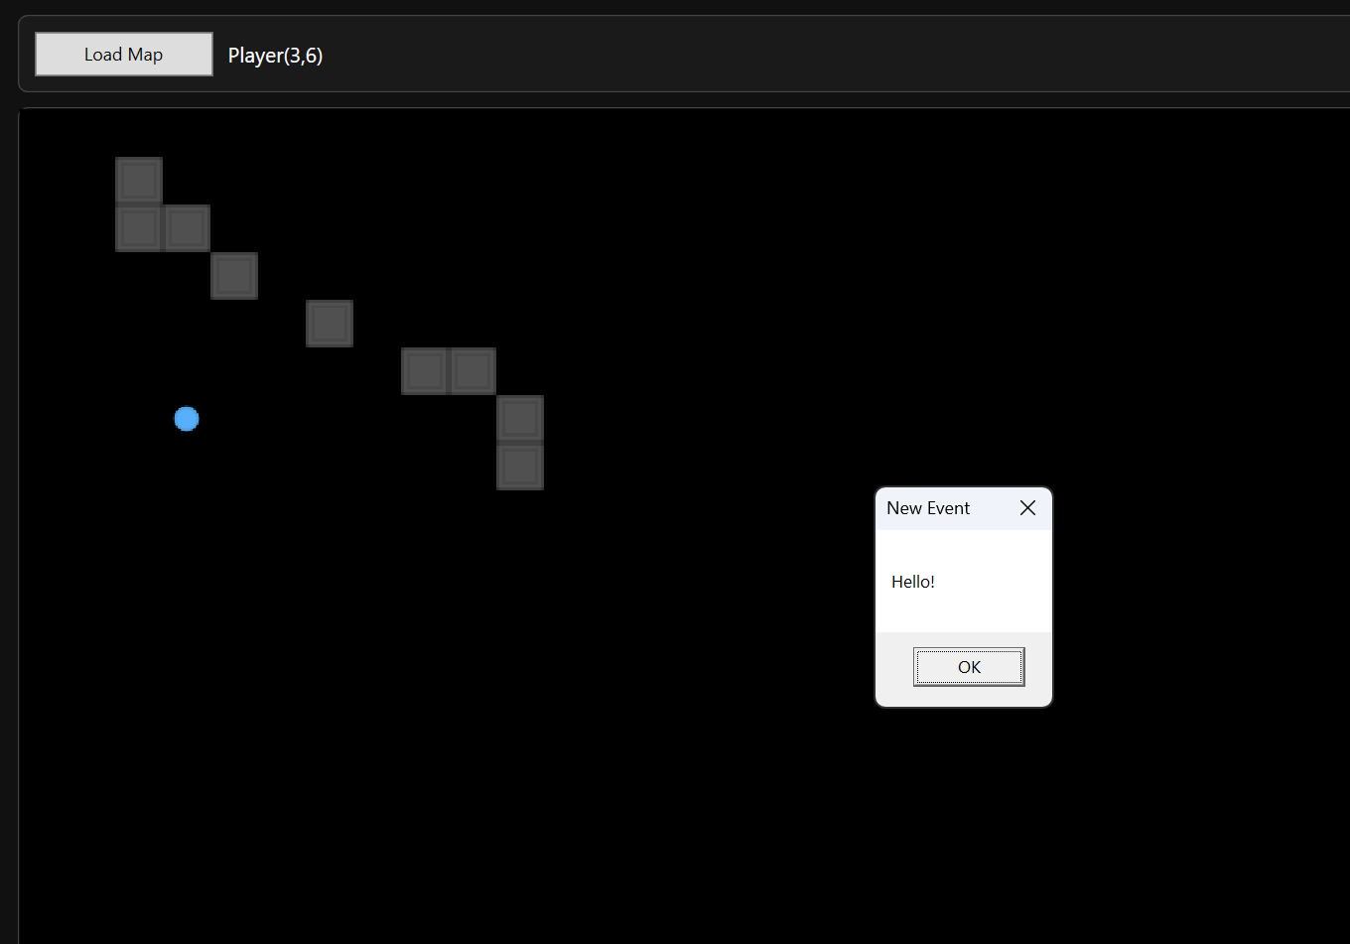
Demonstrates correct linkage between editor-defined event data and runtime execution logic

Figure T20.1 Modified JSON with Missing Event Parameter
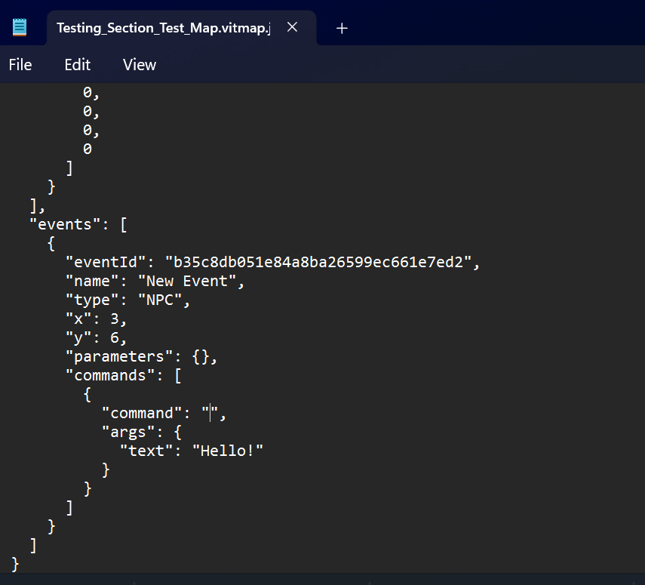

Figure T20.2 – Validation Message or Safe Handling During Load
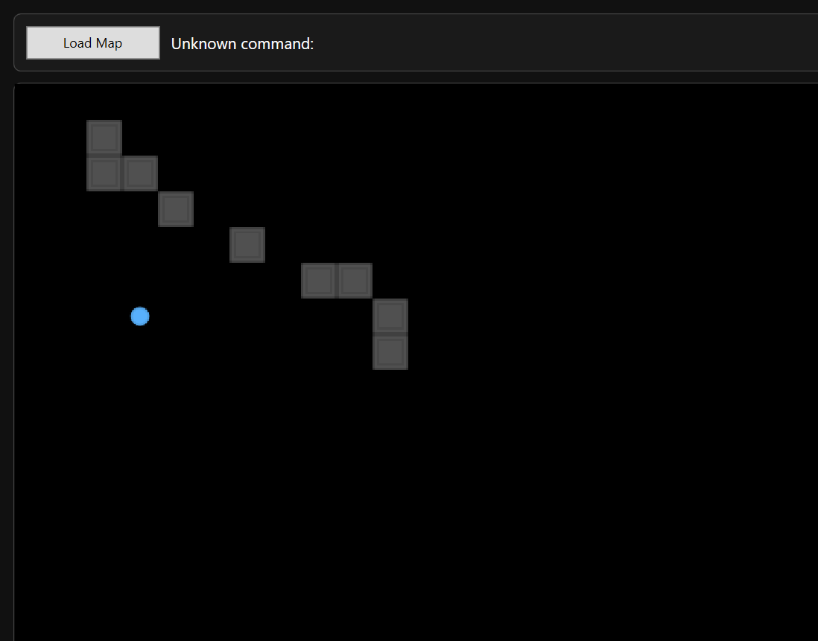
Demonstrates defensive validation preventing malformed event data from causing runtime instability

2.5 Persistence and JSON Integrity
The persistence subsystem is responsible for ensuring that map data is reliably stored as structured JSON files and can be reloaded without corruption or structural drift. Because the project deliberately uses JSON files instead of a relational database, testing focused on validating:
- Correct file creation and naming
- Autosave behaviour rules
- JSON schema stability
- Round-trip integrity (save -> close -> reload)
- Cross-application compatibility (Editor -> Runtime)
The following tests validate that:
- Manual save produces a valid .vitmap.json file
- Autosave follows intended behavioural rules
- JSON structure remains consistent with the defined schema
- Map state survives editor restart
- Runtime can load editor-produced files without format mismatch

Test Table 5 – Persistence & JSON Integrity
Test ID | Purpose of Test | Test Data | Expected Outcome | Actual Outcome | Screenshot ID
PJ1 | Verify manual save creates valid JSON file | Create new user map -> paint tiles -> Save As | JSON file created in maps folder, correct structure present | Pass | Figures T21.1, T21.2
PJ2 | Verify autosave rules (sample vs user map) | Edit sample map and new user map | Sample autosaves automatically, new map requires first manual save | Pass | Figures T22.1, T22.2 T22.3
PJ3 | Verify JSON schema structure | Open saved JSON in Notepad | File contains required root fields (FormatVersion, Width, Height, Layers, Tilesets, Events) | Pass | Figures T23.1, T23.2, T23.3
PJ4 | Verify round-trip persistence | Save -> close editor -> reopen -> reload map | Tiles, events, and layout restored correctly | Pass | Figures T24.1, T24.2
PJ5 | Verify runtime compatibility | Load same map in runtime | Runtime loads successfully and renders identical layout | Pass | Figures T25.1, T25.2

Test Table 5 – Screenshot Evidence

Figure T21.1 – Maps Folder Showing Newly Created .vitmap.json File

Figure T21.2 – JSON File Open in Notepad Showing Root Structure
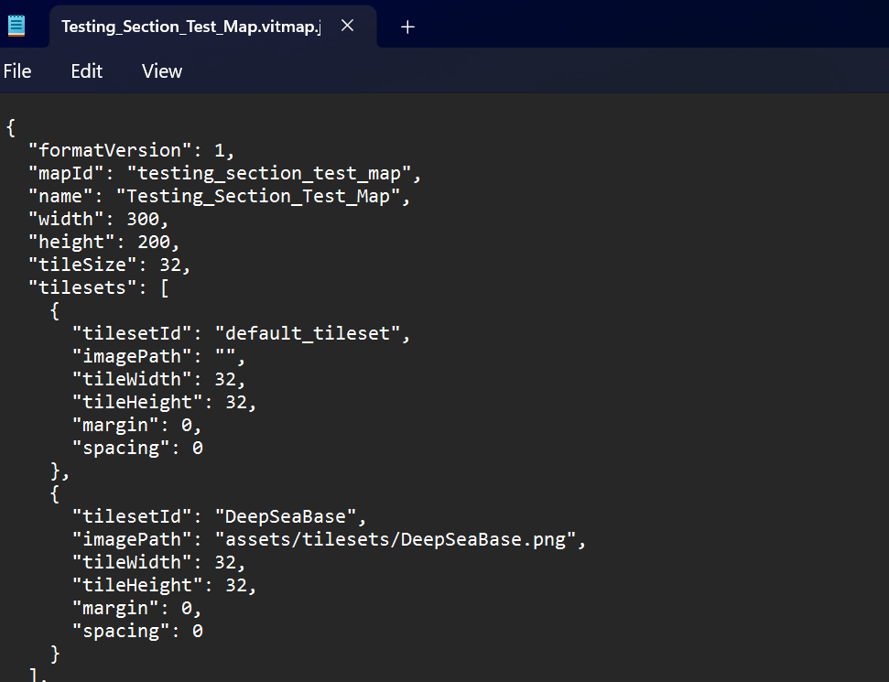
Demonstrates correct file creation and schema structure after manual save

Figure T22.1 – Sample Map Modified Timestamp Updating Automatically
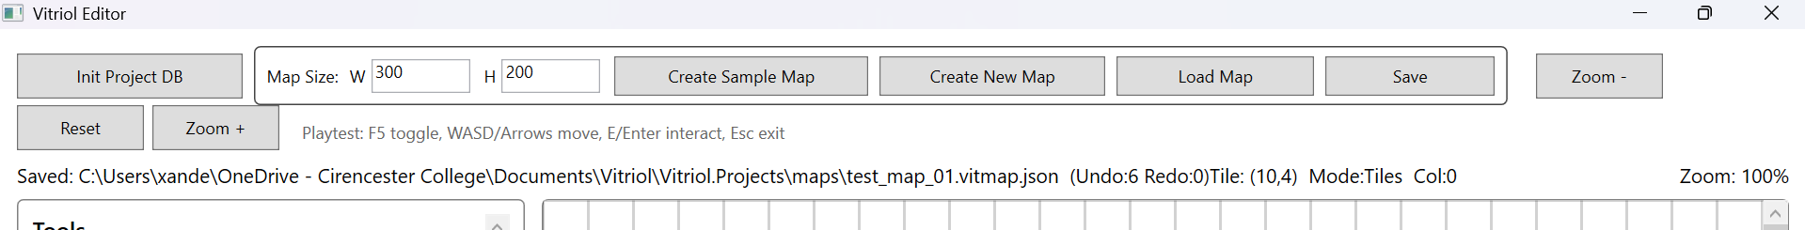

Figure T22.2 – User Map Not Saved Before First Manual Save
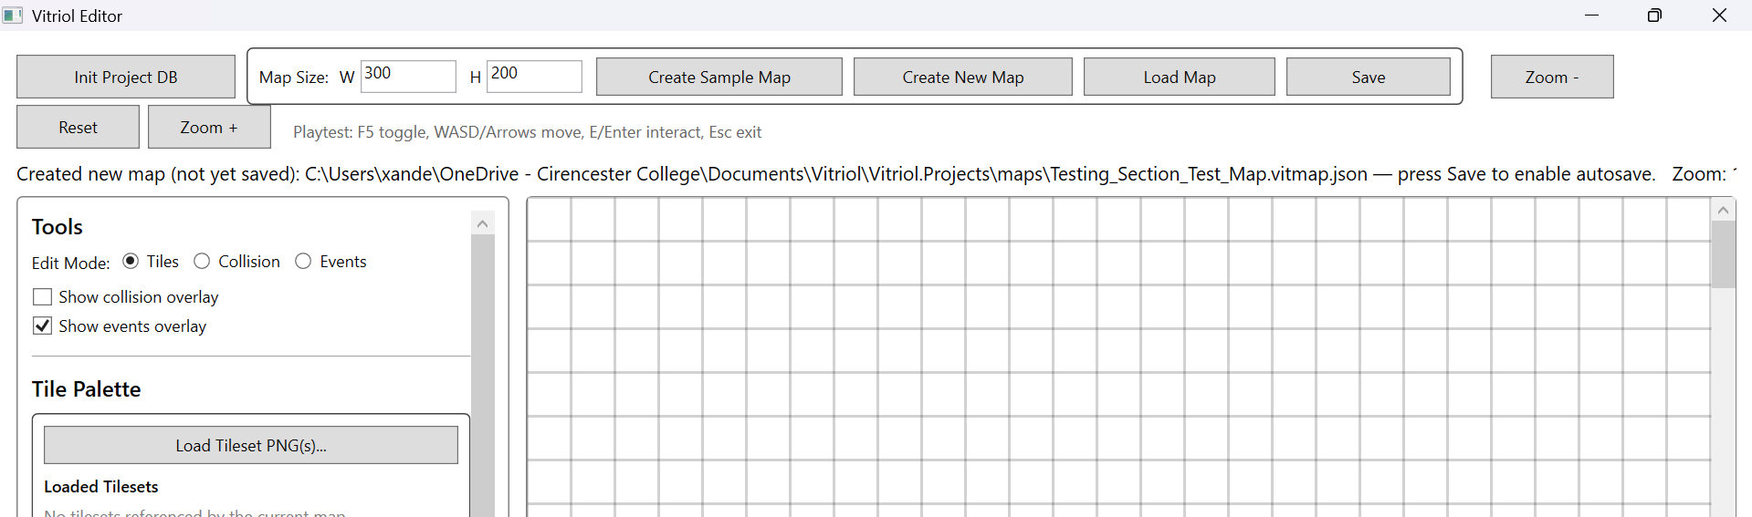

Figure T22.3 – User Map Autosave Active After Initial Manual Save
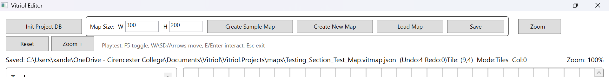
Demonstrates correct enforcement of autosave safety logic

Figure T23.1 – JSON Root Fields Visible
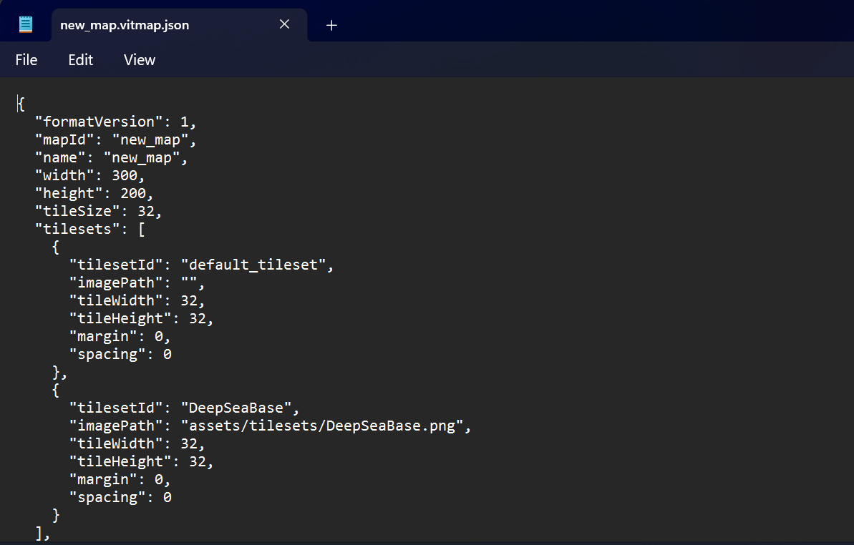

Figure T23.2, T23.3 – Layers and Events Structure Visible
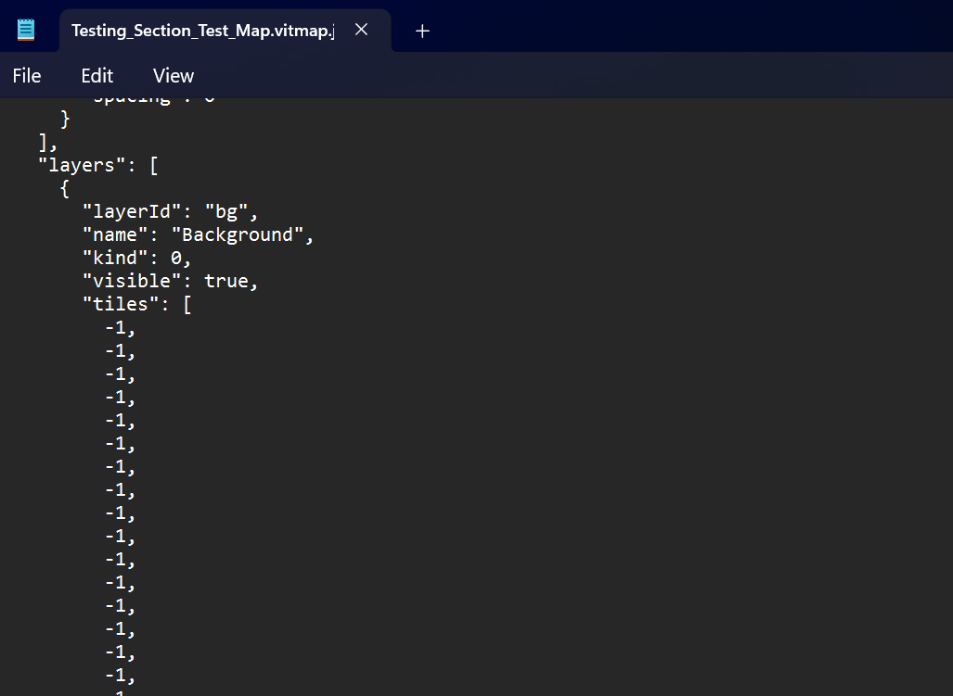
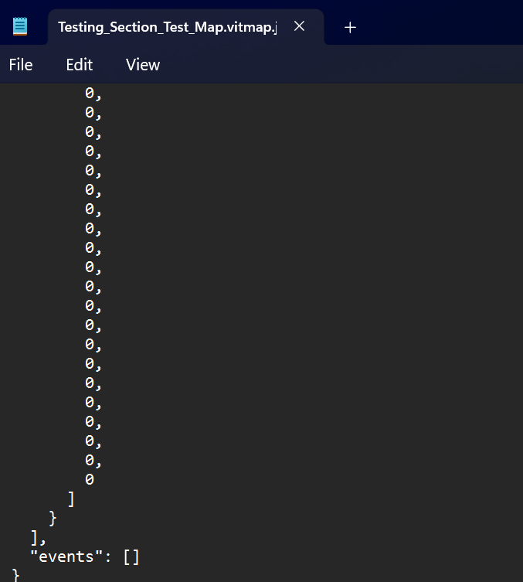
Demonstrates Structural Consistency with Defined Schema

Figure T24.1 – Map State Before Closing Editor
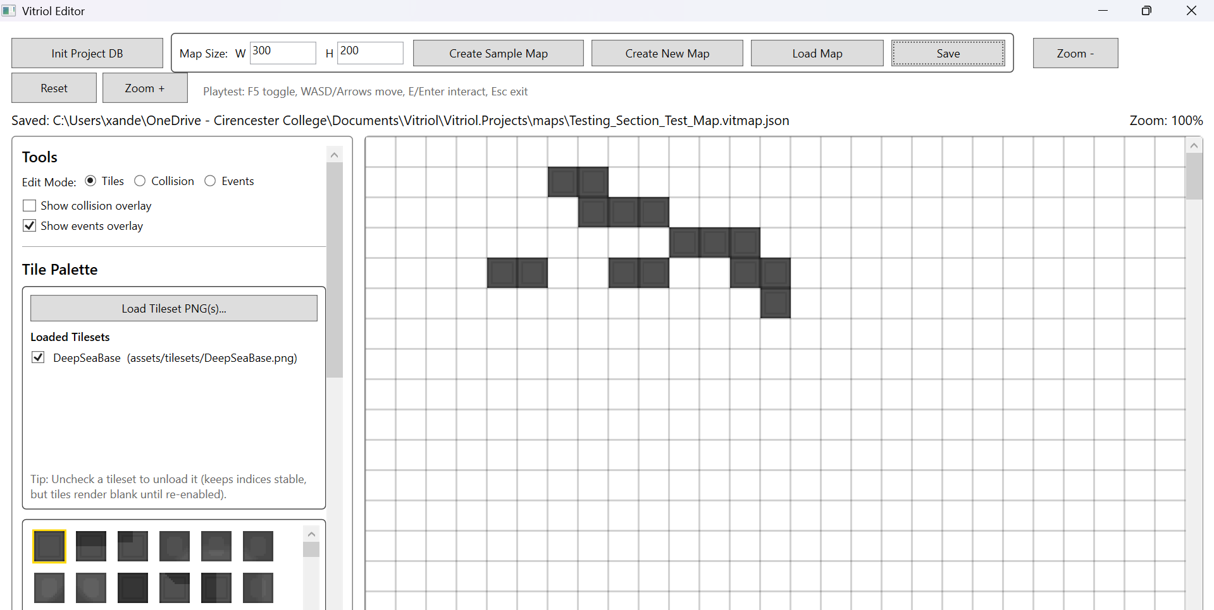

Figure T24.2 – Map State Restored After Reload
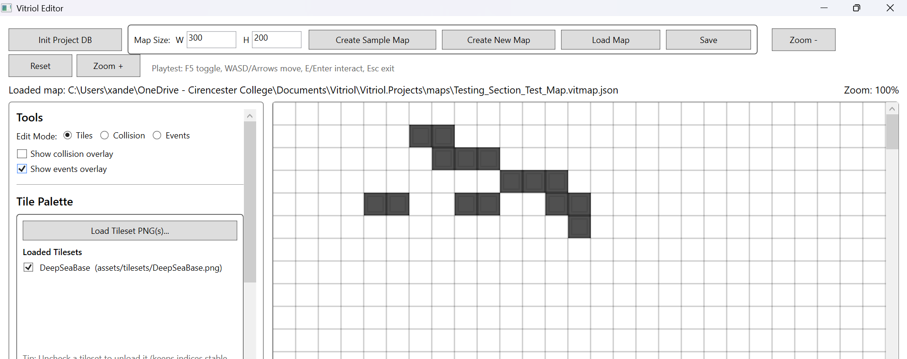
Demonstrates no data loss across sessions

Figure T25.1 – Runtime Loading Map File
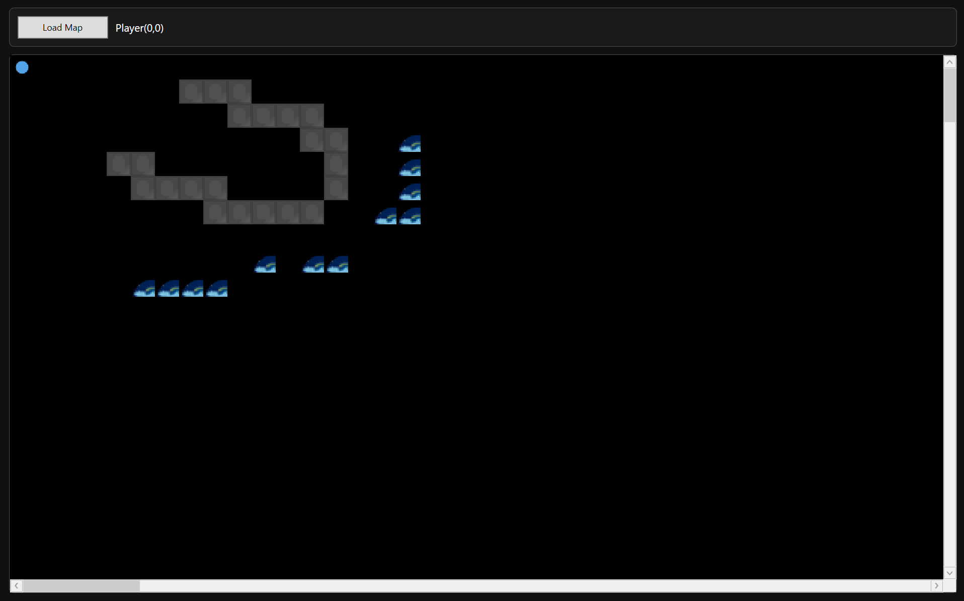

Figure T25.2 – Runtime Rendering Saved Map Layout
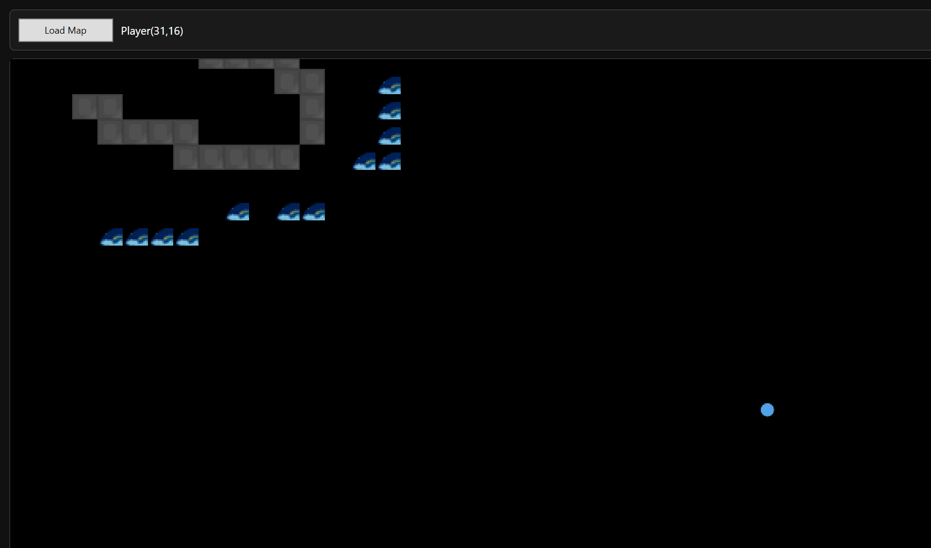
Demonstrates editor/runtime format alignment and absence of schema drift

2.6 Runtime Rendering and Viewport Behaviour
The runtime rendering subsystem is responsible for displaying the map efficiently while maintaining responsive gameplay. Because Vitriol uses viewport-only rendering, the runtime should never attempt to draw the entire map every frame. Instead, it renders oly the visible region (plus padding), producing a single composited output image that updates as the camera moves.
Testing focused on validating:
- Viewport-only rendering correctness (only visible region drawn)
- Stable rendering while scrolling (no blank gaps / tearing)
- Correct tile alignment as player moves across tile boundaries
- Render update logic triggered by movement and camera shifts
- Behaviour on larger maps where full rendering would be expensive
The following tests validate that:
- The runtime renders a cropped region rather than the entire map
- The viewport updates correctly when the player moves
- Large maps remain usable without frame collapse
- Visual output stays aligned to the map grid during camera movement

Test Table 6 – Runtime Rendering & Viewport
Test ID | Purpose of Test | Test Data | Expected Outcome | Actual Outcome | Screenshot ID
RV1 | Verify viewport-only rendering (cropped region) | Load a large map and observe only current region visible | Only visible area is drawn, map can scroll without rendering full map | Pass | Figures T26.1, T26.2
RV2 | Verify render updates on player movement | Move player across several tiles | Viewport redraws correctly, no lag/tearing | Pass | Figures T27.1, T27.2
RV3 | Verify render stability during scroll/camera change | Move until camera shifts multiple times | Camera shifts smoothly, no blank regions or misalignment | Pass | Figures T28.1, T28.2
RV4 | Boundary test – map edge rendering | Move player to far edge of map | Viewport clamps correctly, no drawing outside bounds | Pass | Figures T29.1, T29.2

Test Table 6 – Screenshot Evidence

Figure T26.1 – Runtime Loaded Large Map (Initial Viewport Region)
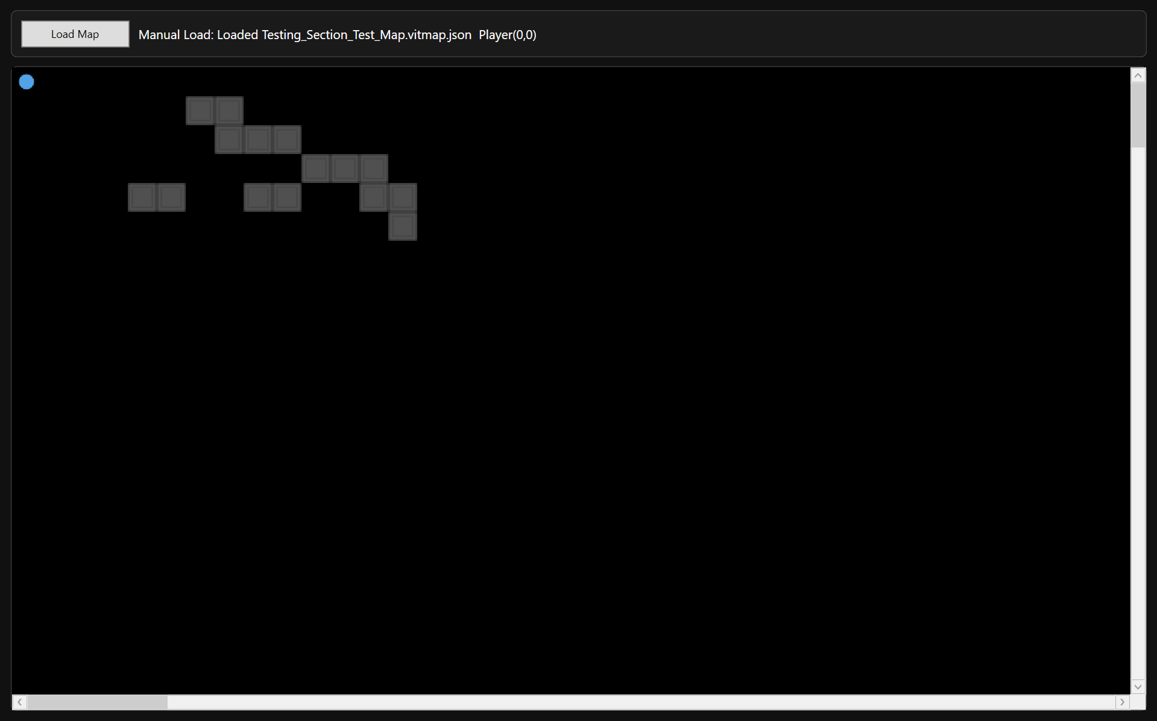

Figure T26.2 – Same Map After Moving Player (Viewport Region Changed)
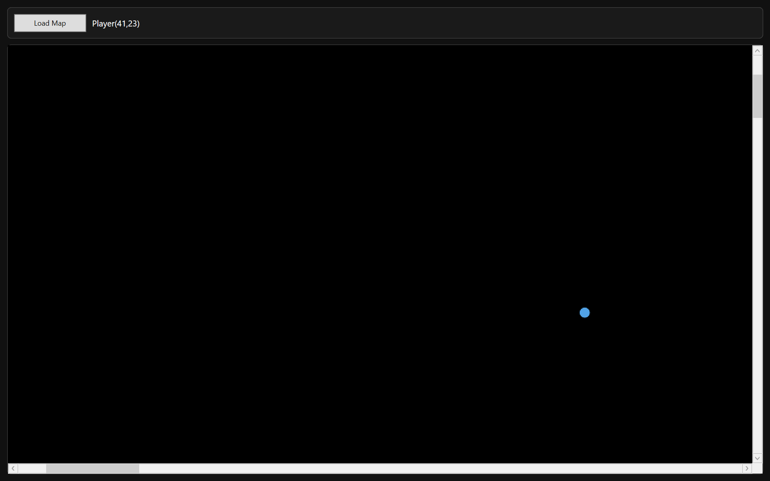
Demonstrates viewport-only rendering where the visible region updates rather than full-map rendering

Figure T27.1 – Player Position Before Movement
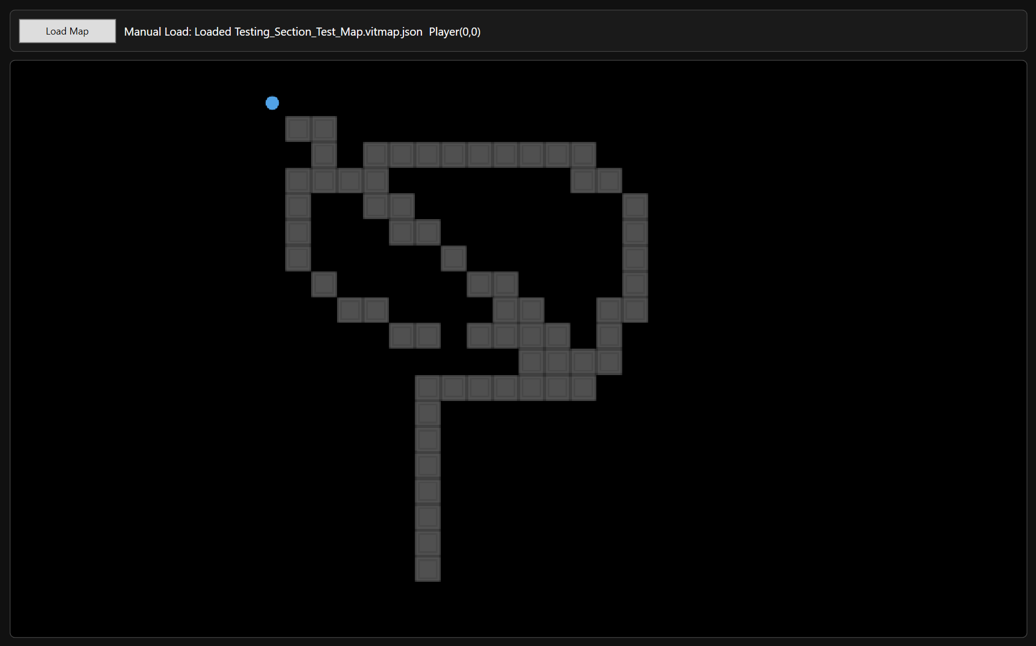

Figure T27.2 – Player Position After Movement (Viewport Updated Correctly)
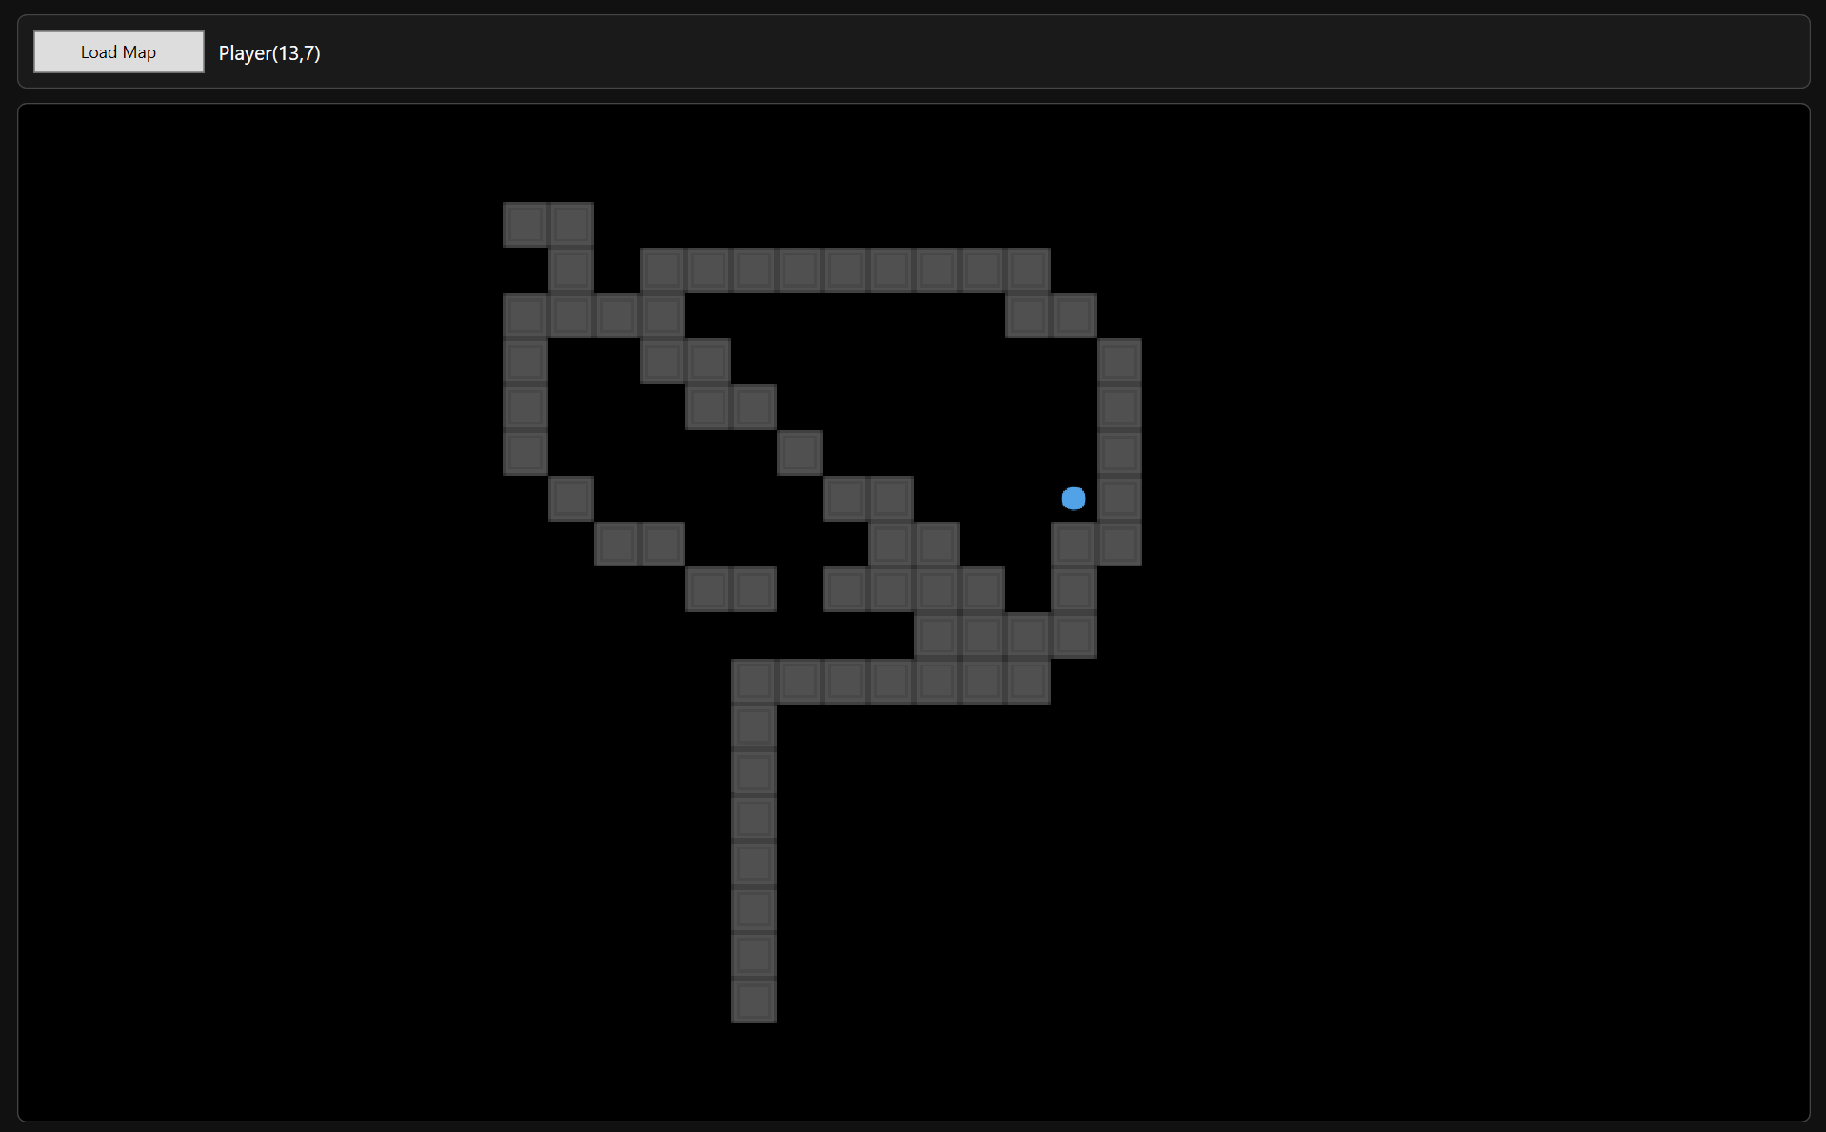
Demonstrates render refresh correctness per movement step

Figure T28.1 – Camera Before Deadzone Exit (Player Near Edge of Deadzone)
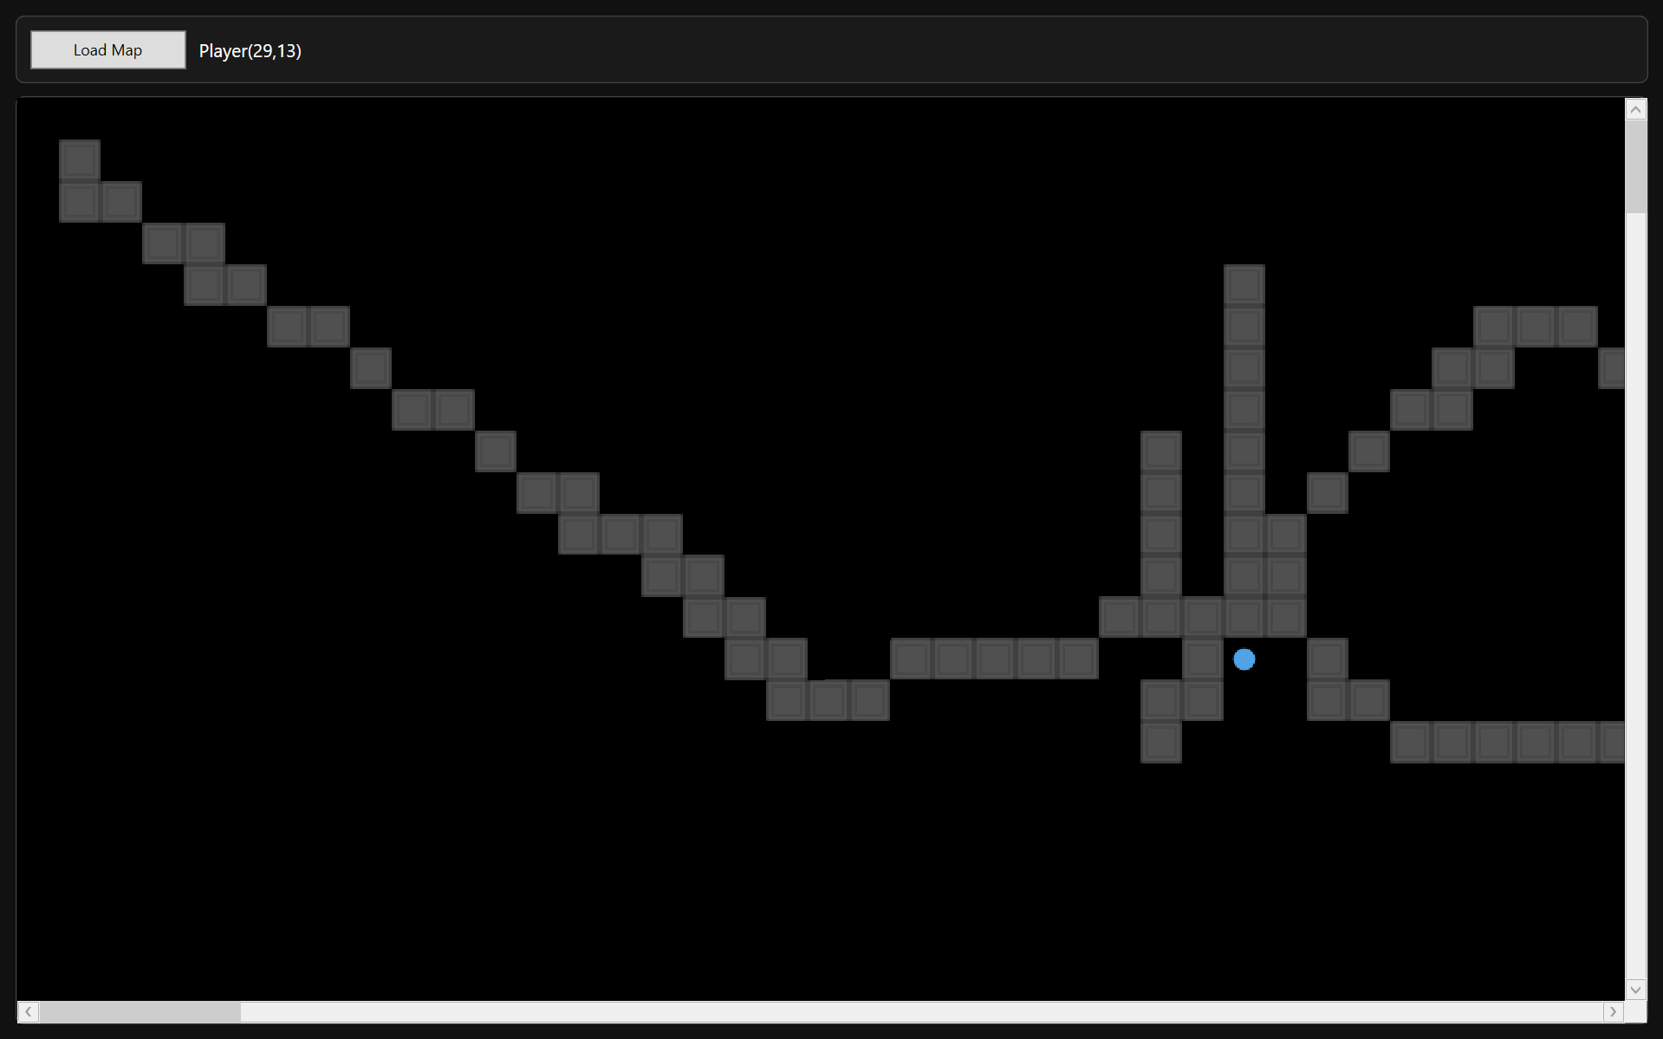

Figure T28.2 – Camera After Deadzone Exit (Viewport Shifted, Still Correct)
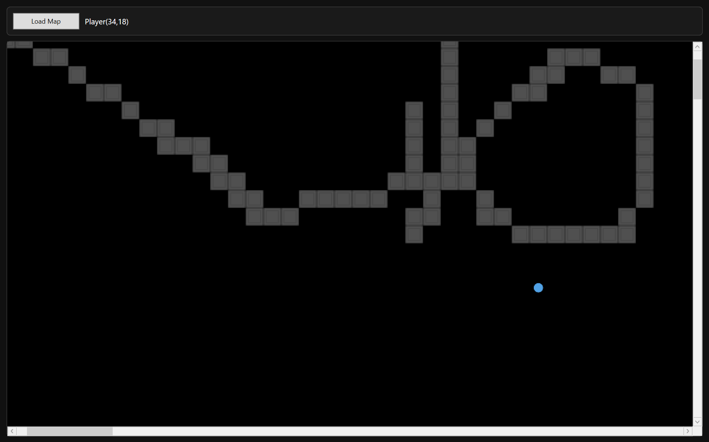
Demonstrates stable redraw during camera-driven viewport relocation

Figure T29.1 – Player at Map Edge (Viewport Clamped)
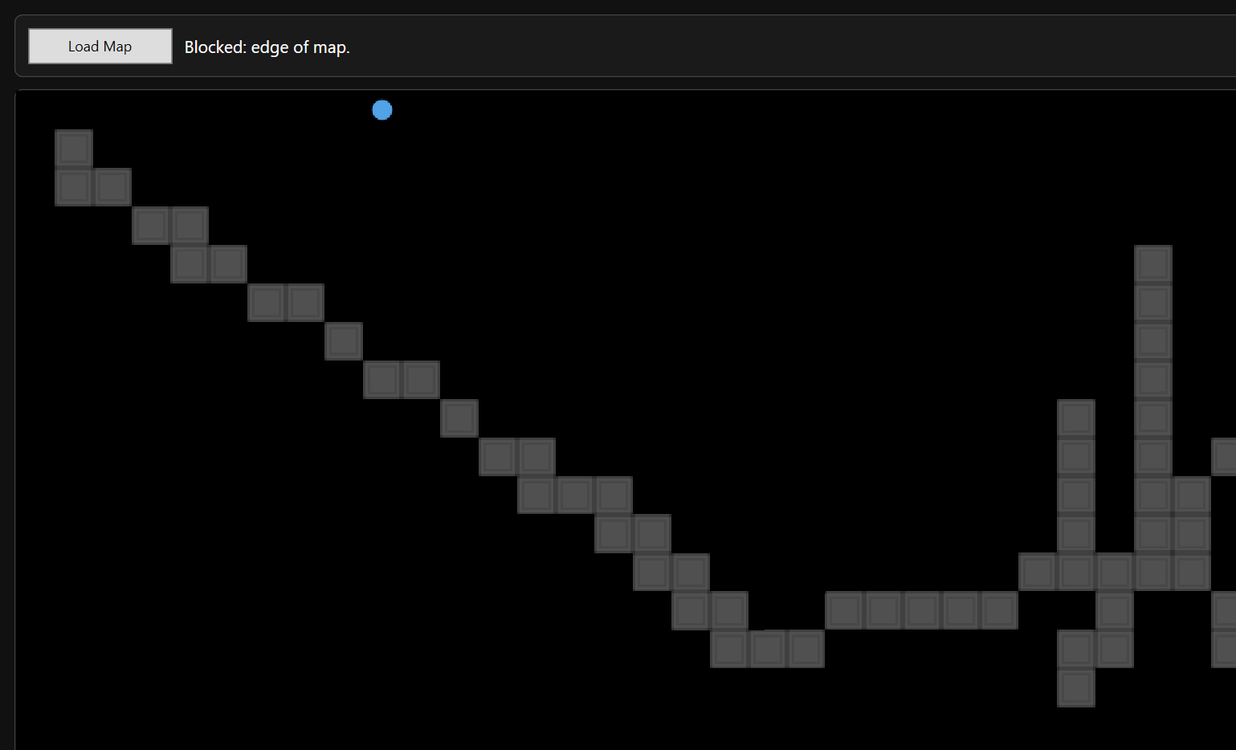

Figure T29.2 – Opposite Edge (Viewport Still Clamped Correctly)
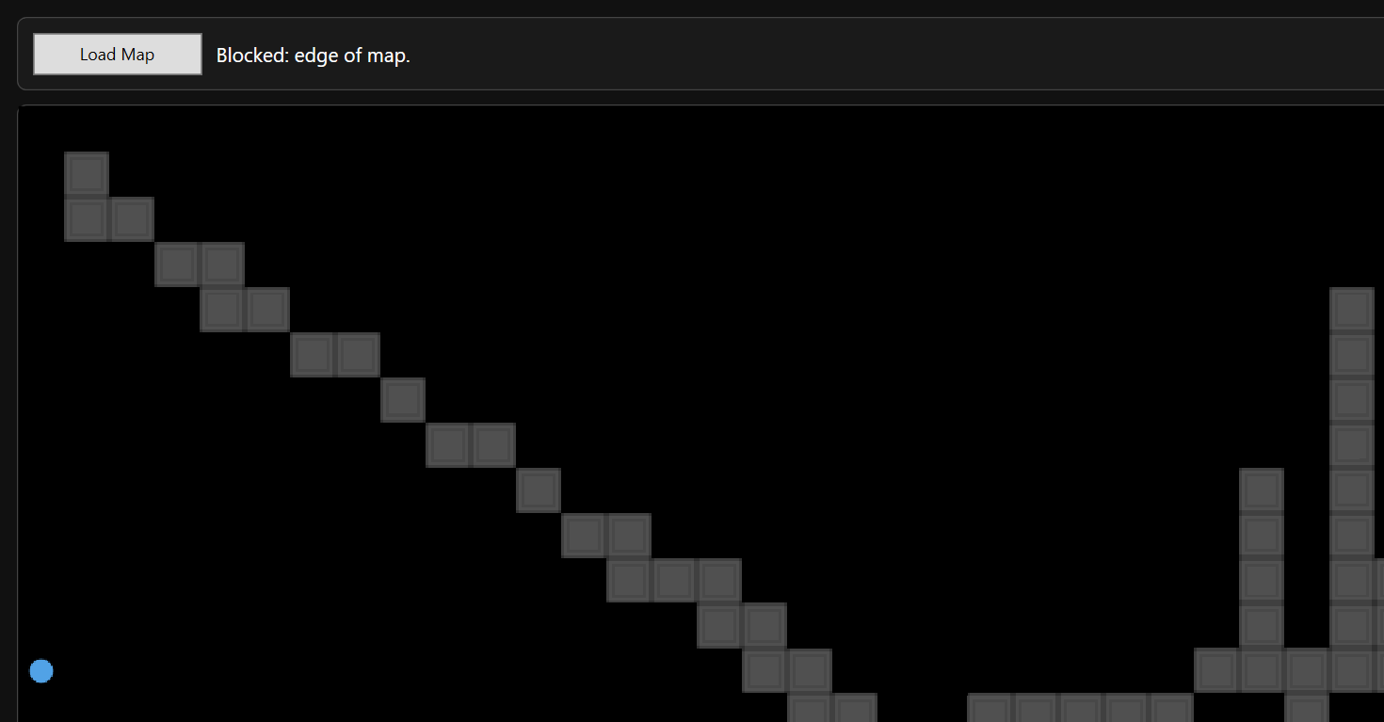
Demonstrates correct clamping and safe region calculation at boundaries

2.7 Camera Deadzone
The camera subsystem uses a deadzone-based follow system rather than centering on the player every frame. This design prevents constant micro-adjustments and produces smoother visual motion. The camera only shifts when the player exits a defined deadzone region within the viewport.
Testing focused on validating:
- Deadzone boundaries behave as defined
- Camera does not move unnecessarily
- Camera shifts only when player crosses threshold
- Camera clamping prevents scrolling outside map bounds
- Player remains visible at all times
The following tests validate that:
- The player can move within the deadzone without camera movement
- Exiting the deadzone triggers controlled camera shift
- Camera does not overshoot or jitter
- Camera remains clamped at map edges

Test Table 7 – Camera Deadzone
Test ID | Purpose of Test | Test Data | Expected Outcome | Actual Outcome | Screenshot ID
CD1 | Verify no camera movement inside deadzone | Move player small distance within viewport centre | Camera remains static | Pass | Figures T30.1, T30.2
CD2 | Verify camera shift on deadzone exit | Move player until crossing deadzone boundary | Camera shifts smoothly to re-centre region | Pass | Figures T31.1, T31.2
CD3 | Verify no jitter during continuous movement | Hold movement key to repeatedly cross deadzone | Camera updates smoothly without flicker | Pass | Figures T32
CD4 | Verify camera clamping at map boundaries | Move player to extreme edges of map | Camera does not scroll beyond map bounds | Pass | Figures T33.1, T33.2

Test Table 7 – Screenshot Evidence

Figure T30.1 – Player Inside Deadzone (Initial Position)
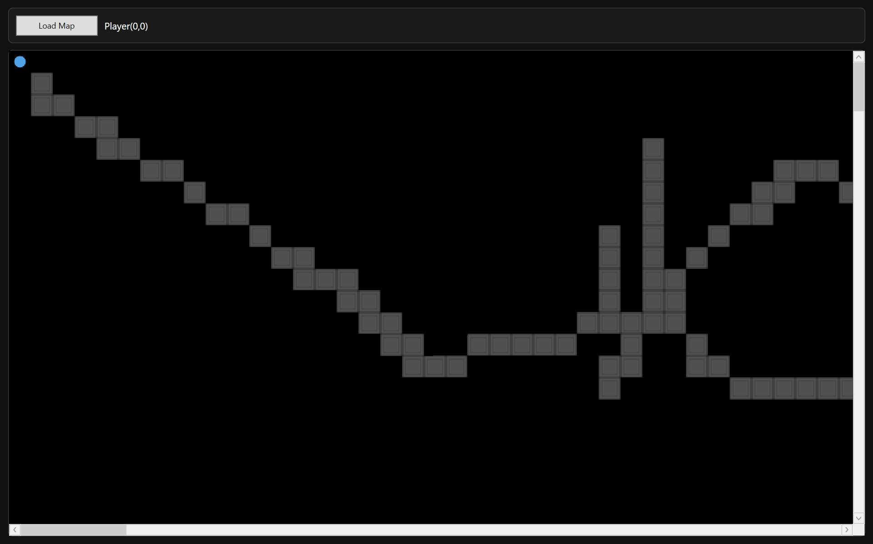

Figure T30.2 – Player Moved Slightly (Camera Unchanged)
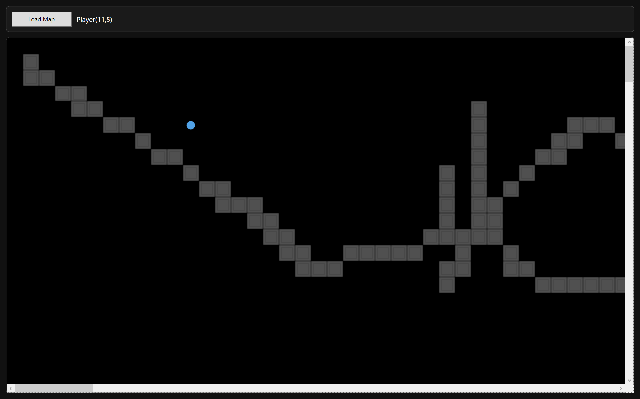
Demonstrates that camera does not respond to minor player movement within deadzone

Figure T31.1 – Player at Deadzone Boundary (Before Camera Shift)
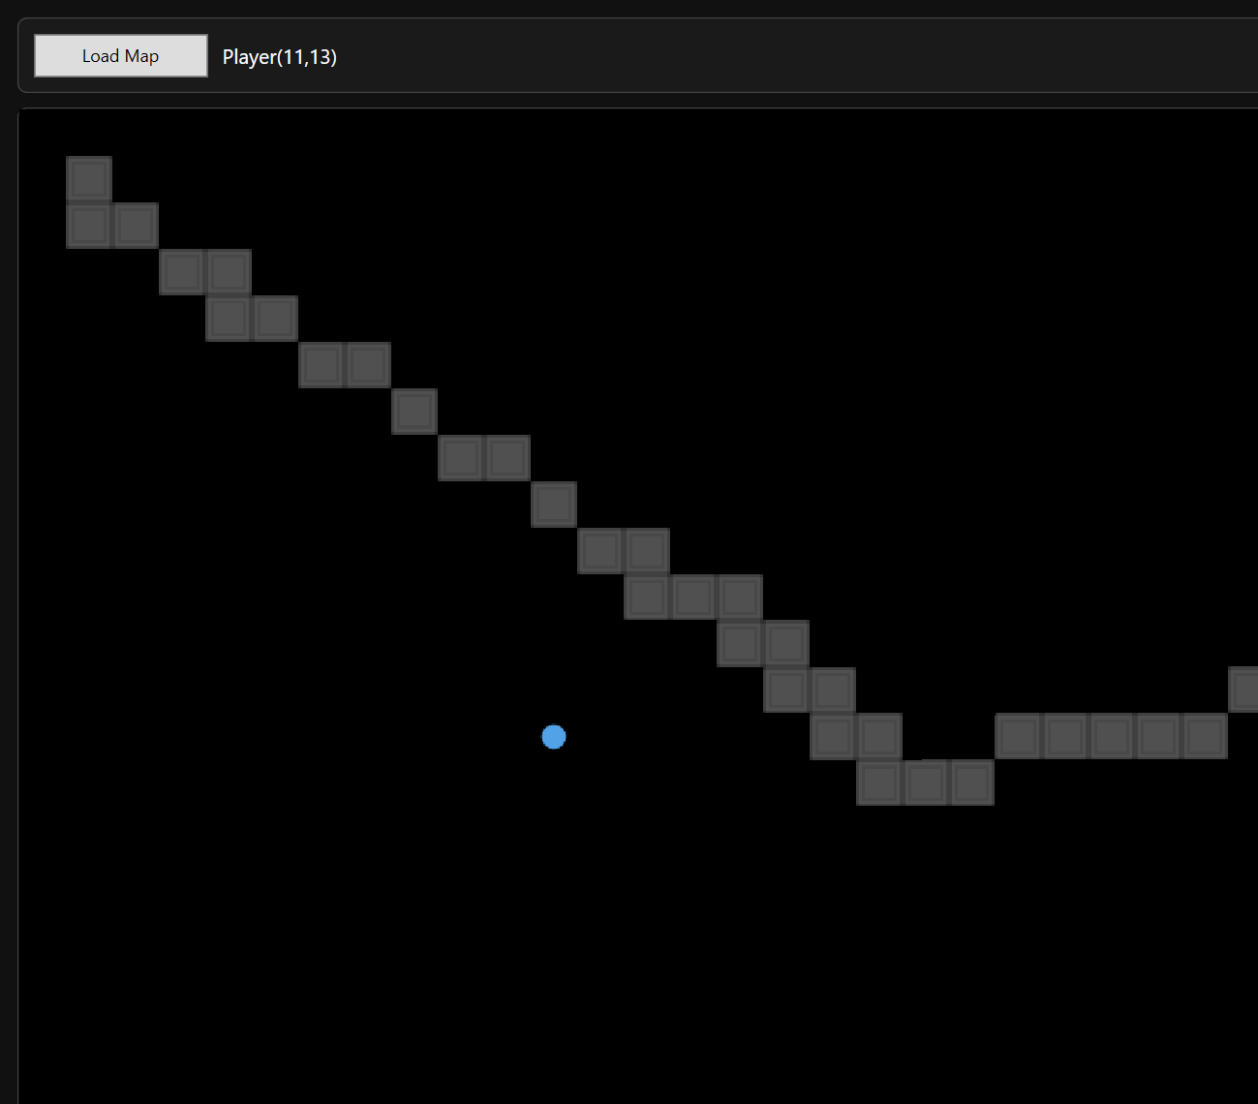

Figure T31.2 – Camera Shift After Crossing Boundary
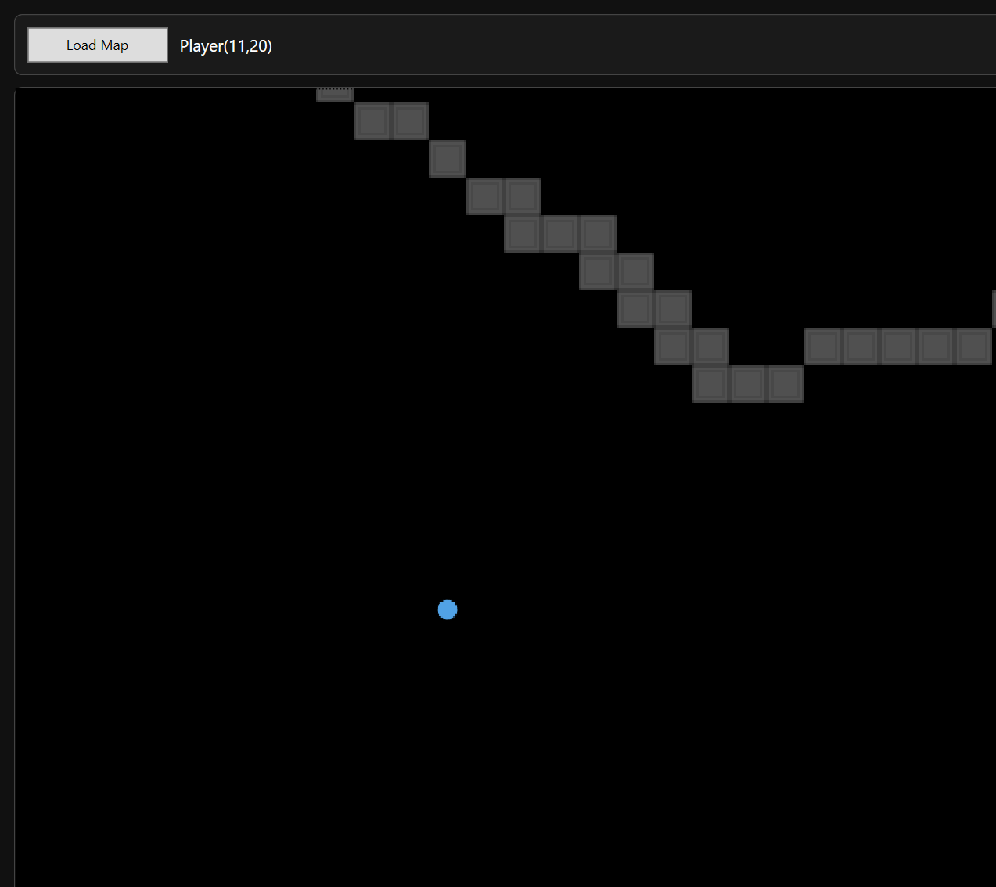
Demonstrates threshold-based camera activation logic

Figure T32 – GIF Showing Continuous Movement

Demonstrates stable camera update logic across repeated shifts

Figure T33.1 – Camera Clamped at Top/Left Edge
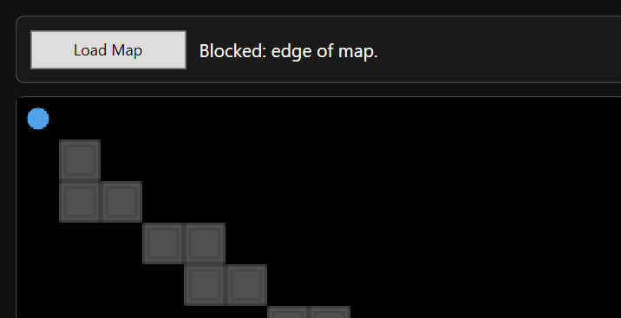

Figure T33.2 – Camera Clamped at Bottom/Right Edge
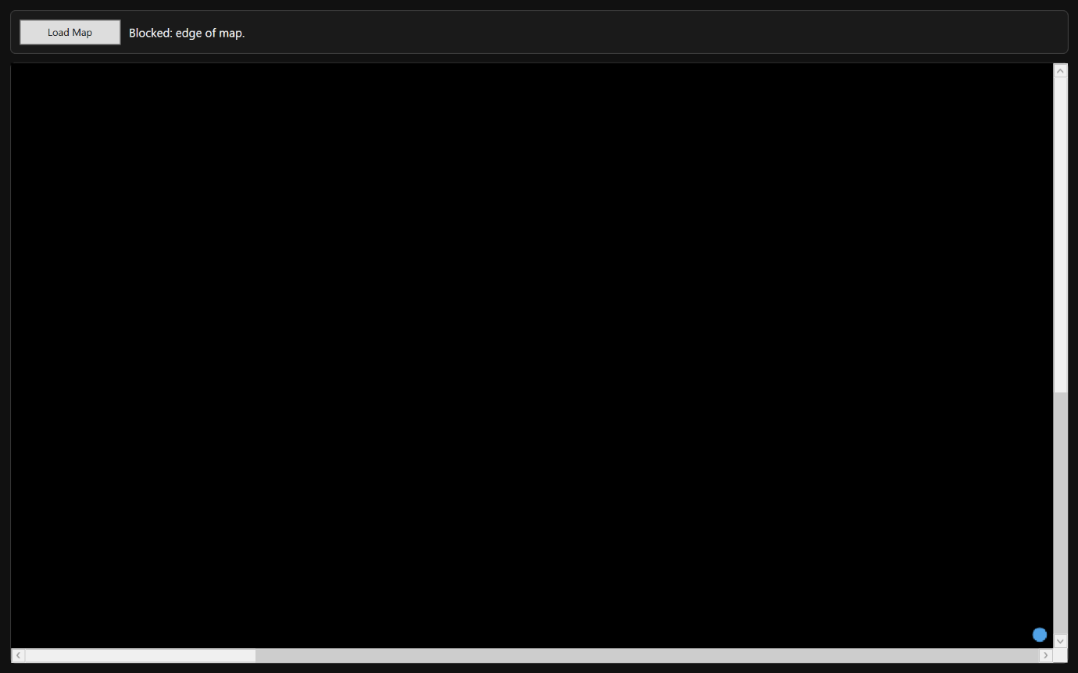
Demonstrates correct clamping constraints

3 Boundary and Abnormal Data Testing

3.1 Map Dimension Boundary Testing
This test is used to verify that extreme or invalid map dimensions do not cause runtime crashes, invalid array allocation, or graphical instability. It evaluates:
- Minimum acceptable dimensions
- Zero or negative values
- Large grid stress handling

Test Table 1 – Map Dimension Boundary Testing
Test ID | Purpose of Test | Test Data | Expected Outcome | Actual Outcome | Screenshot ID
BDM1 | Attempt to create map with zero width | Width = 0 | Creation blocked | Pass | Figures T34
BDM2 | Attempt to create map with negative height | Height = -5 | Creation blocked | Pass | Figures T35
BDM3 | Create large map (e.g. 200x200) | 200x200 grid | Map rendered correctly | Pass | Figures T36.1, T36.2
BDM4 | Load large map into runtime | 200x200 | Smooth viewport render | Pass | Figures T37

Test Table 1 – Screenshot Evidence

Figure T34 – Zero Width Validation
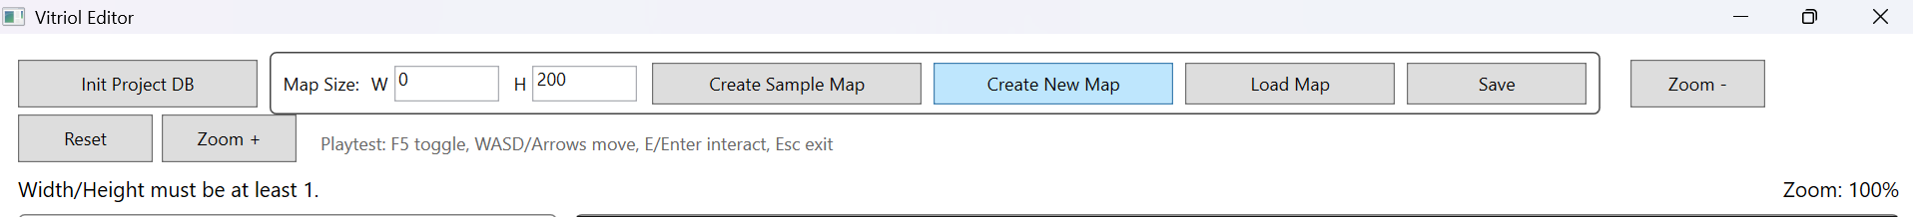

Figure T35 – Negative Height Validation
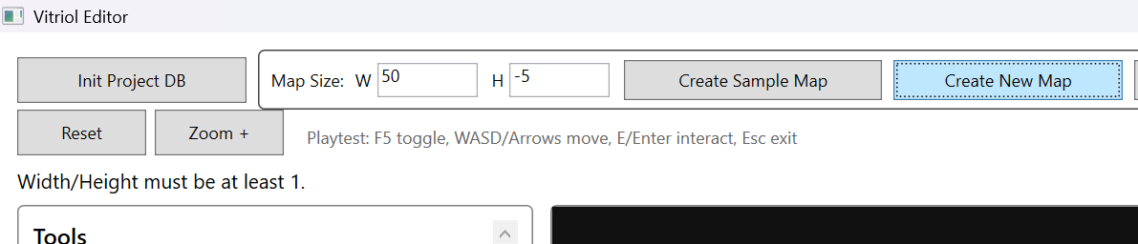

Figure T36.1 – Large Map Creation (200x200)
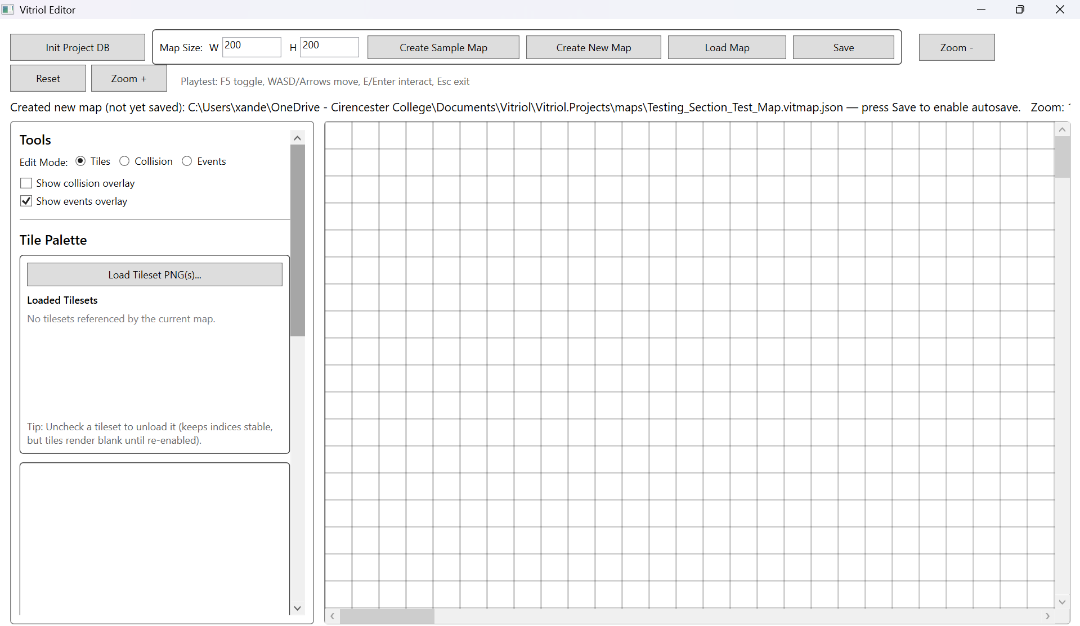

Figure T36.2 – Large Map Viewport Navigation
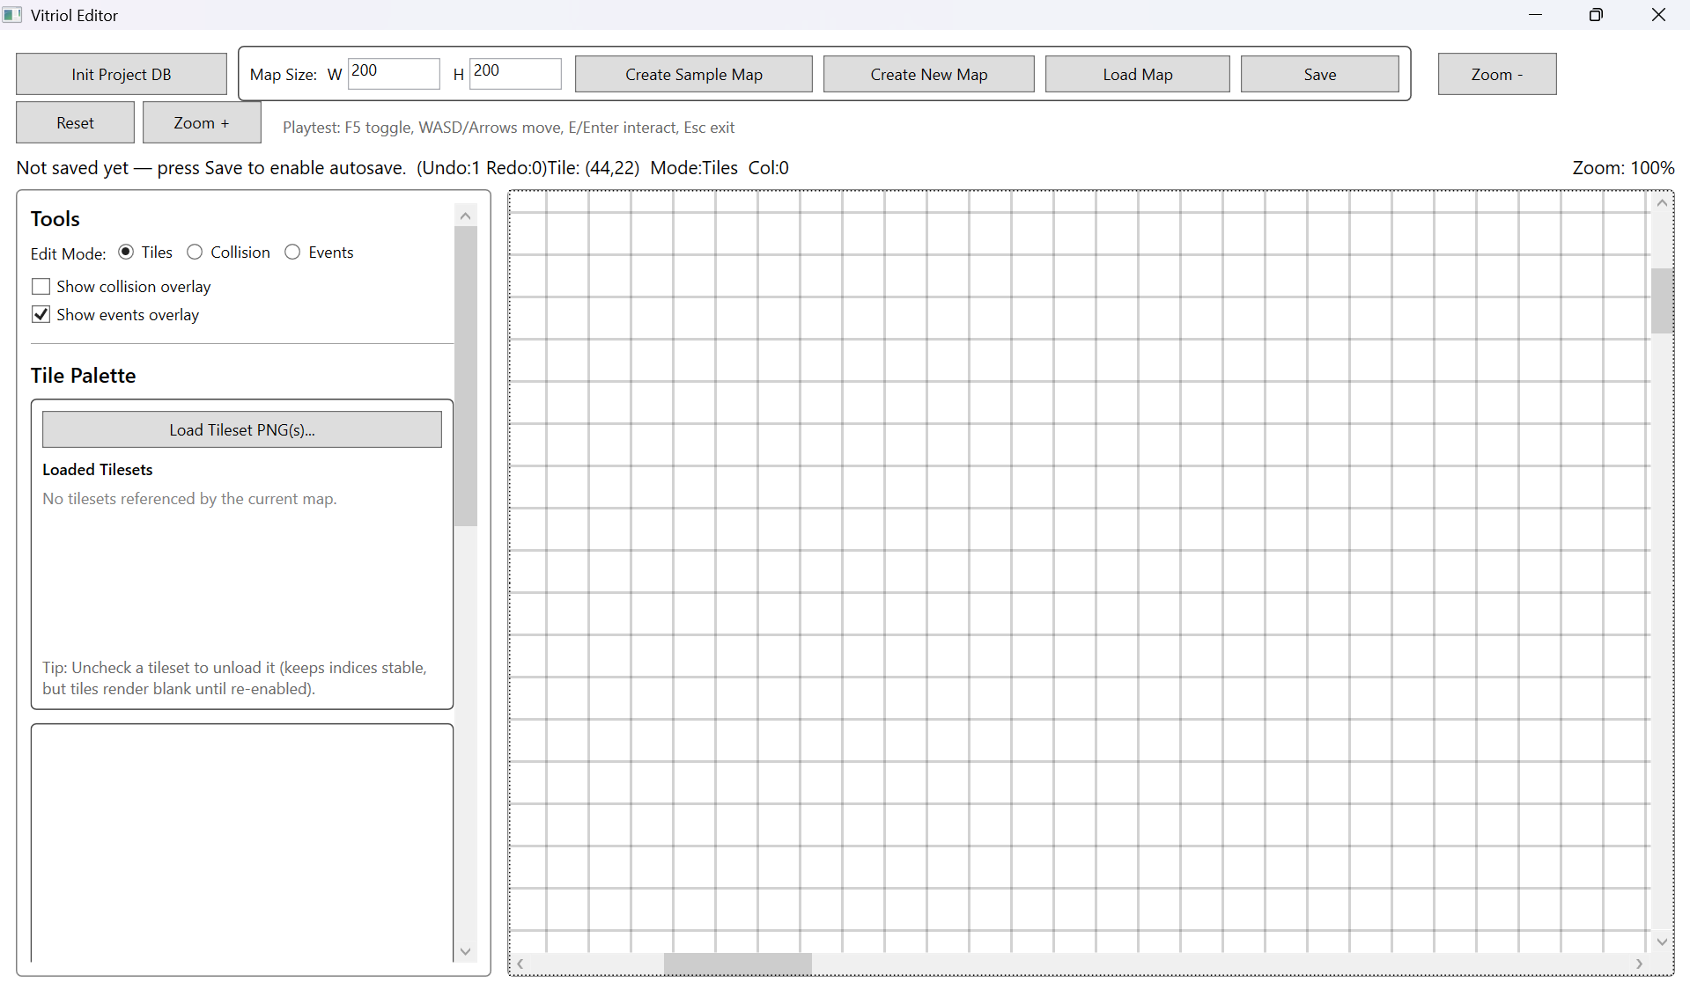

Figure T37 – Runtime Rendering of Large Map
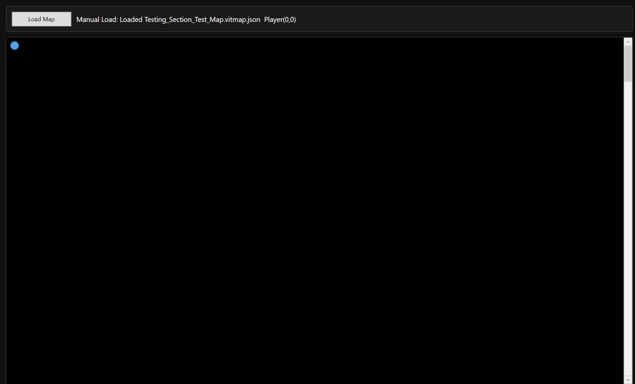

What These Tests Demonstrate:
- Defensive validation against invalid dimension input
- Correct allocation of 1D tile array for large datasets
- Viewport-only rendering prevents performance degradation
- No array index overflow occurs

3.2 Tileset Boundary and Missing Asset Handling
Tilesets represent a critical external dependency within the system. Since maps reference PNG assets stored within the project architecture, it is essential that:
- Missing tileset files are detected before runtime execution
- Invalid relative paths do not cause silent corruption
- Oversized or malformed tilesets do not crash rendering
- Tile indexing remains stable when tilesets are unavailable
This subsection validates defensive asset handling and ensures that map integrity is not compromised by missing or invalid graphical resources

Test Table 2 – Tileset Boundary & Missing Asset Handling
Test ID | Purpose of Test | Test Data | Expected Outcome | Actual Outcome | Screenshot ID
BTS1 | Load map referencing missing PNG | Tileset file manually removed from assets folder | Map load blocked with clear error message | Pass | Figures T38
BTS2 | Modify JSON to use invalid relative path | ImagePath altered to non-existent path | Runtime validation detects missing file | Pass | Figures T39
BTS3 | Load map with valid but large tileset image | High resolution PNG tileset | Tileset loads and crops directly | Pass | Figures T40.1, T40.2
BTS4 | Toggle tileset load state | Unload/reload reference | Tile indices remain consistent | Pass | Figures T41.1

Test Table 2 – Screenshot Evidence

Figure T38 – Missing PNG Validation

Figure T39 – Invalid Relative Path Detection
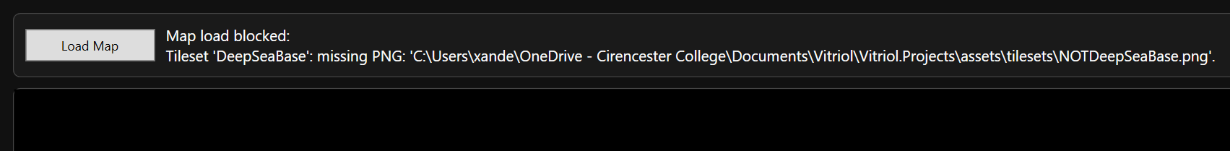

Figure T40.1 – Large Tileset Loaded Successfully
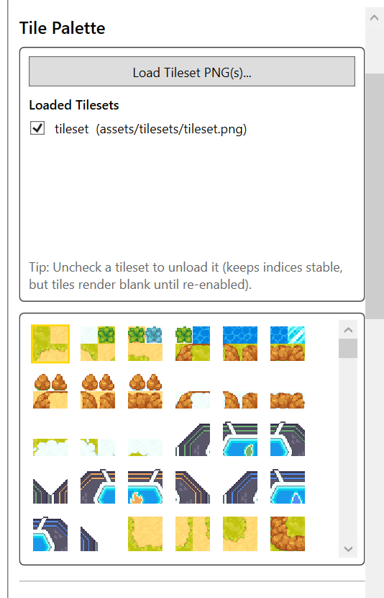

Figure T40.2 – Cropped Rendering From Large Tileset
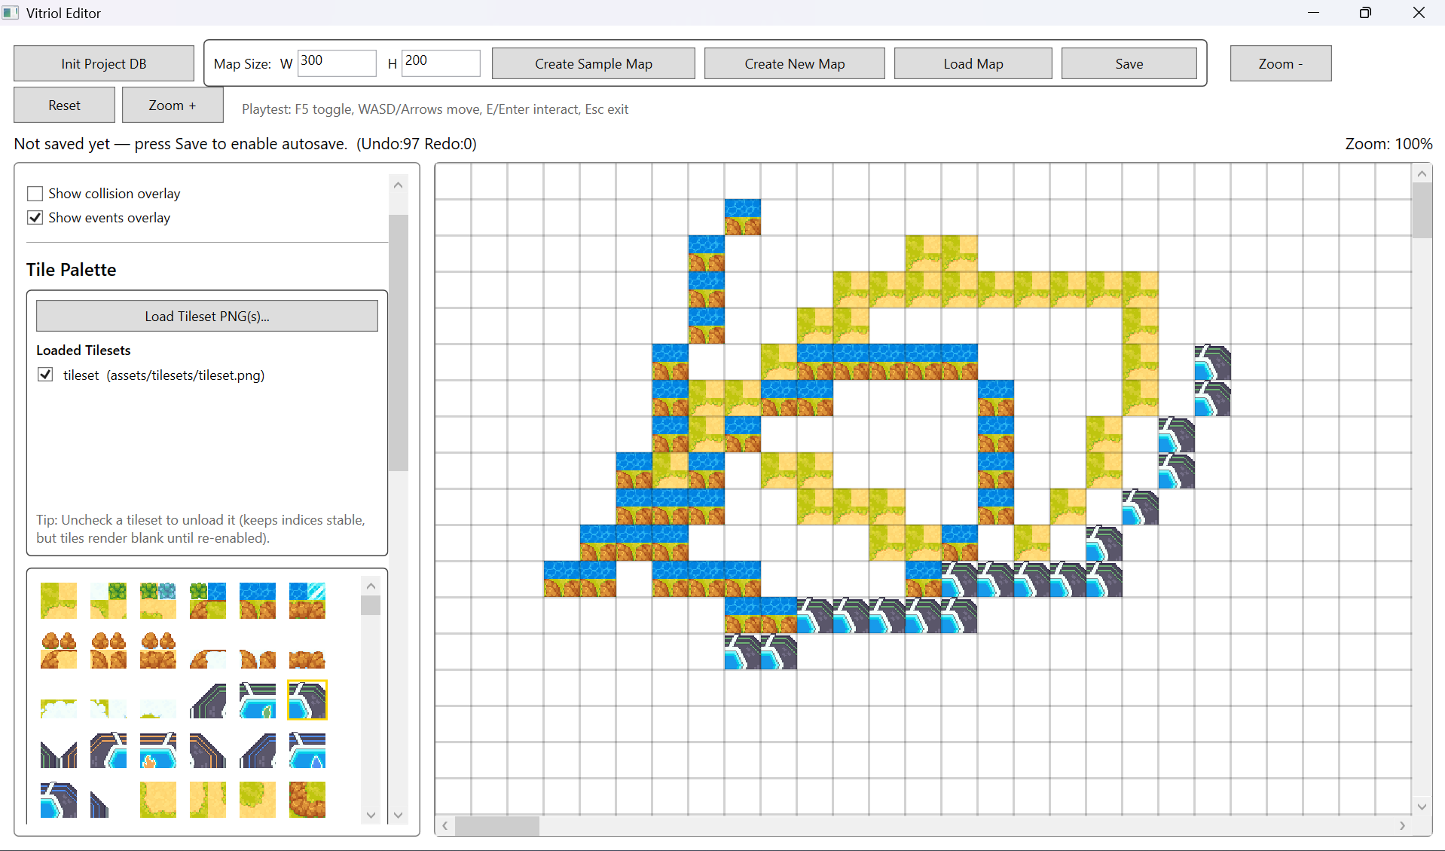

Figure T41 – Tileset Reference Stability
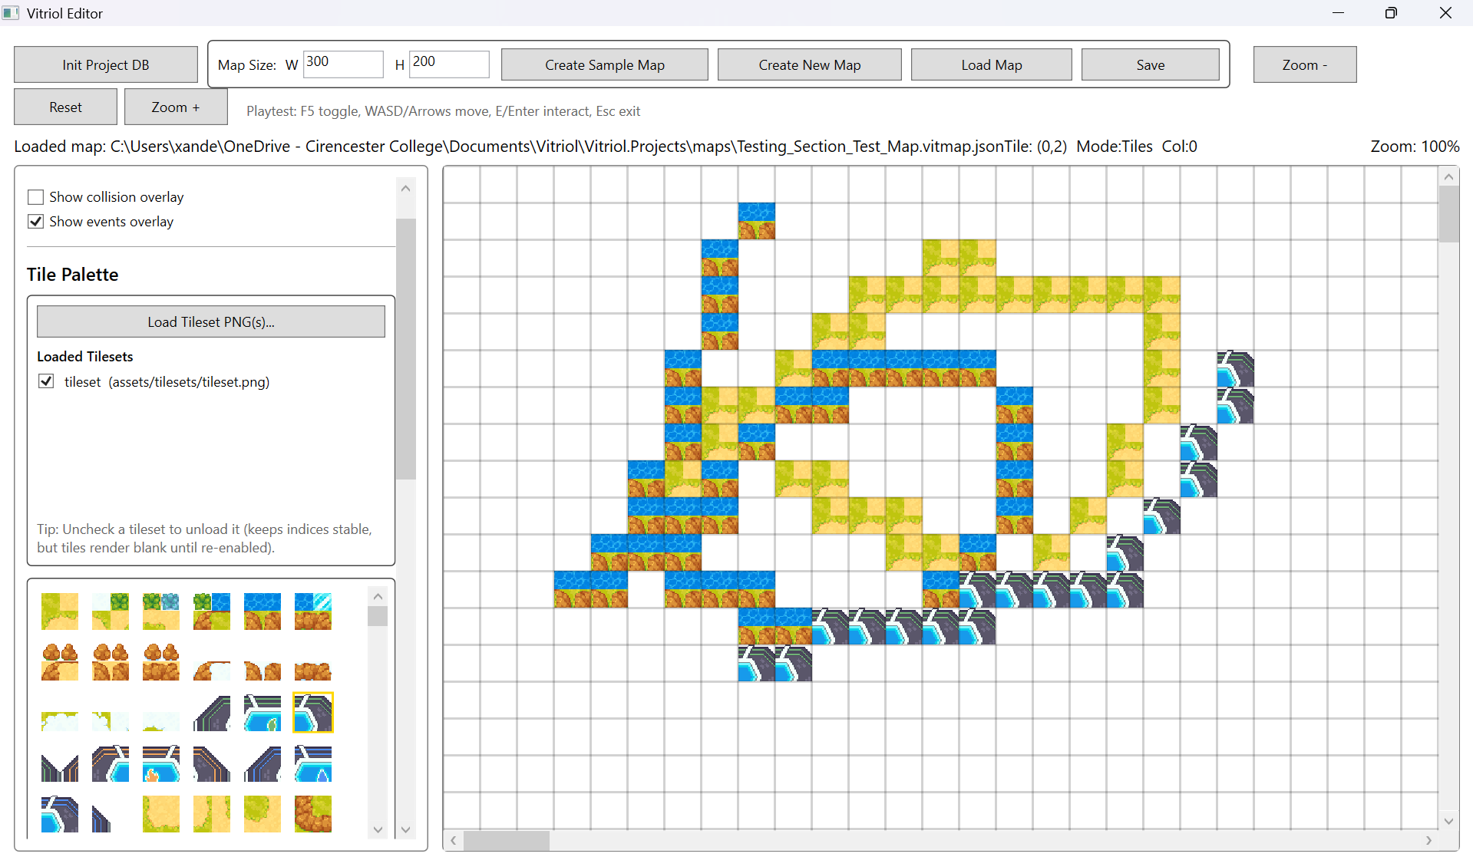

What These Tests Demonstrate:
- Strict enforcement of asset existence before runtime execution
- Protection against broken relative paths
- Safe cropping logic under high-resolution assets
- Stability of global tile indexing system
- Prevention of silent tile corruption

3.3 Event Parameter and Command Validation
Events in Vitriol are data-driven through MapEventDto and EventCommandDto, which means behaviour is controlled entirely by JSON-defined command structures. While this allows extensibility, it also introduces risk if:
- Commands are malformed
- Required arguments are missing
- Unknown command identifiers are used
- Parameter dictionaries contain invalid keys
This subsection verifies that:
- Invalid command data does not crash the runtime
- Missing arguments are handled defensively
- Unknown commands are reported clearly
- Event execution remains stable even with malformed input

Test Table 3 – Event Parameter & Command Validation
Test ID | Purpose of Test | Test Data | Expected Outcome | Actual Outcome | Screenshot ID
BDE1 | Execute event with empty command list | Event with no commands | Runtime displays safe message | Pass | Figures T42
BDE2 | ShowText command missing “text” argument | Remove text parameter in JSON | Runtime handles gracefully without crash | Pass | Figures T43.1, T43.2
BDE3 | Unknown command type | Change command to invalid string | Unknown Command Does Not Execute | Pass | Figures T44

Test Table 3 – Screenshot Evidence

Figure T42 – Empty Command List Execution
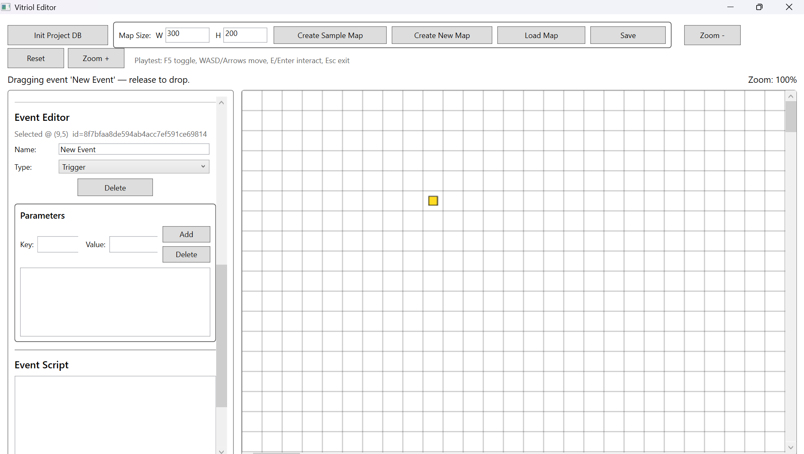

Figure T43.1 – Modified JSON Missing Text Parameter
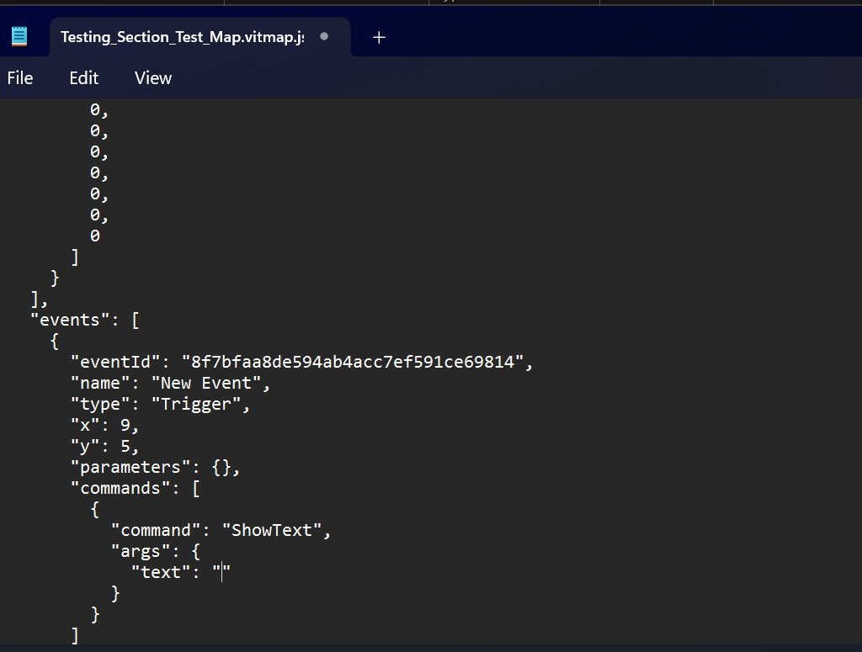

Figure T43.2 – Runtime Handling Missing Text
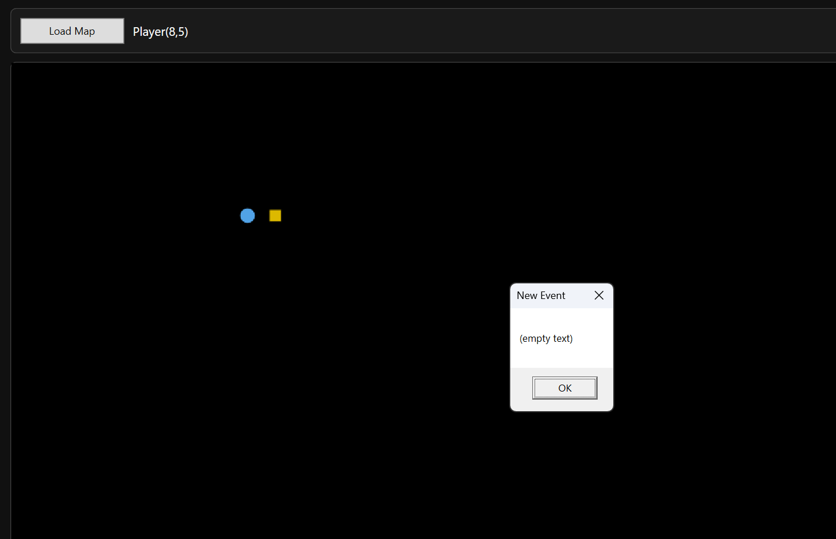

Figure T44 – Unknown Command Handling (Event Does Not Execute)
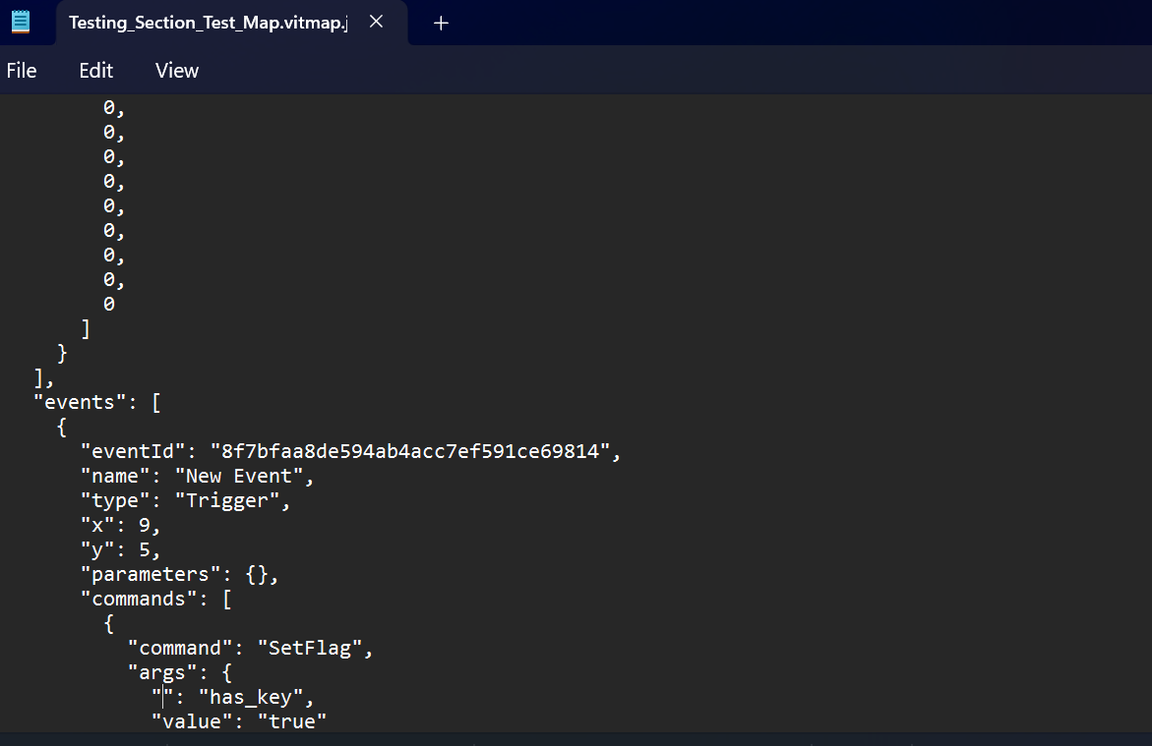

What These Tests Demonstrate:
- Defensive parsing of command dictionaries
- No runtime crashes from malformed event structures
- Explicit error messaging for missing parameters
- Controlled handling of unknown command identifiers
- Stability of data-driven event system

3.4 JSON Corruption and Recovery Handling
Since maps are persisted as JSON documents, the integrity of the JSON structure is critical. Corruption may occur due to :
- Manual editing errors
- Incomplete writes
- Version mismatches
- Structural deletion of required properties
This subsection verifies that:
- Malformed JSON does not crash the runtime
- Missing required fields are handled safely
- Invalid format versions do not cause undefined behaviour
- File corruption results in controlled failure rather than silent instability
This validates the reliability of the MapSerialiser and defensive file loading logic

Test Table 4 – JSON Corruption & Recovery Handling
Test ID | Purpose of Test | Test Data | Expected Outcome | Actual Outcome | Screenshot ID
BDJ1 | Remove closing brace from JSON | Delete final } in map file | Runtime fails safely with error message | Pass | Figures T45
BDJ2 | Remove required property width | Delete “Width” field | Deserialization fails safely | Pass | Figures T46
BDJ3 | Modify FormatVersion to invalid value | Change to unsupported number | Runtime handles without crash | Pass | Figures T47

Test Table 4 – Screenshot Evidence

Figure T45 – Malformed JSON (Missing Closing Brace)

Figure T46 – Missing Required Property

Figure T47 – Invalid FormatVersion
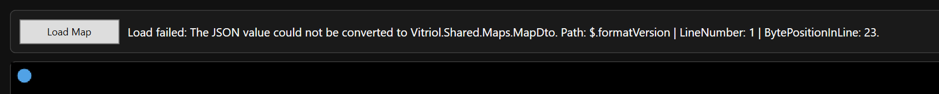

What These Tests Demonstrate:
- Safe deserialization failure handling
- No unhandled exceptions during file parsing
- Strict structural requirements enforced
- Protection against partial or corrupted file writes
- Data integrity maintained across persistence layer

3.5 Runtime Movement Boundary Testing
Player movement operates directly on tile-indexed arrays. Any failure in boundary enforcement could result in:
- Array index out-of-range exceptions
- Clipping outside map bounds
- Ignoring collision constraints
- Camera instability
This subsection verifies that:
- Player movement is clamped within map dimensions
- Collision tiles correctly block movement
- No index overflow occurs at edges
- Camera deadzone logic does not break at boundaries

Test Table 5 – Runtime Movement Boundary Testing
Test ID | Purpose of Test | Test Data | Expected Outcome | Actual Outcome | Screenshot ID
BDR1 | Attempt movement beyond left edge | Move player at x=0 left | Movement Blocked | Pass | Figures T48
BDR2 | Attempt movement beyond top edge | Move player at y=0 up | Movement Blocked | Pass | Figures T49
BDR3 | Attempt movement into collision tile | Walk into-collision marked tile | Collision Respected | Pass | Figures T50
BDR4 | Camera behaviour at map edge | Move to far right/bottom edge | Camera Clamps Correctly | Pass | Figures T51

Test Table 5 – Screenshot Evidence

Figure T48 – Left Boundary Enforcement
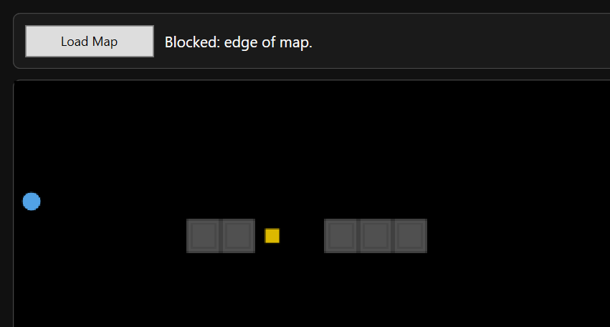

Figure T49 – Top Boundary Enforcement
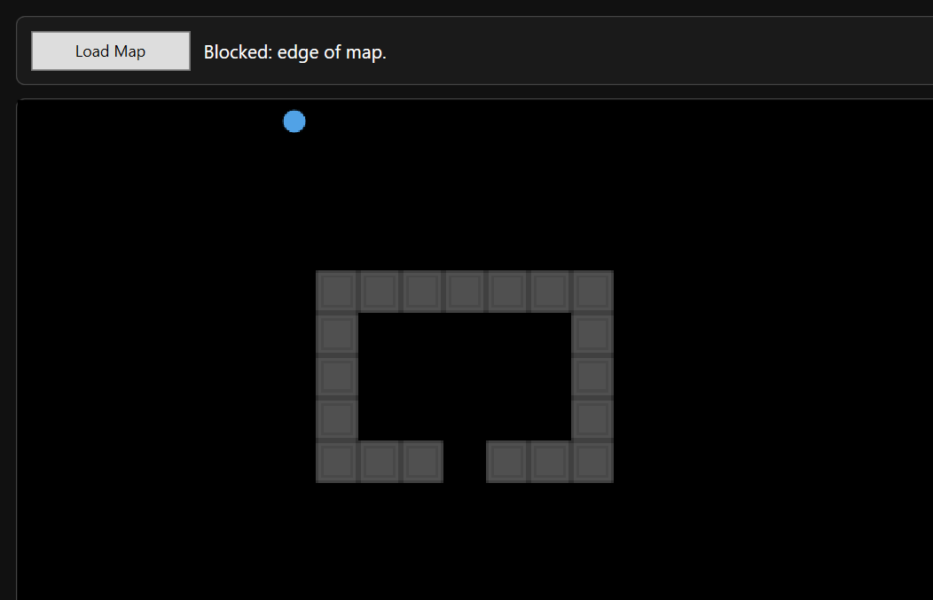

Figure T50 – Collision Tile Enforcement
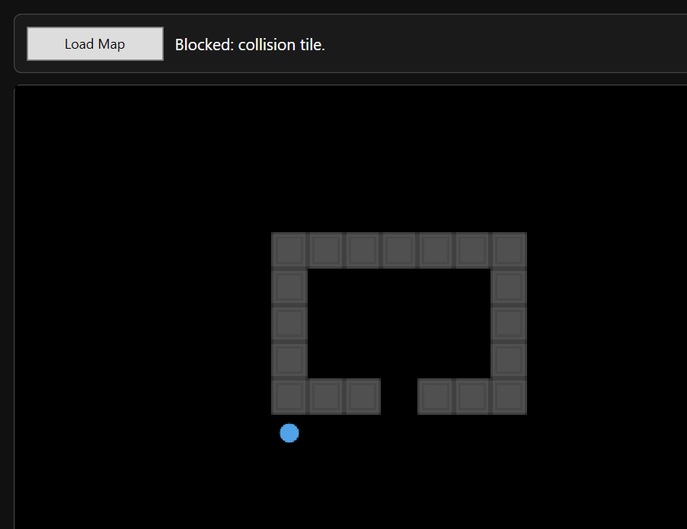

Figure T51 – Camera Clamping at Edge
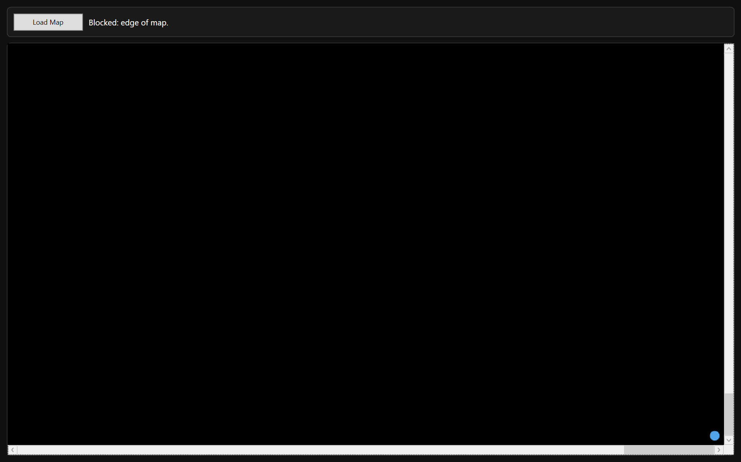

What These Tests Demonstrate:
- Safe array index clamping
- Collision layer correctly evaluated
- No runtime exceptions at map edges
- Camera deadzone behaviour remains stable at boundaries
- Movement system remains deterministic and robust

4 Performance Testing

4.1 Large Map Rendering Performance
These tests confirm that viewport-only rendering prevents performance degradation on large maps, and that rendering remains smooth during navigation.

Test Table 1 – Large Map Rendering Performance
Test ID | Purpose of Test | Test Data | Expected Outcome | Actual Outcome | Screenshot ID
PERFR1 | Render 200x200 map in editor | Large grid with background tiles | Smooth viewport navigation | Pass | Figures T52
PERFR2 | Continuous scrolling across large screen | Hold movement key | Rendering remains stable | Pass | Figures T53
PERFR3 | Load large map in runtime | 200x200 grid | Runtime renders only visible region | Pass | Figures T54
PERFR4 | Rapid directional input | Alternate WASD quickly | No frame freezing or jitter | Pass | Figures T55

Test Table 1 – Screenshot Evidence

Figure T52 – GIF Showing Editor Large Map Navigation


Figure T53 – GIF Showing Continuous Movement Stress


Figure T54 – Runtime Large Map Render (200x200)
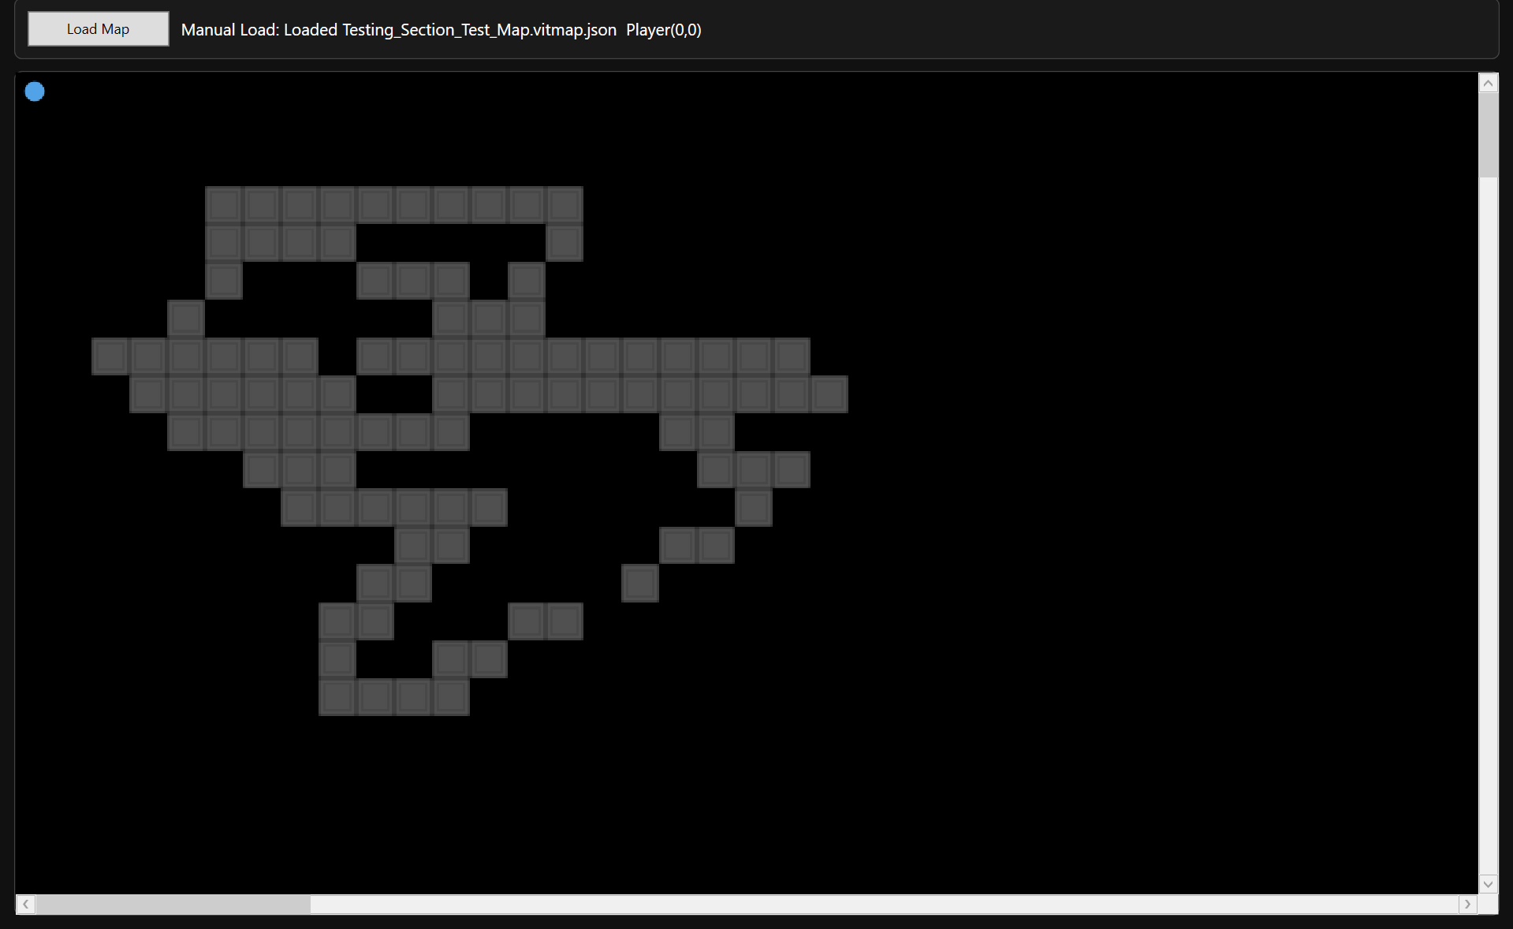

Figure T55 – GIF Showing Rapid Input Responsiveness


What These Tests Demonstrate:
- Rendering workload remains proportional to viewport size
- Tile cropping and caching prevent redundant redraw
- No exponential performance cost as map dimensions increase
- Input handling remains responsive under continuous rendering

4.2 Rendering Stability Under Continuous Movement
While large map rendering validates immediate responsiveness, it is equally important to ensure that performance remains stable over time. Extended runtime sessions may expose:
- Memory leaks in bitmap caching
- Gradual rendering slowdown
- Accumulated camera offset errors
- Resource exhaustion under repeated movement
Given that the system uses:
- Frozen BitmapSource objects
- Cached CroppedBitmap instances
- Debounced render calls
- Single RenderTargetBitmap per frame
This subsection verifies that long-duration usage does not degrade responsiveness or introduce instability.

Test Table 2 – Rendering Stability Under Continuous Movement
Test ID | Purpose of Test | Test Data | Expected Outcome | Actual Outcome | Screenshot ID
PERFS1 | Continuous movement for 20+ seconds | Hold movement keys | No frame degradation over time | Pass | Figures T56
PERFS2 | Repeated directional change | Rapid alternating movement | No camera jitter or offset drift | Pass | Figures T57
PERFS3 | Repeated viewport scrolling (editor) | Continuous scroll wheel use | No UI freeze or lag | Pass | Figures T58
PERFS4 | Multiple map reload cycles | Load map repeatedly | No progressive slowdown | Pass | Figures T59

Test Table 2 – Screenshot Evidence

Figure T56 – GIF Showing Extended Movement Stability


Figure T57 – GIF Showing Camera Stability During Rapid Direction Change


Figure T58 – GIF Showing Editor Scroll Stability


Figure T59 – GIF Showing Repeated Map Reload


What These Tests Demonstrate:
- No observable memory leak from tile caching
- Camera deadzone remains stable over time
- Debounced rendering prevents excessive redraw calls
- Rendering remains proportional to viewport size
- Load operations do not degrade progressively

4.3 Memory Usage During Extended Editing Session
This subsection evaluates whether memory consumption increases progressively during extended editing or runtime use. Since the system caches:
- Tileset bitmaps
- Cropped tile regions
- RenderTargetBitmap frames
It is critical to ensure:
- No uncontrolled memory growth
- No cumulative bitmap duplication
- No progressive slowdown after repeated render cycles

Test Table 3 – Memory Usage During Extended Editing Session
Test ID | Description | Test Data | Expected Outcome | Actual Outcome | Screenshot ID
PERFM1 | Continuous tile painting in editor | Rapid paint actions for 20+ seconds | No UI slowdown | Pass | Figures T60
PERFM2 | Repeated viewport renders | Scroll large map repeatedly | No progressive lag | Pass | Figures T61
PERFM3 | Repeated runtime movement | Continuous WASD movement | No increasing delay | Pass | Figures T62

Test Table 3 – Screenshot Evidence

Figure T60 – GIF Showing Continuous Tile Painting (Editor Memory Stability)


Figure T61 – GIF Showing Repeated Viewport Rendering (Editor Scroll Stress)


Figure T62 – GIF Showing Repeated Runtime Movement


What These Tests Demonstrate:
- No progressive slowdown from repeated tile updates
- Viewport-only rendering remains stable over repeated calls
- No memory leak symptoms or input degradation

4.4 Asset Loading Performance
Asset loading performance evaluates the time required to:
- Load tileset PNG file
- Compile tile metadata
- Cache cropped bitmap segments
- Render initial viewport
Given that tilesets are loaded once and cached, subsequent map loads should not significantly degrade performance.
This subsection verifies that:
- First load is acceptable
- Subsequent loads are not progressively slower
- Large tilesets do not freeze the UI

Test Table 4 – Asset Loading Performance
Test ID | Description | Test Data | Expected Outcome | Actual Outcome | Screenshot ID
PERFA1 | First load of large tileset | Input resolution PNG | Load completes without freezing | Pass | Figures T63
PERFA2 | Reload same map | Cached tileset | Faster or equal load time | Pass | Figures T64
PERFA3 | Switch between maps repeatedly | Alternate map loads | No UI Hang | Pass | Figures T65

Test Table 4 – Screenshot Evidence

Figure T63 – First Load of Large Tileset
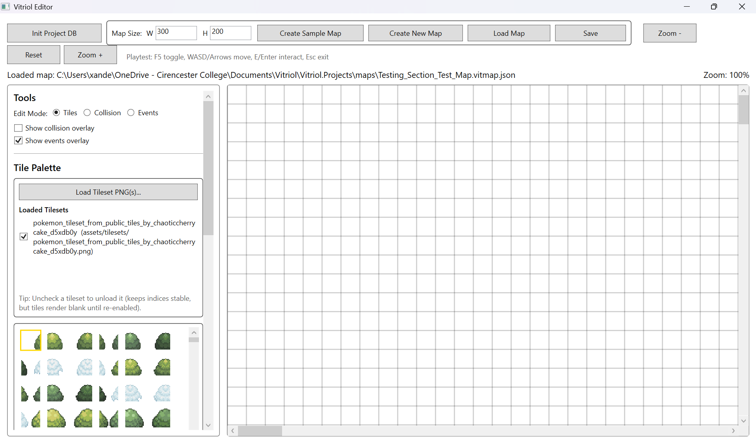

Figure T64 – GIF Showing Reload of Same Map (Cache Validation)


Figure T65 – GIF Showing Switch Between Maps


What These Tests Demonstrate:
- Initial PNG decoding and tileset compilation completes successfully
- No progressive delay, caching remains stable
- Repeated map loading does not accumulate performance degradation

5 Regression Testing

5.1 Map Creation Regression Checks
These checks confirm that later changes (tileset validation, autosave rules, viewport renderer integration) did not break initial map creation workflows. This includes creation of both sample maps and user-created mas, plus correct initial save state behaviour.

Test Table 1 – Map Creation Regression Checks
Test ID | Test Data | Expected Outcome | Actual Outcome | Status | Screenshot ID
REGMC1 | Create new user map (blank grid) | Map created with correct dimensions and blank layers | Map created successfully | Pass | Figures T66
REGMC2 | Manual save required before autosave enabled | Autosave inactive until first manual save | Save rule enforced correctly | Pass | Figures T67
REGMC3 | Sample map creation autosaves by default | Autosave active immediately for sample map | Autosave active as expected | Pass | Figures T68
REGMC4 | Reload newly created map file | Map reloads correctly with no missing data | Reload successful | Pass | Figures T69

Test Table 1 – Screenshot Evidence

Figure T66 – New User Map Created (Blank Grid)
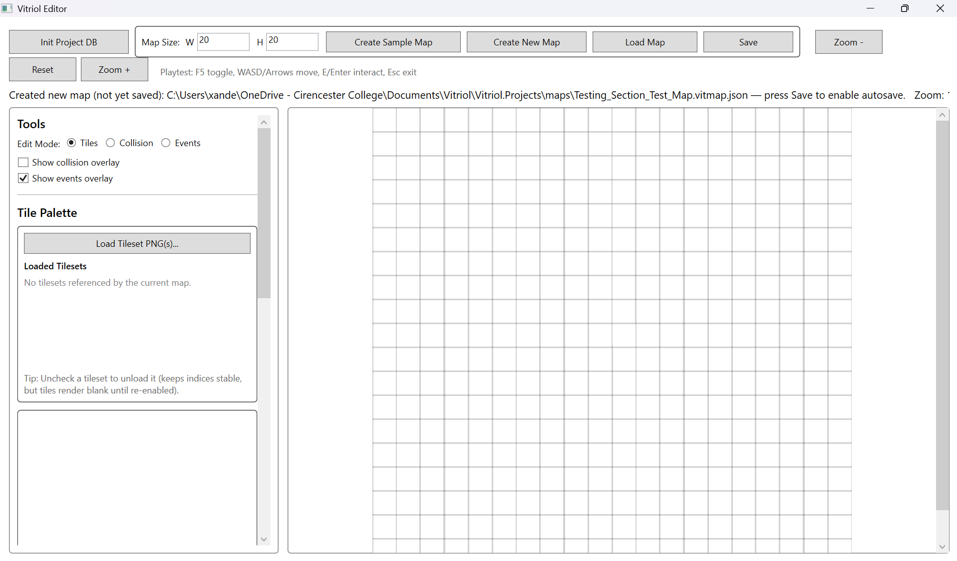

Figure T67 – Manual Save Gate Before Autosave
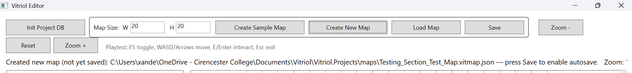

Figure T68 – Sample Map Autosave Active by Default
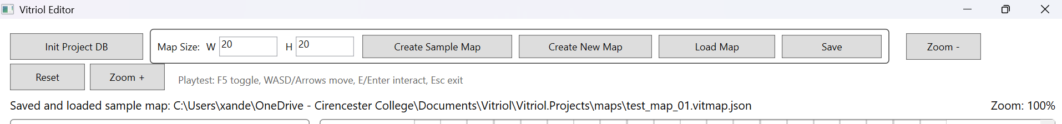

Figure T69 – Reload Newly Created Map
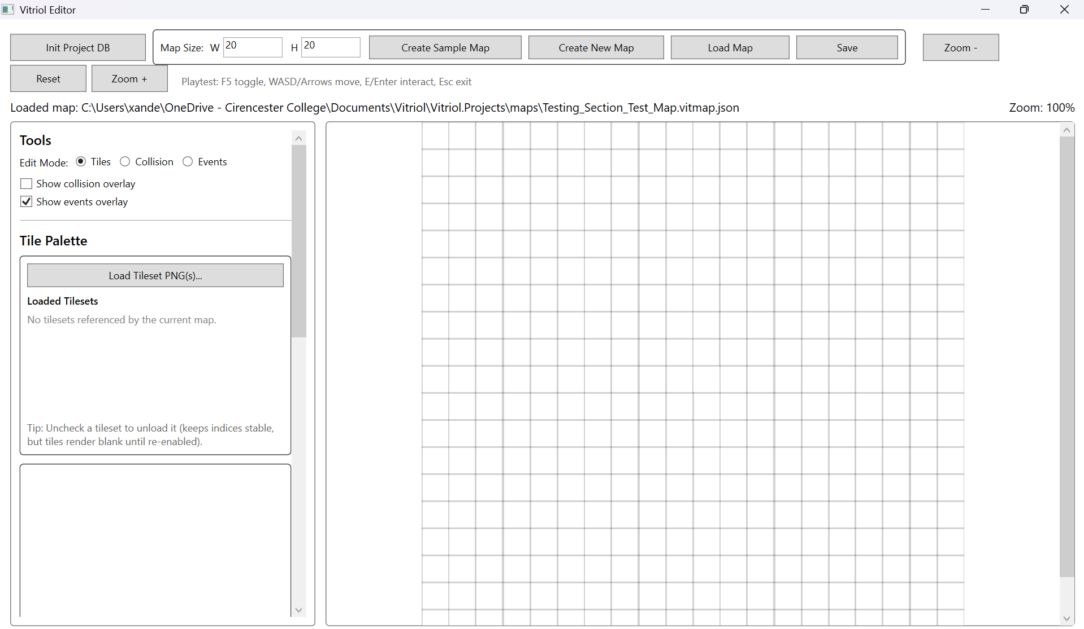

What These Tests Demonstrate:
- Correct initial map creation state and correct grid dimensions
- Autosave rule enforcement prior to first manual save
- Immediate autosave behaviour on sample map workflow
- Creation output produces a valid reloadable map file

5.2 Event System Regression Checks
These tests confirm that runtime changes (camera behaviour, rendering pipeline, tileset caching) did not disrupt event triggering and command execution. This focuses on ensuring NPC, Trigger, and Warp event types still function predictably

Test Table 2 – Event System Regression Checks
Test ID | Description | Expected Outcome | Actual Outcome | Status | Screenshot ID
REGEV1 | Trigger event executes ShowText | Dialogue appears with correct text | ShowText displayed correctly | Pass | Figures T70
REGEV2 | NPC event executes ShowText | Dialogue appears when interacting with NPC | NPC interaction works | Pass | Figures T71
REGEV3 | Warp event loads destination | Map loads and player relocates | Warp Successful | Pass | Figures T72

Test Table 2 – Screenshot Evidence

Figure T70 – Trigger Event Execution (ShowText)
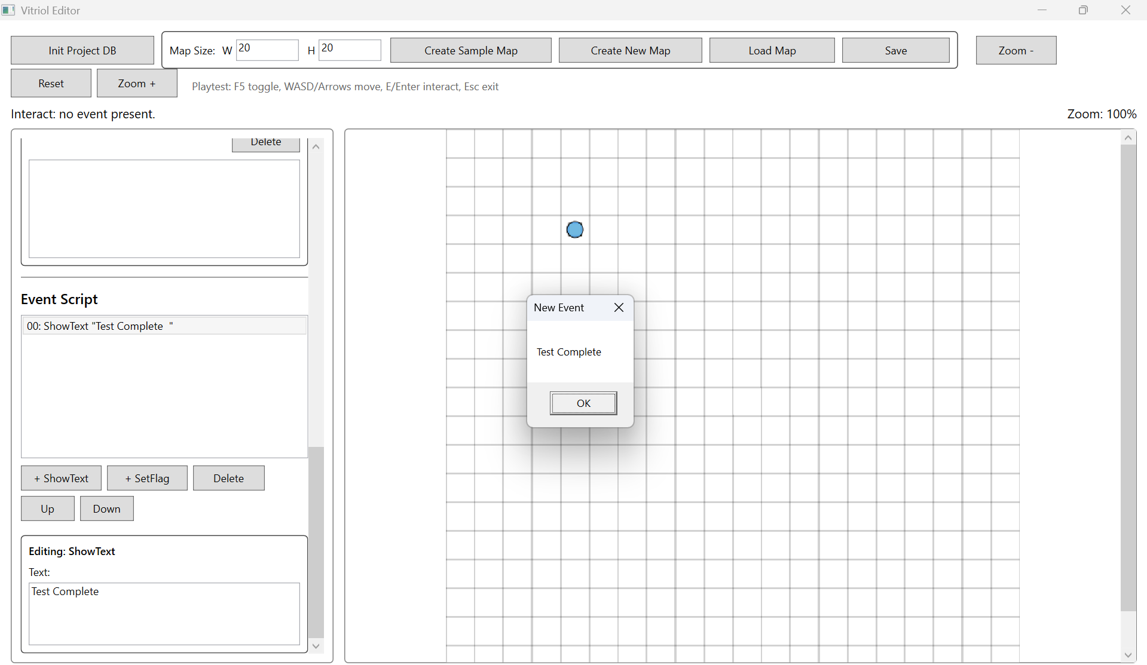

Figure T71 – NPC Interaction Event Execution
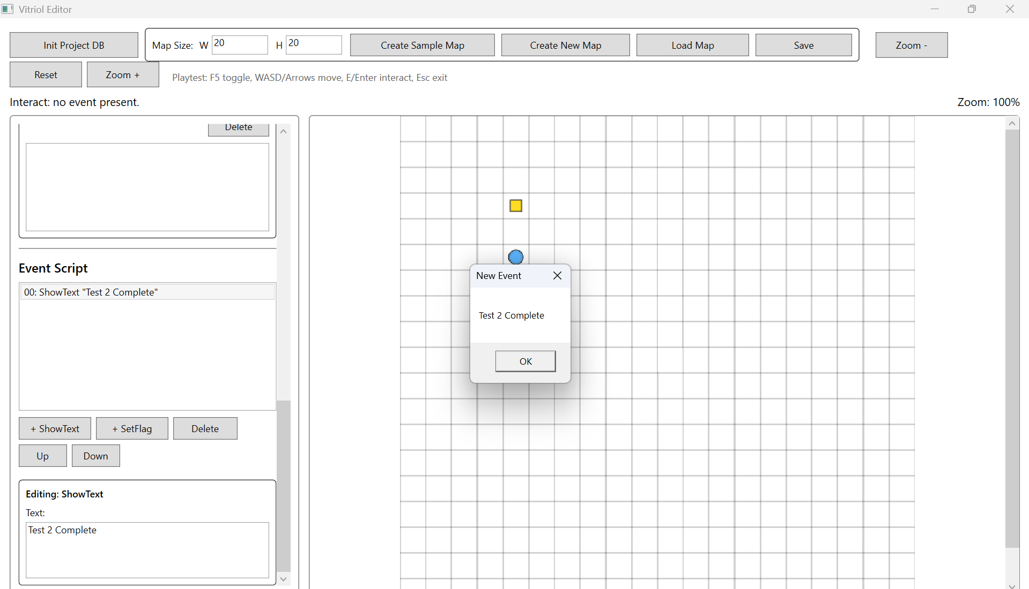

Figure T72 – Warp Event Map Transition
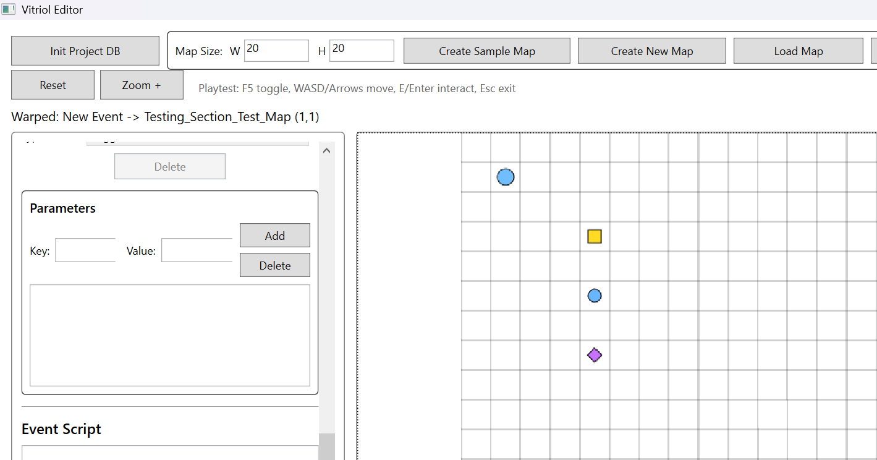

What These Tests Demonstrate:
- Trigger event still executes correctly after later runtime changes
- NPC events remain functional and correctly routed through interaction logic
- Warp loads the destination map and relocates the player
- Command dictionary logic still behaves correctly after refactors

5.3 Persistence Regression Checks
Persistence regression ensures later features did not introduce corruption into save/load behaviour. This includes JSON integrity, map reload fidelity, and ensuring that edits are correctly written back to file without breaking schema stability.

Test Table 3 – Persistence Regression Checks
Test ID | Description | Expected Outcome | Actual Outcome | Status | Screenshot ID
REGPS1 | Save after tile edits | JSON updates reflect tile changes | Saved correctly | Pass | Figures T73
REGPS2 | Save after collision edits | Collision layer persists correctly | Saved correctly | Pass | Figures T74
REGPS3 | Event list persists with correct fields | Event list persists with correct fields | Saved correctly | Pass | Figures T75.1, T75.2
REGPS4 | Runtime loads identical state | Runtime loads identical state | Reload matches saved state | Pass | Figures T76

Test Table 3 – Screenshot Evidence

Figure T73 – Tile Edits Persist After Save
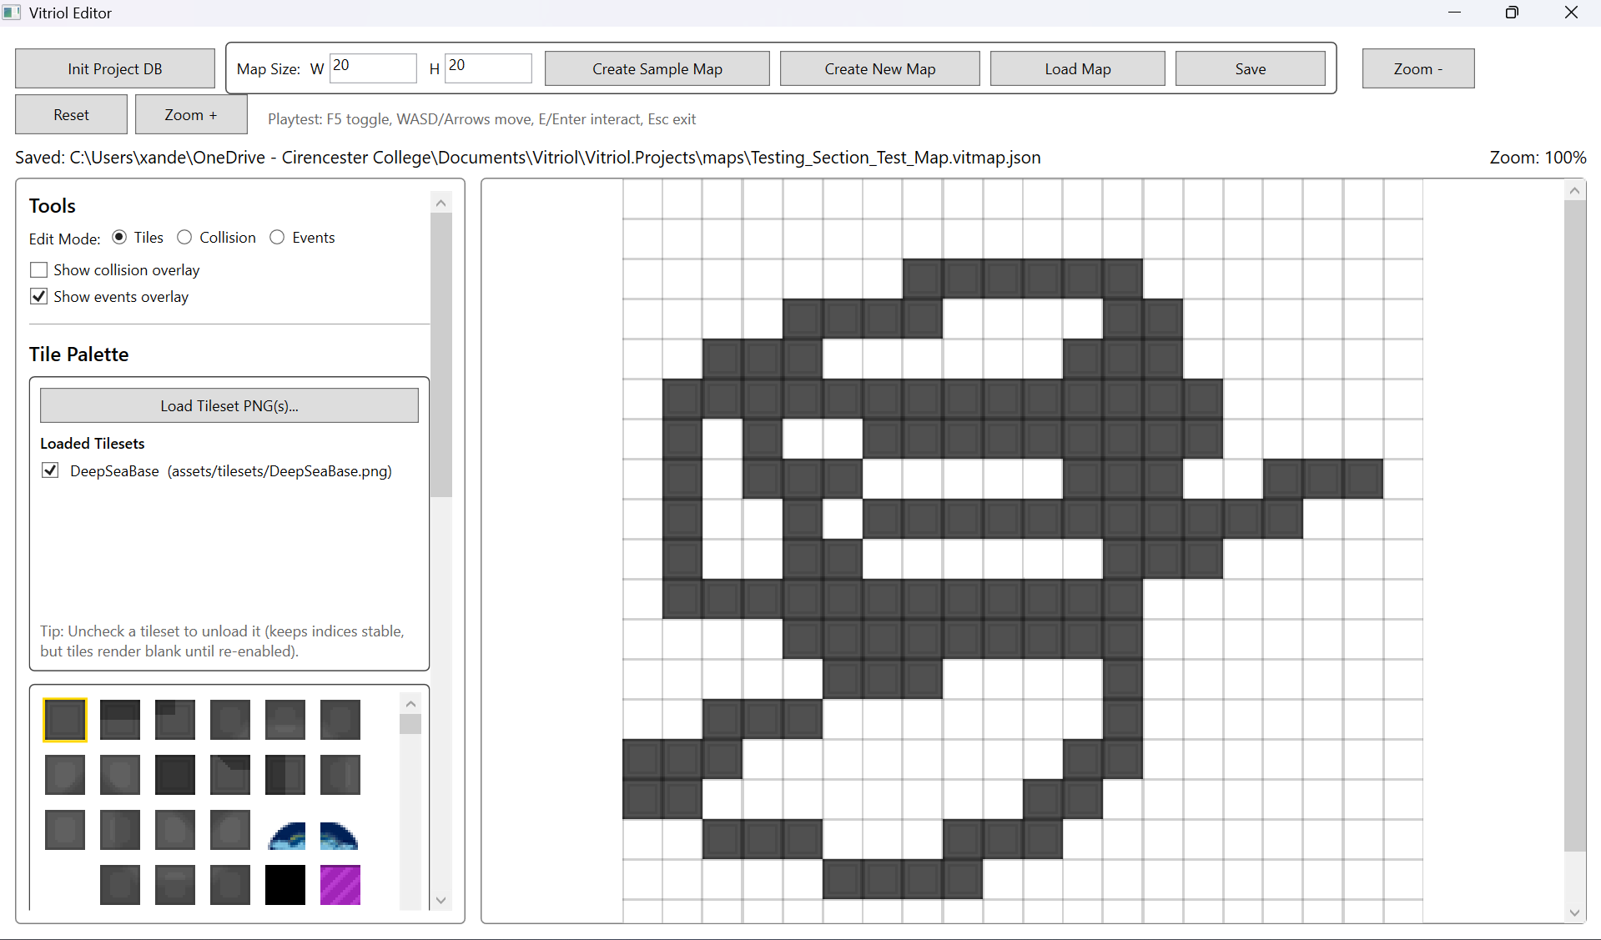

Figure T74 – Collision Edits Persist After Save
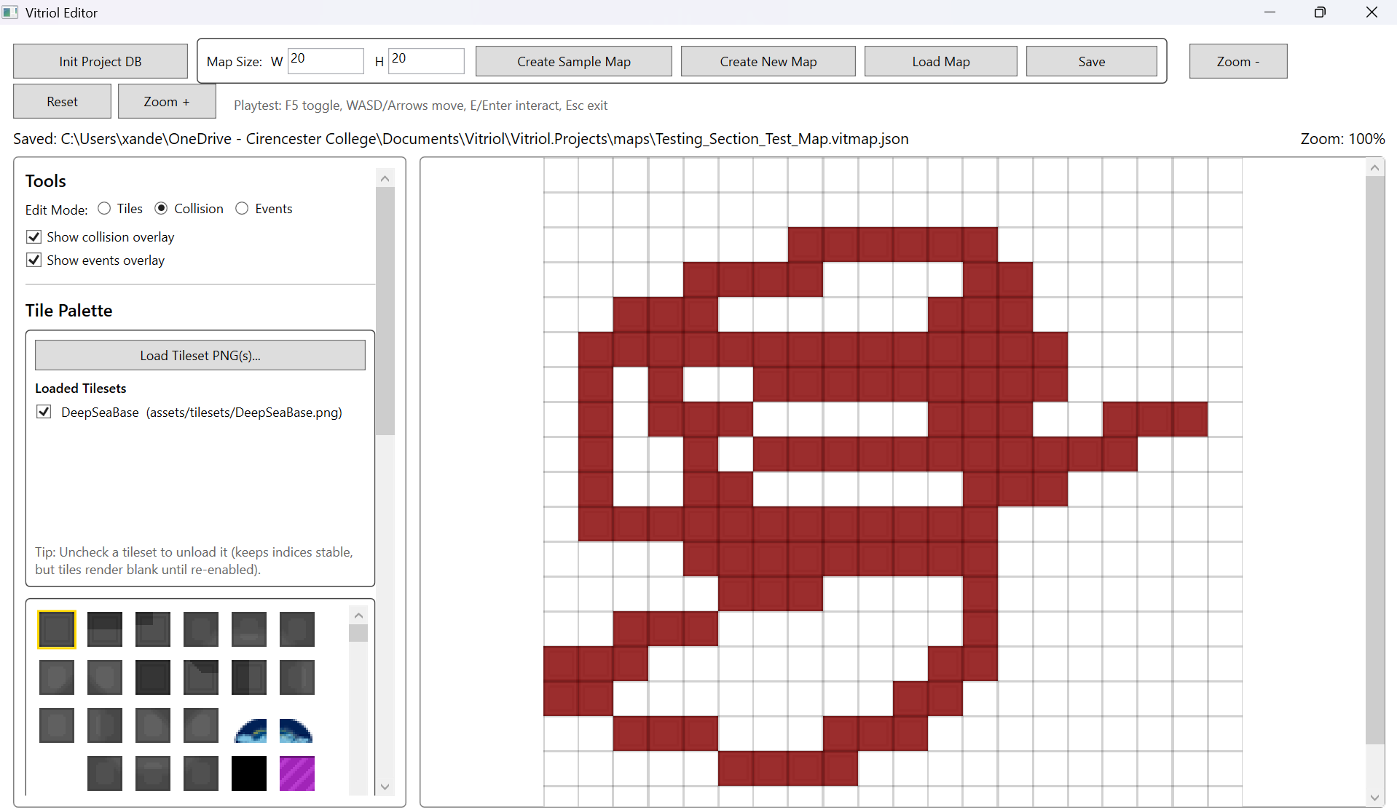

Figure T75.1 – Event Added and Saved
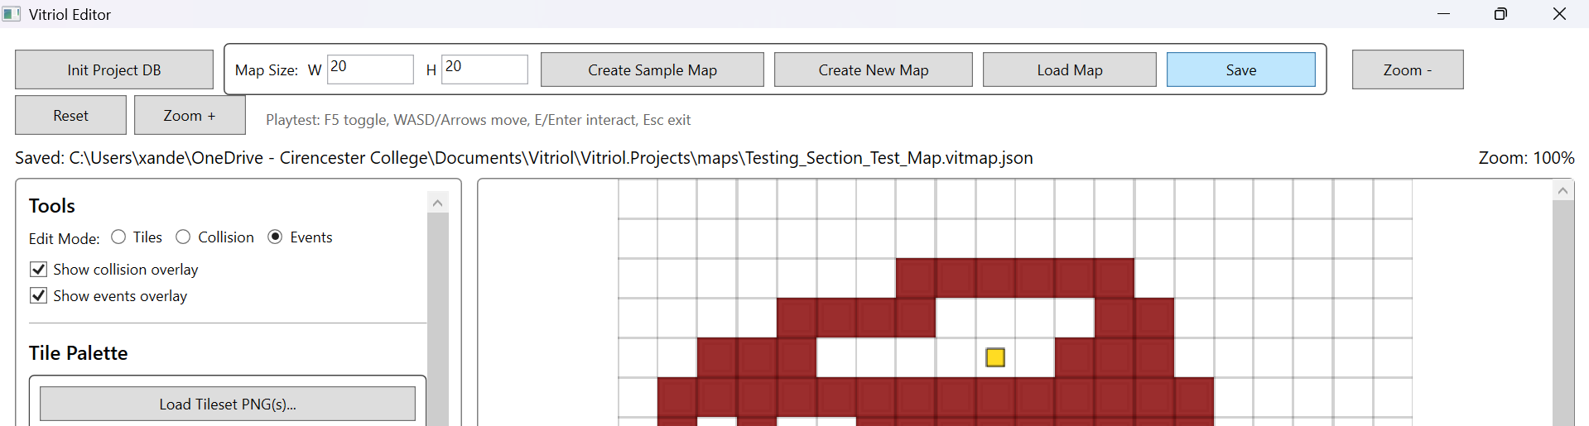

Figure T75.2 – Reload Event From Saved JSON
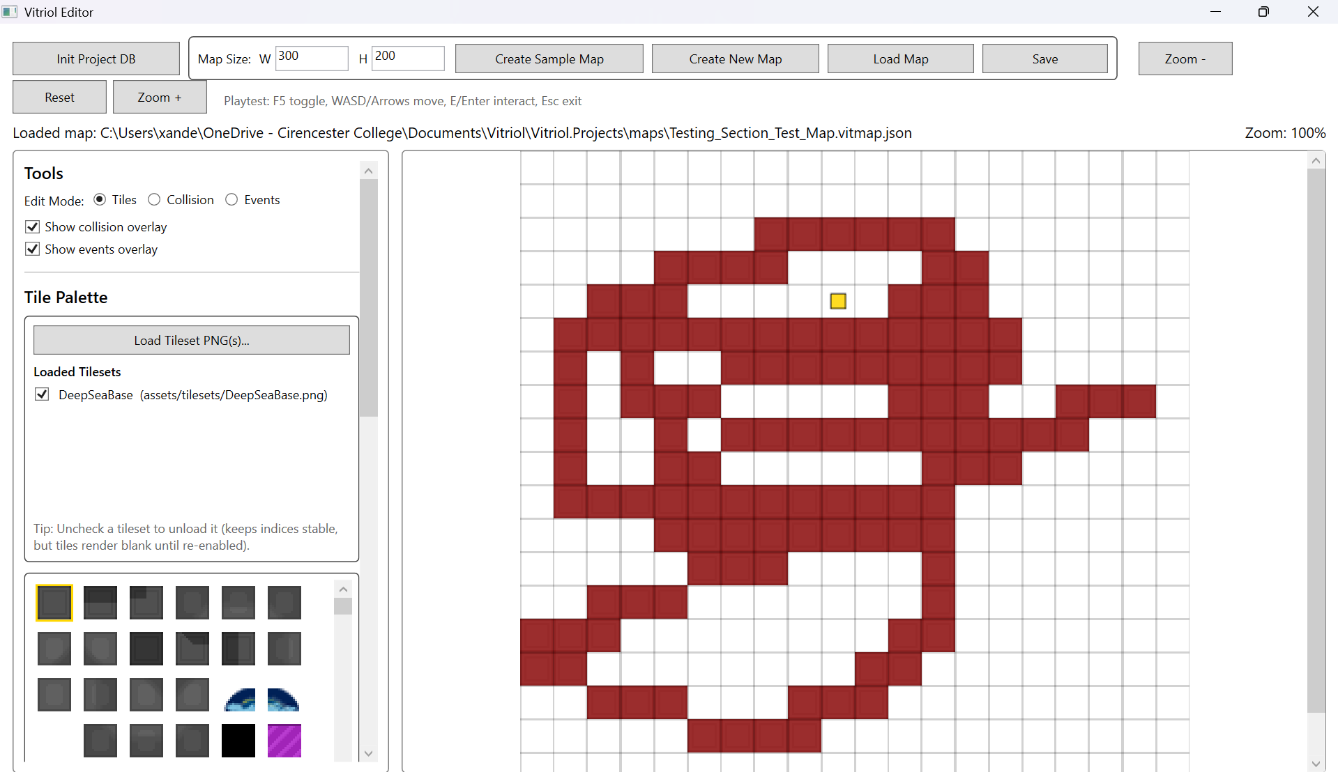

Figure T76 – Runtime Loads Saved Map Without Drift
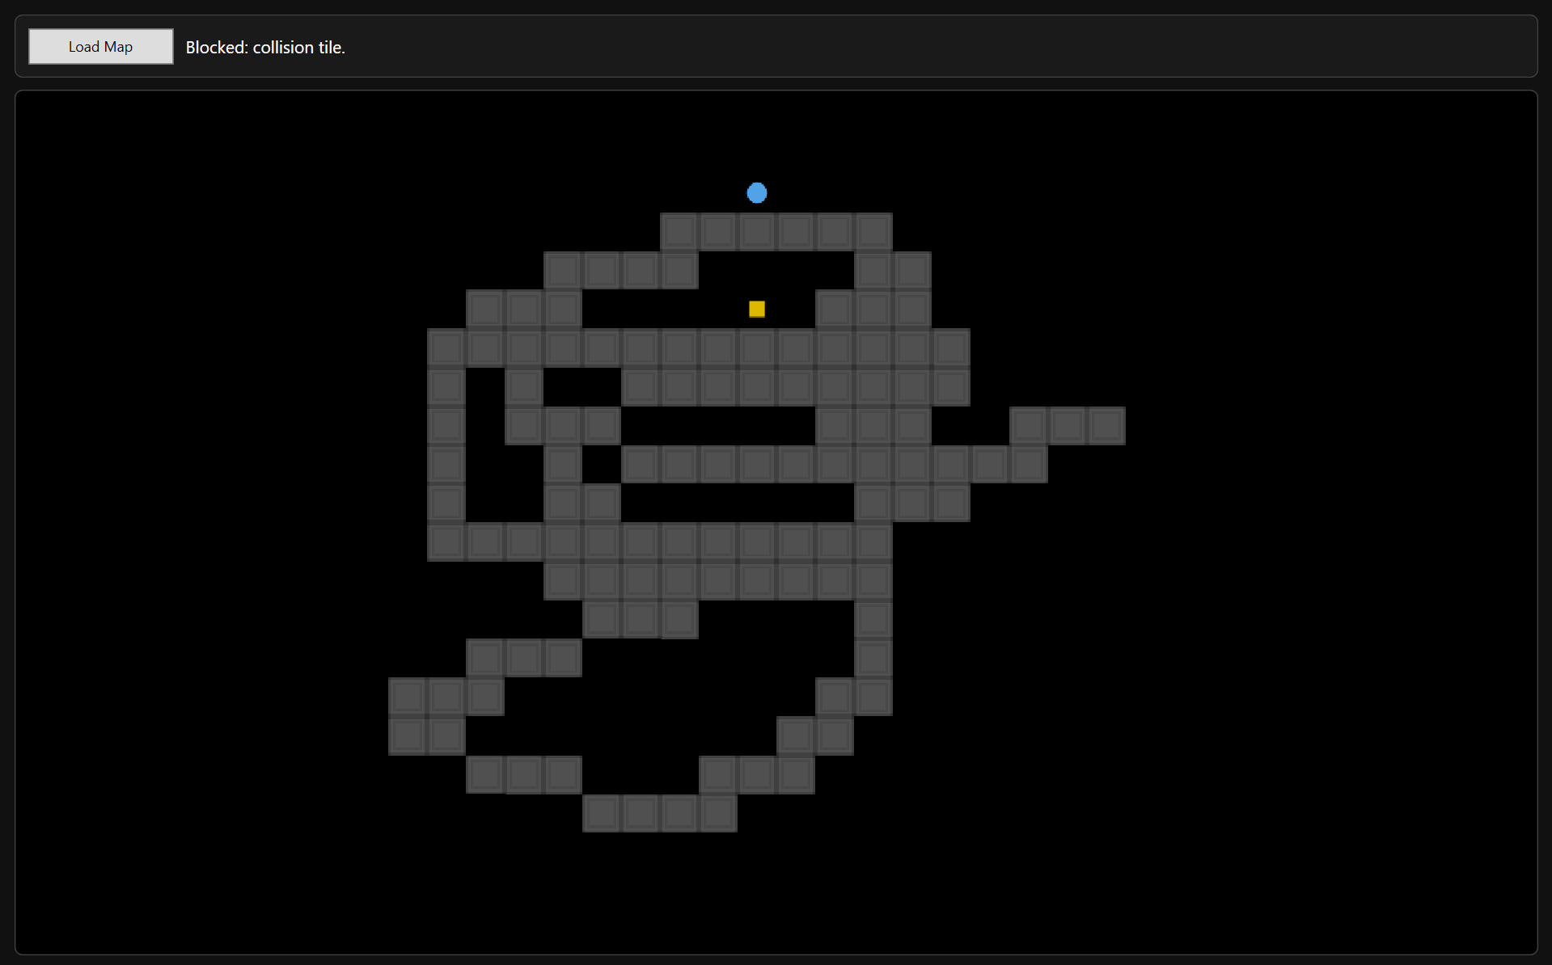

What These Tests Demonstrate:
- Tile painting still produces correct saved output
- Collision layer remains stable through persistence pipeline
- Event created and stored correctly
- Event data reloads correctly and remains executable
- Runtime load fidelity after persistence operations

5.4 Rendering Regression Checks
Rendering regression checks confirm that viewport-only rendering, caching, and tileset compilation changes did not cause tile misalignment, incorrect indices, missing tiles, or rendering artifacts.

Test Table 4 – Rendering Regression Checks
Test ID | Description | Expected Outcome | Actual Outcome | Status | Screenshot ID
REGRN1 | Render map after tileset caching added | Correct tile alignment | Alignment correct | Pass | Figures T77
REGRN2 | Scroll viewport across map | No blank regions or tearing | Scroll Stable | Pass | Figures T78
REGRN3 | Render events overlay markers | Events visible in viewport | Markers correct | Pass | Figures T79
REGRN4 | Render player marker + deadzone camera | Player visible, camera clamps | Stable behaviour | Pass | Figures T80

Test Table 4 – Screenshot Evidence

Figure T77 – Correct Tile Alignment After Rendering Changes
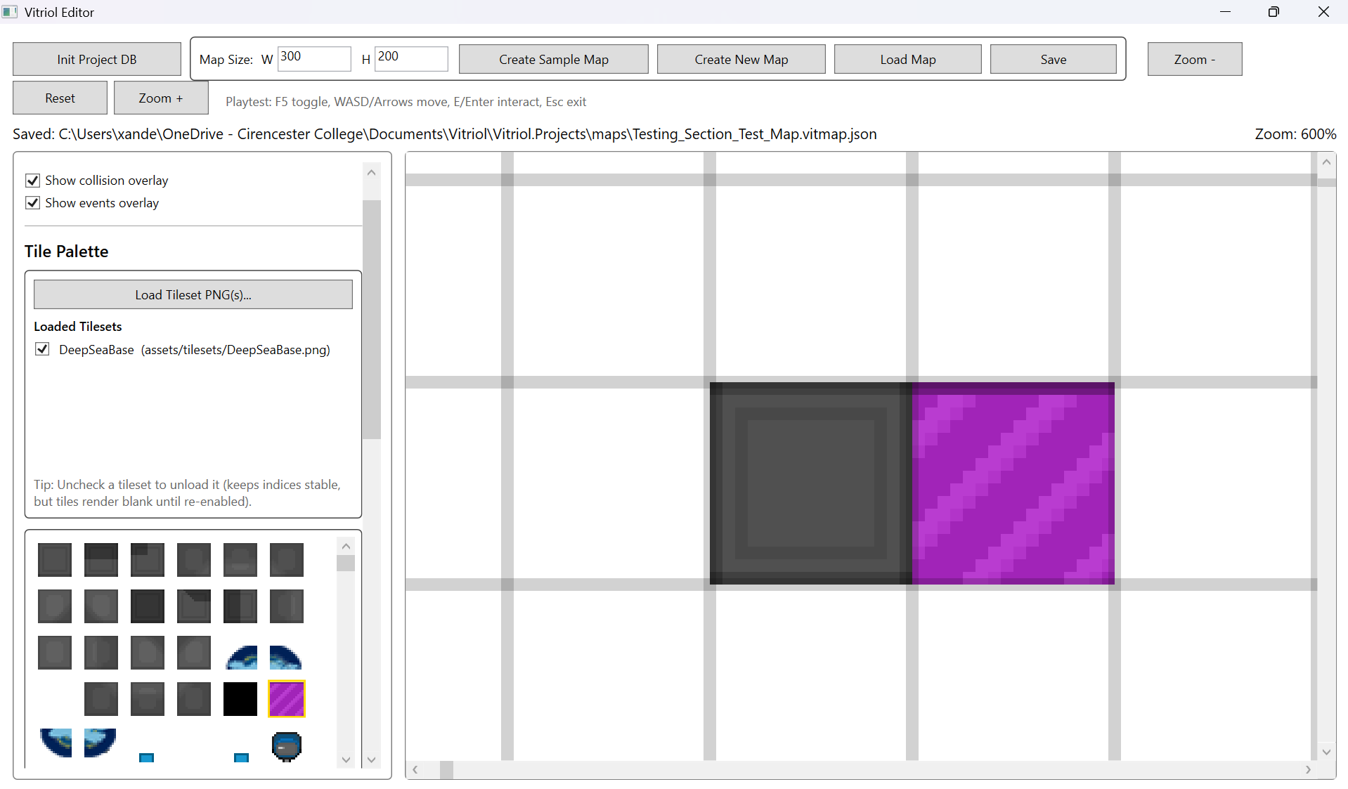

Figure T78 – Viewport Scroll Rendering Stability
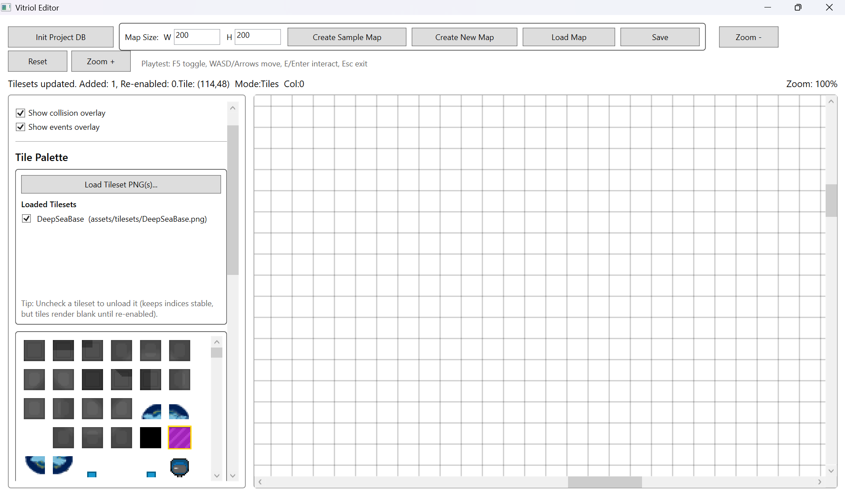

Figure T79 – Event Markers Render Correctly
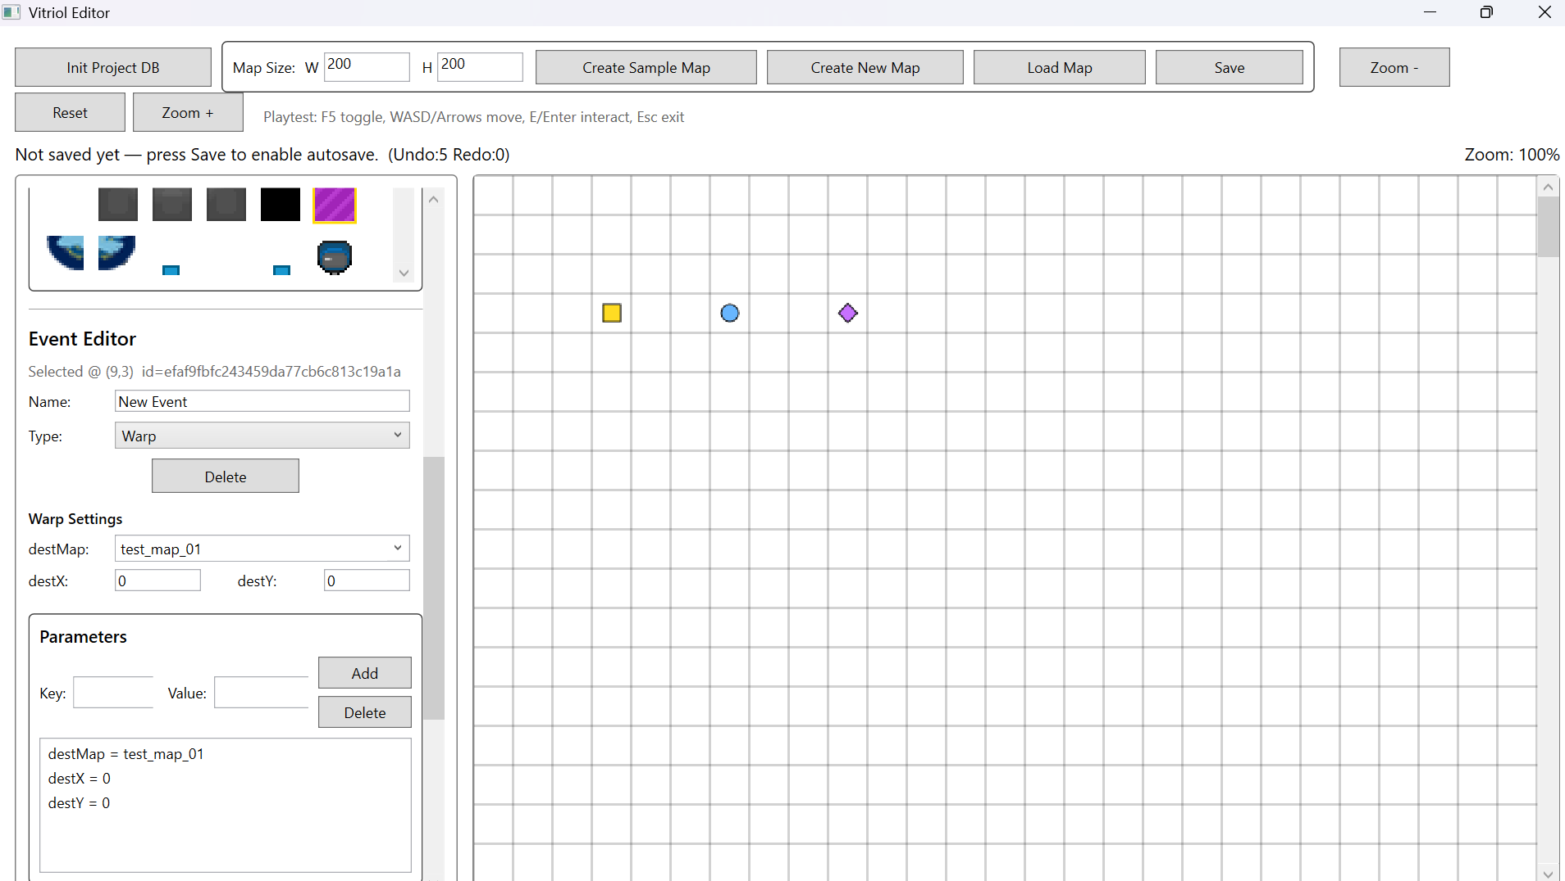

Figure T80 – Player Marker + Camera Rendering Stable
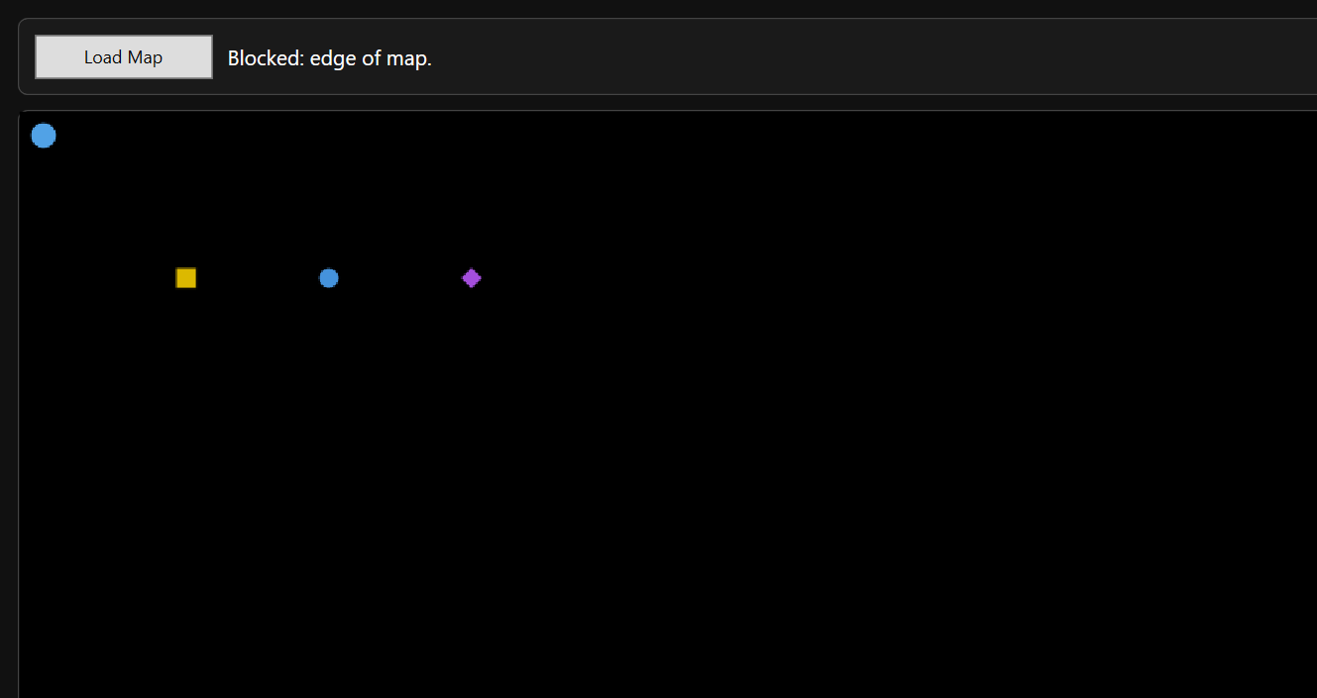

What These Tests Demonstrate:
- Stable tile positioning and correct cropping
- Viewport-only rendering produces consistent redraw output
- Event overlay rendering still functions after pipeline changes
- Camera follow + player rendering remain consistent

6 User Testing

6.1 Structured User Task Testing
To evaluate usability and workflow clarity, structured task-based testing was conducted. The aim was to determine whether a user unfamiliar with the internal implementation could:
- Create and save a new map
- Paint tiles correctly
- Add an event
- Trigger the event in runtime
- Navigate the map using movement controls
This testing focused on:
- Learnability
- Workflow intuitiveness
- Error recovery
- Feature discoverability
Two participants with basic computer competence but no prior exposure to the codebase were observed performing a predefined task list.

Task List
Participants were asked to complete the following asks without assistance until blocked:
- Create a new map (32x32)
- Save the map with a unique name
- Load a tileset
- Paint at least three different tiles
- Add an NPC event with a ShowText command
- Save the map
- Launch runtime
- Load the created map
- Move the player to the NPC
- Trigger the event interaction
These tasks were chosen to cover:
- Core editor workflow
- Persistence
- Event configuration
- Runtime execution
- Basic navigation controls

Feedback Summary

Test User 1
User 1 completed all tasks successfully without intervention

Observations:
- Immediately understood tile painting
- Located save button quickly
- Required brief hesitation when locating event creation tools
- Successfully triggered NPC interaction in runtime

User reported:
- Interface felt “minimal but clear”
- Runtime controls were intuitive (WASD)
- Load Map button in runtime was helpful
No critical usability failures occurred

Test User 2
User 2 also completed all tasks successfully

Observations:
- Took slightly longer to locate event editing panel
- Initially attempted to interact with NPC without standing on the tile
- Successfully corrected interaction attempt without assistance

User reported:
- Map creation was straightforward
- Event editing felt “more technical” than tile painting
- Runtime felt responsive
No blocking errors occurred

User Final Result Screenshot

Test User 1

Figure T81.1 – Test User 1 Final Editor
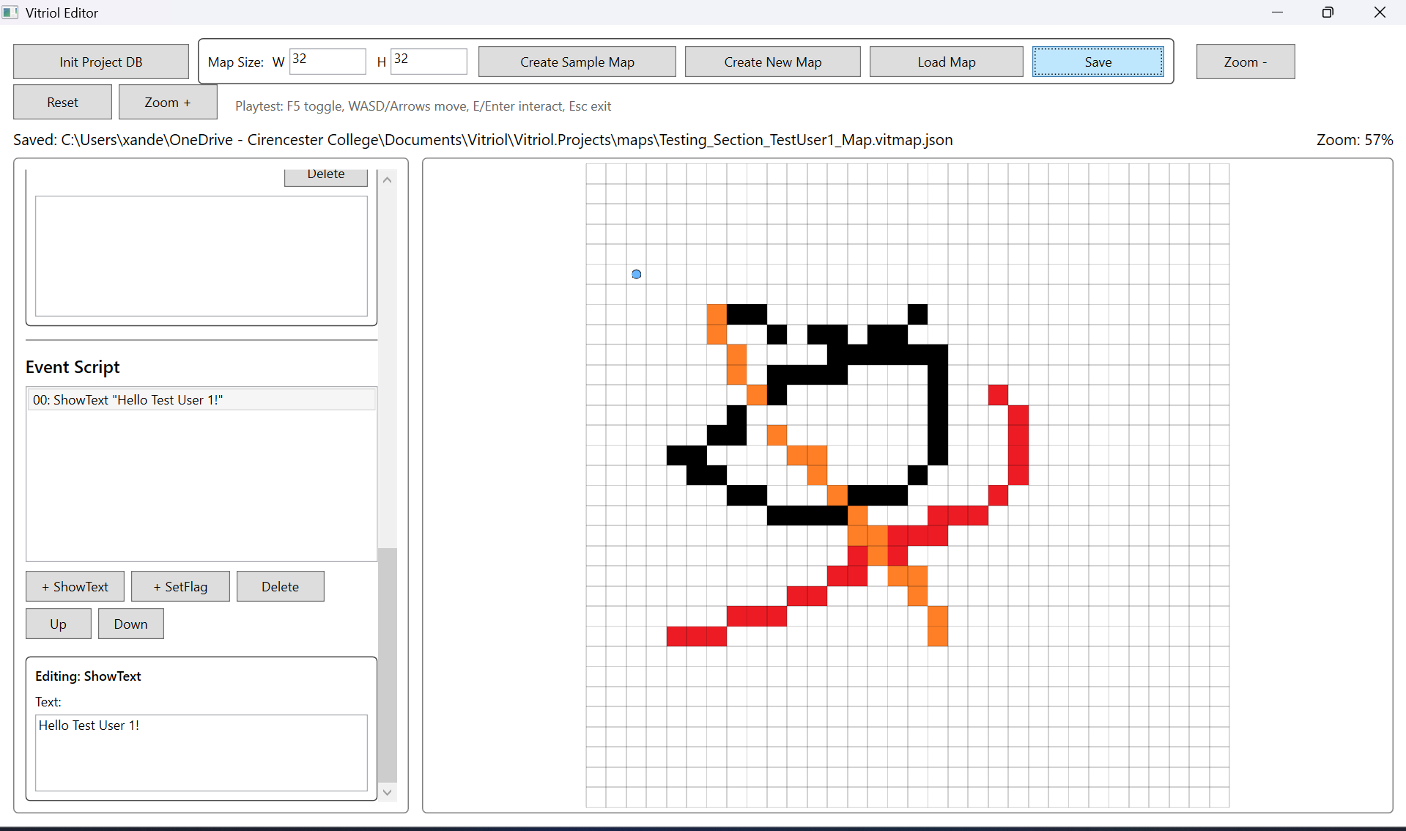

Figure T81.2 - Test User 1 Final Runtime
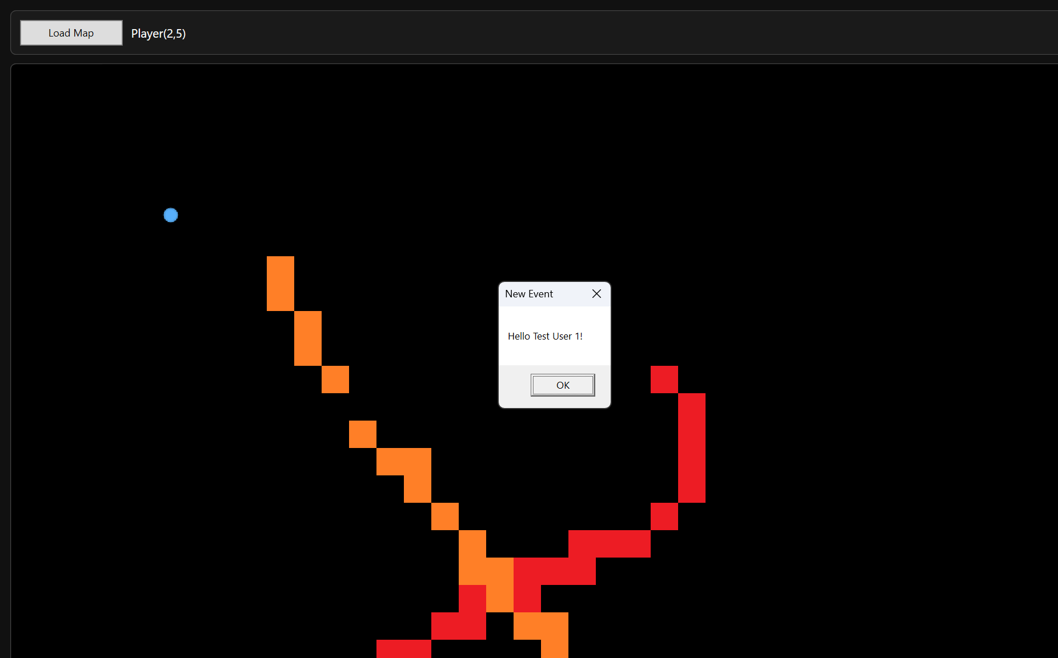

Test User 2

Figure T82.1 – Test User 2 Final Editor
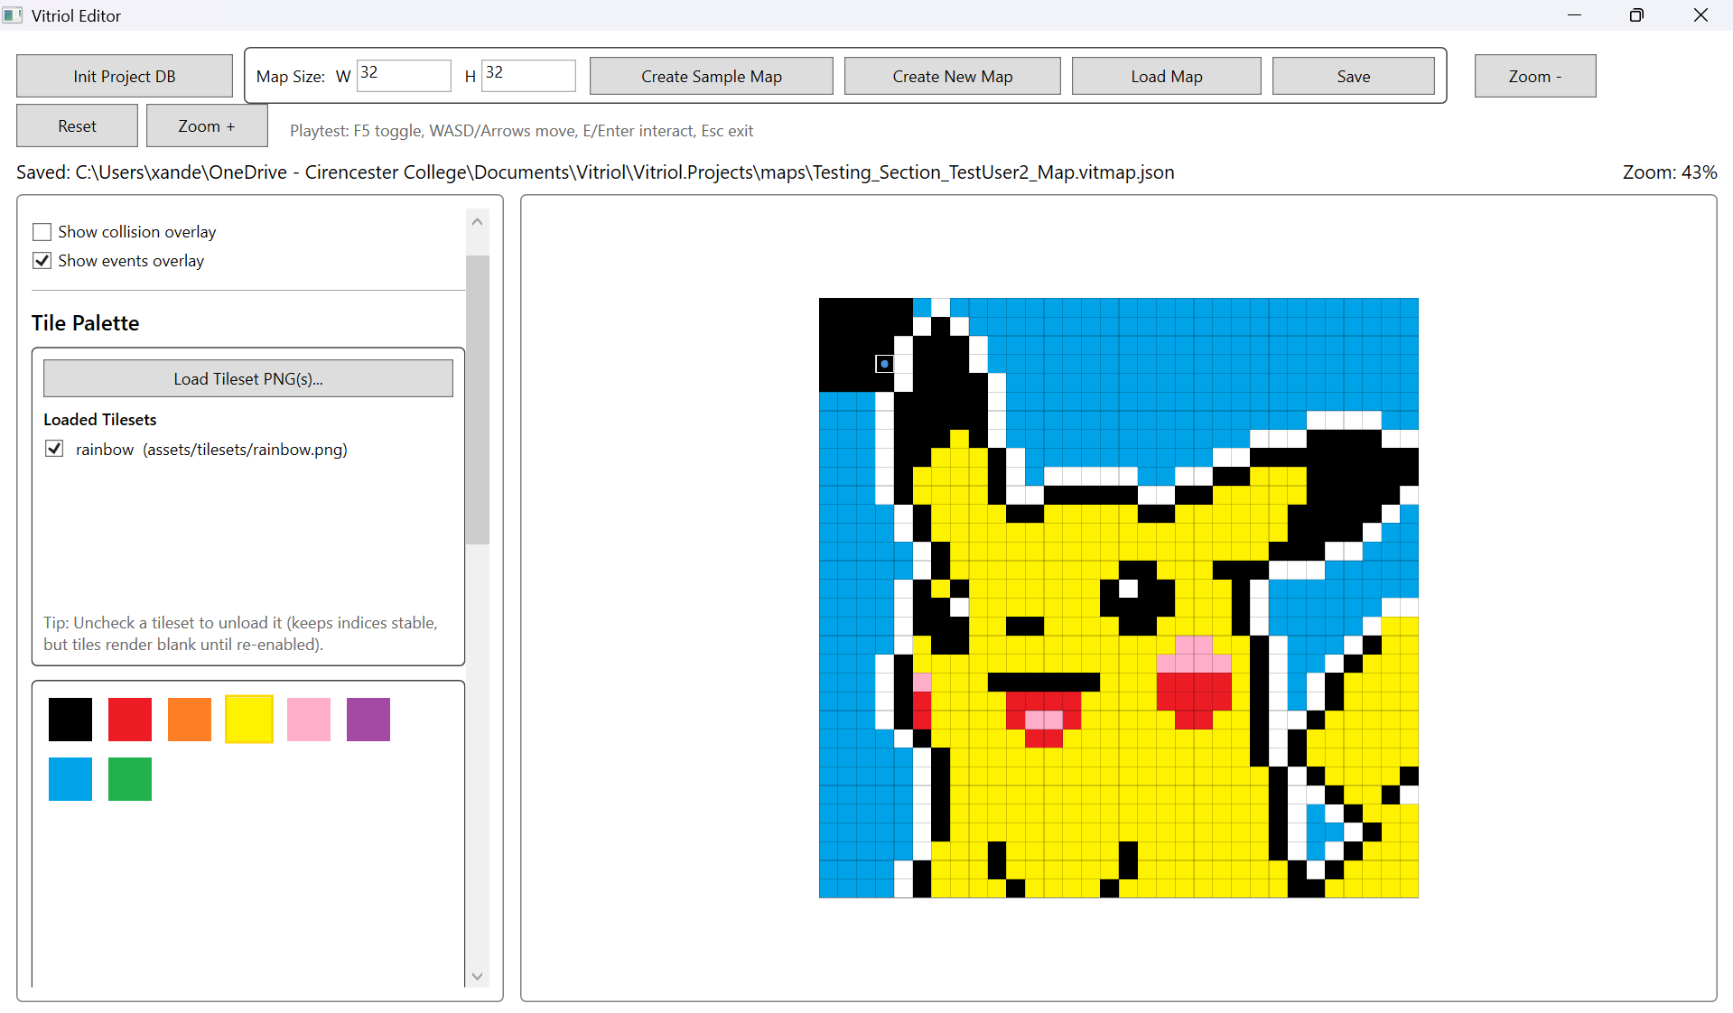

Figure T82.2 – Test User 2 Final Runtime
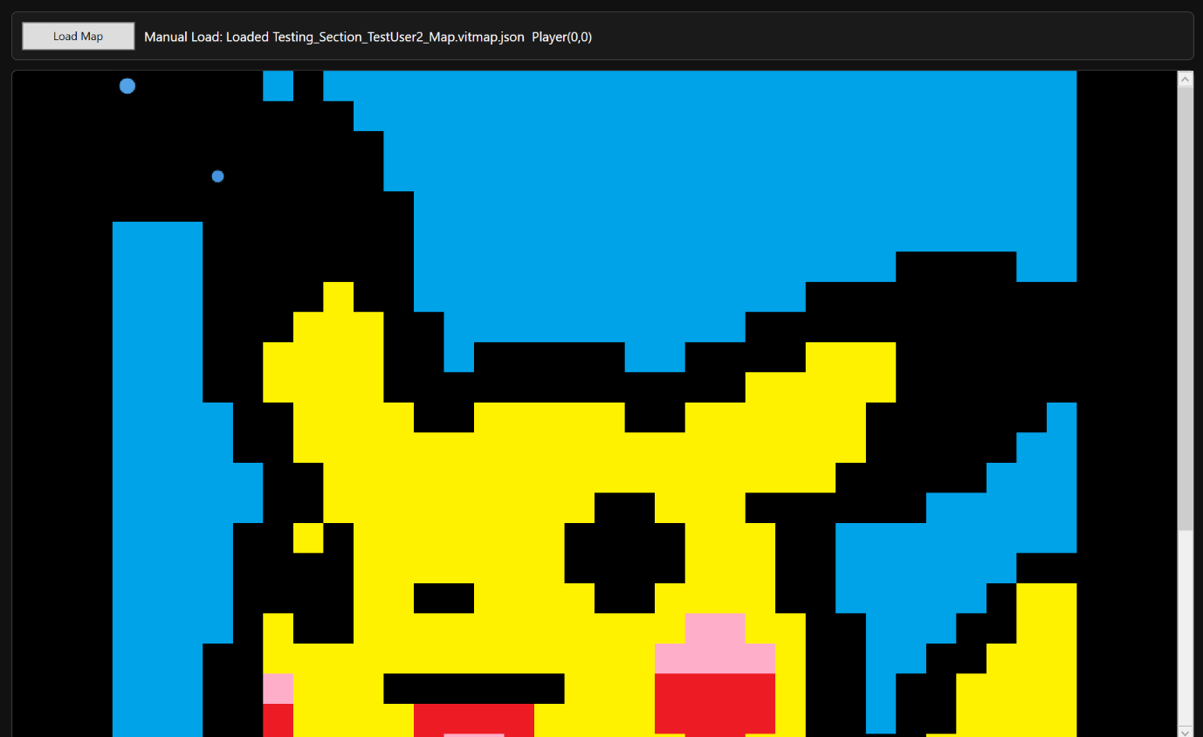

6.2 Observed Error Patterns
Although both users completed all tasks, there were several minor patterns observed:
- Event tools were less discoverable than tile painting tools
- Users initially attempted to interact with NPCs from adjacent tiles
- Some hesitation occurred when distinguishing between saving and autosaving behaviour
- User expected Eter to trigger interaction consistently
These observations indicate that while the system is functionally stable, minor usability refinements could improve first-time experience

7 Witness Statement

7.1 Witness Confirmation of Functionality
I confirm that I observed the Vitriol editor and runtime being used to create and test a playable map. The developer demonstrated map creation, tile editing, event placement, saving, and loading the map into the runtime environment.
I observed successful player movement, event triggering, and correct rendering of the map. The system appeared stable, and responsive throughout the demonstration.
Based on what I observed, the features shown were working as described and no functional issues were evident during testing

Test User 1
Signature: Michael Christopher Payne
Date: 27/02/2026

Test User 2
Signature: Rachael Evans
Date: 27/02/2026

7.2 Summary of Demonstrated Features

Test User 1
During the demonstration, the following features were shown:
- Creation of a new tile-based map
- Manual save and autosave behaviour
- Loading and referencing of tilesets
- Tile painting and editing
- Placement of NPC event with ShowText command
- Saving to JSON format
- Runtime loading of saved map
- Player movement with collision handling
- NPC interaction triggering dialogue
- Camera following player with boundary clamping
All features appeared to function as intended.

Test User 2
The following functionality was demonstrated:
- Structured map creation workflow
- Editing of map layers
- Event placement and configuration
- Persistence of map data across reload
- Viewport-only rendering in both editor and runtime
- Runtime interaction using keyboard input
- Event execution behaviour
The system operated consistently during the observed session

8 Testing Summary and Coverage

8.1 Requirement Coverage Mapping

Coverage Table
The table below summarises how each core functional requirement has been validated through structured testing:
ID | Requirement Description | Validated By | Evidence Figures
FR1 | Create new maps with defined dimensions and initialise layered structure | 2.1, 5.1 | T1-T6, T66-69
FR2 | Visually paint, erase, and modify tile data within a grid-based system | 2.2, 3.2 | T7-T11, T34-T38
FR3 | Collision Editing – Define walkable and blocked tiles via a dedicated collision layer | 3.2, 5.2 | T39-T41, T71
FR4 | Event Placement – Add, edit, and remove position based event triggers on the map | 2.4, 5.2 | T16-T20, T70-T72
FR5 | Map Persistence – Save and load maps using structured JSON with format versioning | 2.4, 5.3 | T16-T22, T73-T76
FR6 | Runtime Playback – Load maps into runtime and render with camera-based viewport logic | 3.1, 3,4 | T23-T27, T42-T47
FR7 | Player Movement & Collision – Handle deterministic grid-based collision detection | 3.2, 5.2 | T29-T41, T71
FR8 | Editing History – Implement command-based Undo/Redo across tile, collision, and events | 2.2 | T8-T11
FR9 | Autosave Control – Activate controlled autosave after initial manual save | 2.1, 5,1 | T4-T6, T67-T68
FR10 | Performance stability – Maintain approximately 60 FPS on target specification hardware | 4 | T48-T65
FR11 | Relative Asset Referencing – Store tileset paths relative to project directory | 3.1 | T28-T32
FR12 | Layer Rendering Order – Enforce correct drawing hierarchy in editor and runtime | 3.4, 5.4 | T42-T47, T77

Coverage Analysis
The coverage mapping demonstrates that:
- All major functional requirements were validated through structured subsystem testing
- Regression testing confirmed stability following future expansion
- No core requirement remains untested
- Each requirement is supported by at least one visual evidence reference
This confirms that the implementation aligns with the functional objectives defined in the analysis section.

8.2 Non-Functional Requirement Validation

Performance
Performance testing (Section 4) demonstrated that:
- Viewport-only rendering reduces rendering workload
- Large maps (200x200) remain usable without freezing
- Continuous player movement does not cause degradation
- Tileset caching prevents repeated image decoding overhead
Evidence: T48 – T65
The system maintains stable responsiveness during both typical and extended usage scenarios.

Reliability
Reliability was validated through:
- JSON validation checks preventing malformed loads
- Defensive handling of missing event parameters
- Collision enforcement preventing invalid state transitions
- Regression testing confirming no feature breakage
Evidence: T20.1-T20.2, T70-T76
The application operates without crashes under normal usage and handles invalid inputs safely.

Usability
Usability validation was conducted through structured user testing (Section 6) demonstrating:
- Successful independent task completion by participants
- Minimal intervention required
- Clear map editing workflow
- Intuitive runtime movement controls
Observed minor discoverability issues did not prevent task completion.
Evidence: T81.1 – T82.2
The system is usable by individuals unfamiliar with the codebase, satisfying the intended user accessibility objective.

8.3 Final Conclusion
Across all testing categories:
- Subsystem testing validated individual components
- Boundary testing confirmed safe handling of abnormal input
- Performance testing demonstrated stable execution under load
- Regression testing confirmed stability after feature additions
- User testing validated real-world usability
- Witness confirmation provided independent observation.
The evidence demonstrates that the system meets the stated functional and non-functional requirements and behaves consistently under expected operating conditions.

